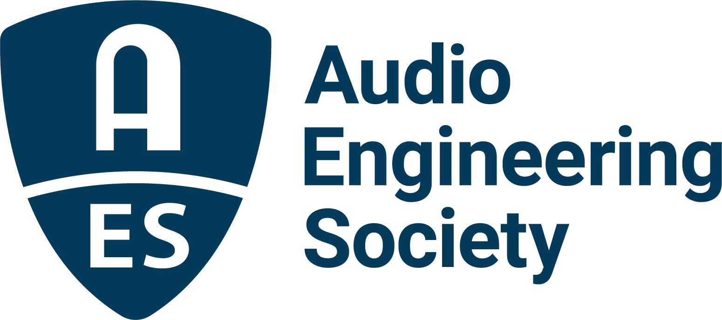

FOR IMMEDIATE RELEASE

AES New York 2022 Convention Registration Now Open – Join the Audio Industry in New York this October

— The Audio Engineering Society returns to in-person U.S. Convention —

New York, NY, June 16, 2022 – The Audio Engineering Society has announced registration is now open for the AES New York 2022 Convention, taking place at the Jacob Javits Center, October 19–20, with pre-and post-show activities on the 18th and 21st, followed by an online component, October 26–27.

“While we’ve been delivering quality online events and will continue to take Convention content to a worldwide audience through an online component of the Fall Convention, there’s just nothing that completely replaces gathering as a community and interacting face-to-face," shares AES New York 2022 Convention Chair Jonathan Wyner. "We’re hard at work putting together a program that promises to educate and inspire. We hope you’ll join us this October.”

Whatever an attendee’s audio interest or level of expertise, AES New York 2022 offers targeted content and opportunity at every turn. Along with reconnecting with colleagues, clients and friends and making new acquaintances, the eagerly anticipated return to the in-person AES Convention experience will feature a comprehensive selection of workshops, panels, demonstrations, training, research presentations, student-focused sessions and inspirational special events in its unparalleled Technical Program, in addition to the popular exhibition floor filled with the latest gear and offerings from top brands in audio. This 153rd International Audio Engineering Society International Convention will once again be co-located with the NAB Show New York, offering access to a shared exhibition floor and even greater networking opportunities among the content-creator attendees to both events.

AES New York 2022 offers several registration options: All Access for admission to all Convention events and sessions, in-person and online; Online Only registration for exclusive access from nearly anywhere in the world, in real-time October 26 - 27 and in replay through December 31; and a free Exhibits+ option for access to the in-person exhibition floor and related sessions. Advanced registration pricing, including additional discounts for AES Members and AES Student Members, is available at AESShow.com.

Additionally, attendees looking to have their work featured during the AES New York 2022 Convention can now submit proposals for Workshops, Tutorials, Papers and Express Papers, with initial deadlines coming up July 31. Exhibition, Partner Presentation sessions and digital marketing opportunities are also available for brands looking to showcase products and technologies.

AES New York 2022 event partners include Dell, IMES (Iron Mountain Entertainment Services) and Qualcomm.

Visit AESShow.com for details and registration.

…ends 386 words

Links
AES New York 2022 Convention

Photo File 1: AESNY_2022.JPG
Photo Caption 1: The AES New York 2022 Convention will take place at the Jacob Javits Center, October 19 – 20, with pre-and post-show activities on the 18th and 21st, followed by an online component, October 26 – 27. Register now at AESShow.com.

About the Audio Engineering Society
The Audio Engineering Society, celebrating over 70 years of audio excellence, serves as the pivotal force in fostering the development and dissemination of technical information for the audio community. Currently, its members are affiliated with 90 AES professional sections and more than 120 AES student sections around the world. Section activities include guest speakers, technical tours, demonstrations, online events and social functions. Through Conventions, Conferences, Training and Development, Member Events and peer-reviewed Publications, as well as the Society’s vast online resources, members experience valuable opportunities for professional networking and personal growth. For additional information, visit AES.org.

Join the conversation and keep up with the latest AES News and Events:
Twitter: #AESorg (AES Official)
Facebook: facebook.com/AES.org
LinkedIn: https://www.linkedin.com/company/audio-engineering-society
Instagram: https://www.instagram.com/aes_org/

AES Marketing Communications:
Email: robert.clyne@aes.org
Tel: 615-662-1616
Clyne Media, Inc.,
169-B Belle Forest Circle, Nashville, TN 37221;
Web: http://www.clynemedia.com

