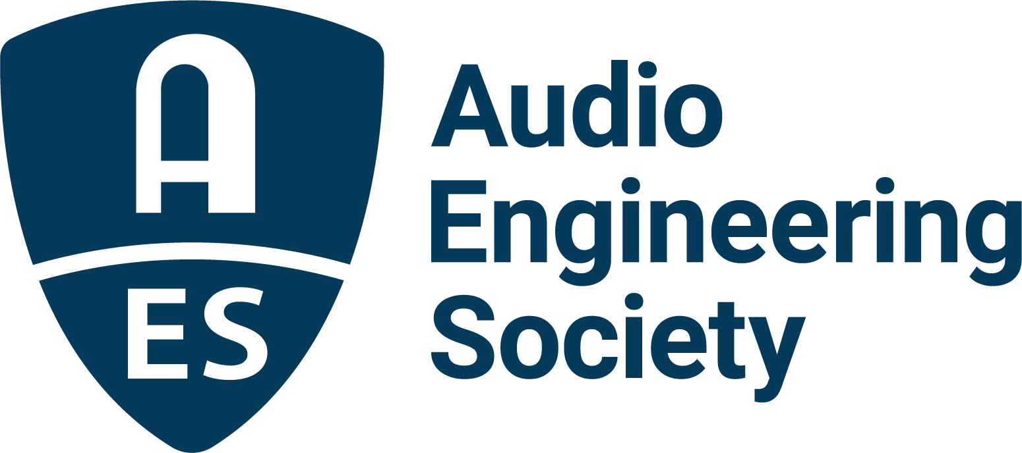

FOR IMMEDIATE RELEASE

AES Launches Redesigned AES.org Website and Branding

— A clean look and intuitive navigation on a modern platform characterizes the new site which is branded with a refresh of the AES logo —

New York, NY, August 2, 2021 — The Audio Engineering Society, to further its position as the leading organization to promote the science and art of audio, has been busy improving the member experience and accessibility of its online portal, AES.org. Earlier this year, phase one debuted with a new and more user-friendly membership and event management interface, simplifying the processes of joining the Society, renewing memberships and event registration.

While AES.org is already the destination repository of the entirety of audio knowledge, the site was overdue for a website content management system update which in turn would allow for a functionality update. Today’s relaunch reveals an AES.org that retains familiarity while expanding exponentially on the previous site’s capabilities and usability.

“The redesigned AES.org focusses on AES member and industry support,” shares Colleen Harper, AES Executive Director. “There’s so much to find at AES.org, and those resources are only growing. A modern, flexible platform with a streamlined and intuitive user interface was needed to enhance navigation and deep dives into the site’s rich content. That’s what this redesign is giving us. The initial advances lay the foundation for improvement of site user’s experience sitewide. We’re so excited to share it with our membership and community.”

The relaunched site debuts with core navigation, event information news and membership pages sporting the new look. The updates will continue over coming months as the full site is morphed to the updated platform. That task is daunting, as AES.org is home to massive amounts of data – 27,000+ individual web pages, 20,000+ pdf articles and papers in the AES E-Library, archives of 70+ years of the Journal of the Audio Engineering Society, 90+ Standards documents and 400+ tutorial and inspirational videos in the connected AES Live: Videos searchable archive. The full transition is well underway towards an AES.org that meets the needs of AES members and the audio industry at large into the future.

The site’s look and feel, implemented by creative content agency Copper Leaf Media in collaboration with the AES marketing team and Clyne Media, is modern, uncluttered and logically organized with the needs of the professional audio community consistently in mind during the development process. The fact that Copper Leaf’s Directors Roland Hemming and Kiera Leeming are audio industry veterans – Hemming a 15-year member of the AES – was a welcome element of the design process.

A key component of the redesign, with visibility far beyond, is a refresh of the AES logo for the first time since it was introduced as a hand-crafted design in 1948 when the Society was founded. The iconic “A” in the familiar shield shape remains as the foundation, with an aesthetically pleasing look that will better serve branding applications across print, web and even on AES swag. Those interested can learn more about the logo’s history and the evolution of the design by clicking the Brand Assets link on the AES.org About page, where there’s also downloadable artwork and a logo usage guide.

To experience the Audio Engineering Society’s new online home, please visit www.aes.org.

...ends 501 words

Photo File 1: AES_org_screenshot.JPG
Photo Caption 1: AES has launched the initial core of its revamped website along with a refresh of the AES logo

Photo File 2: AES_logo.JPG
Photo Caption 2: The new AES logo is at once familiar and recognizable, yet fresh and contemporary

About the Audio Engineering Society
The Audio Engineering Society, celebrating over 70 years of audio excellence, now counts over 12,000 members throughout the U.S., Latin America, Europe, Japan and the Far East. The organization serves as the pivotal force in the exchange and dissemination of technical information for the industry. Currently, its members are affiliated with 90 AES professional sections and more than 120 AES student sections around the world. Section activities include guest speakers, technical tours, demonstrations and social functions. Through local AES section events members experience valuable opportunities for professional networking and personal growth. For additional information, visit aes.org.

Join the conversation and keep up with the latest AES News and Events:
Twitter: #AESorg (AES Official)
Facebook: facebook.com/AES.org

AES Marketing Communications:
Email: robert.clyne@aes.org
Tel: 615-662-1616, Fax: 615-662-1636,
Clyne Media, Inc.,
169-B Belle Forest Circle, Nashville, TN 37221;
Web: http://www.clynemedia.com

