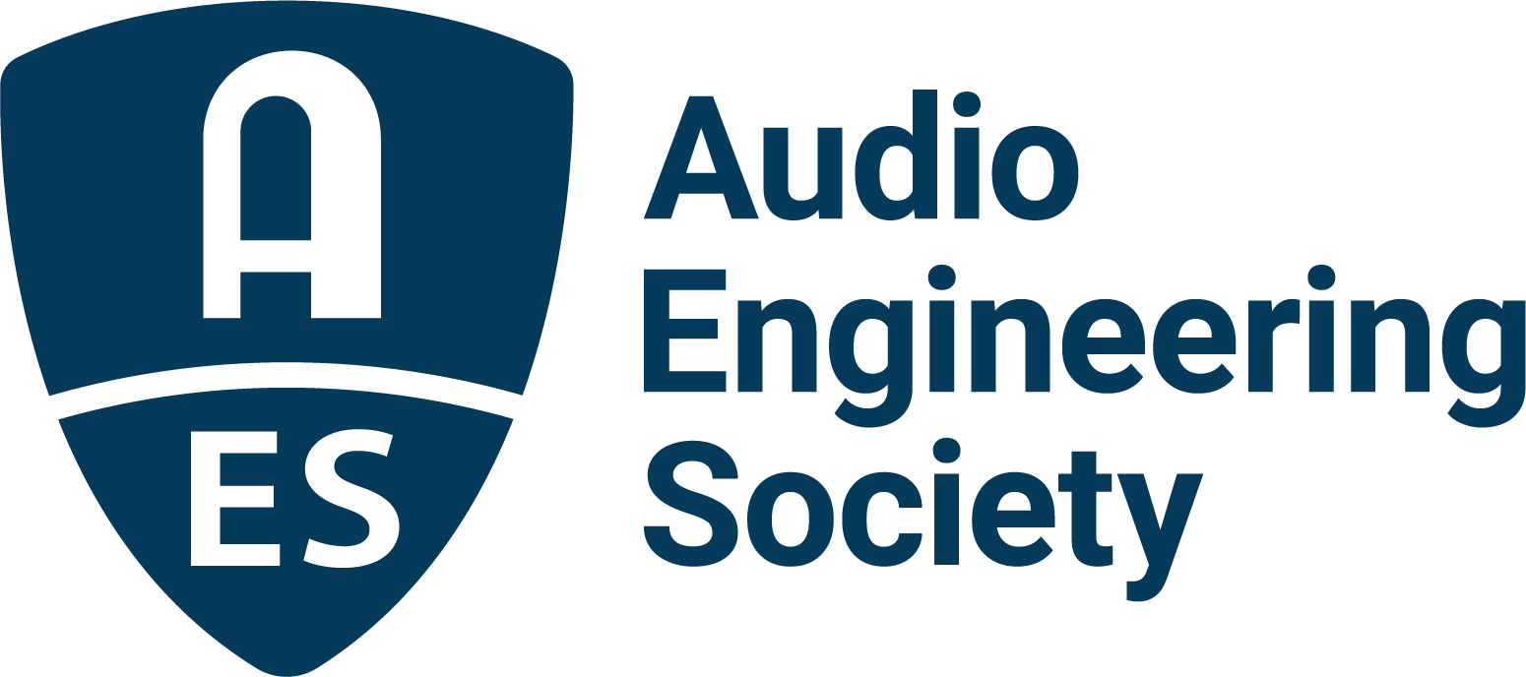

FOR IMMEDIATE RELEASE

AES Educational Foundation Announces Awardees for the 2021/2022 Academic Year

— Annual grants and scholarships continue to help audio students realize their full potential —

New York, NY, August 23, 2021 — The Audio Engineering Society Educational Foundation has announced the awardees of AES Educational Scholarships and Grants for Graduate and Undergraduate Studies in Audio Engineering. “The AES Educational Foundation was established in 1984 to encourage talented students to enter the profession of audio engineering,” commented AES Education Foundation president Jim Anderson. “Annually, we give grants for graduate studies with emphasis on audio in its many forms. The recipients are selected based on their demonstrated talent, achievements, goals and recommendations. The AES Educational Foundation’s grants are made possible by a host of contributions from benefactors, including from manufacturers Audio Precision, Dolby, Genelec, L-Acoustics and PMC, and from the families of John Eargle, Mary Lea Simpson, Emil Torick, Bruce Swedien, and Larry Estrin.” The Board of the Audio Engineering Society Educational Foundation is pleased to name the scholarship awardees:
Audio Precision’s Tom Kite Advancing Audio Scholarship – Cesar Lamschtein, attending University of Colorado Denver
Genelec Ilpo Martikainen Audio Visionary Scholarship – Gregor McWilliam, attending New York University, Steinhardt School of Culture, Education, and Human Development, New York City, USA
Genelec Mike Chafee Audio Pioneering Scholarship – Aizhou (Amy) Liu, attending New York University, Steinhardt School of Culture, Education, and Human Development, New York City, USA
L-Acoustics’ Dr. Christian Heil Future of Sound Scholarship – Michael Edwin, attending New York University, Steinhardt School of Culture, Education, and Human Development, New York City, USA
Emil Torick Award – Akshada Bandekar, attending University of Miami, Frost School of Music, Coral Gables, Florida, USA
John Eargle Award – Carolina Rodríguez, attending McGill University, Schulich School of Music, Montreal, Quebec, Canada
Mary Lea Simpson Memorial Scholarship – Nick Catrambone, attending New York University, Clive Davis Institute of Recorded Music, Brooklyn, New York, USA
AES Educational Foundation Scholarship – Kerri-Ann Chandler, attending New York University, Steinhardt School of Culture, Education, and Human Development, New York City, USA
AES Educational Foundation Scholarship – Matthew Cheshire, attending Birmingham City University, Birmingham, UK
AES Educational Foundation Scholarship – Yoonjeong Choi, attending McGill University, Schulich School of Music, Montreal, Quebec, Canada
AES Educational Foundation Scholarship – Zhi-Xiong Jiang, attending Pusan National University, Busan, South Korea
AES Educational Foundation Scholarship – Cuauhtemoc Mendez, attending Peabody Institute of The Johns Hopkins University, Baltimore, Maryland, USA
AES Educational Foundation Scholarship – Leonard Menon, attending McGill University, Schulich School of Music, Montreal, Quebec, Canada
AES Educational Foundation Scholarship – Mike Middleton, attending University of York, Helsington, York, UK
AES Educational Foundation Scholarship – Jigar Rajpopat, attending University of Miami, Frost School of Music, Coral Gables, Florida, USA
AES Educational Foundation Scholarship – Luisa Fernanda Pinzon Rivero, attending California Institute of Arts – CALARTS, Valencia, California, USA
AES Educational Foundation Scholarship - Ashell Sickmen, attending University of Colorado Denver, Denver, Colorado, USA

The creation of the AES Educational Foundation illustrates the AES’s commitment to promoting the science and art of audio engineering and related disciplines through the development of future industry leaders. The Foundation welcomes support for these goals from individual benefactors and companies, including in-memoriam contributions. Application forms and additional information are available from the Audio Engineering Society, Audio Engineering Society, Inc., International Headquarters, 132 East 43rd Street, Suite 405, New York, NY 10017, USA, or on its web site: www.aes.org/education/foundation/.

...ends 517 words

Photo File 1: AES_Educational_Foundation.jpg
Photo Caption 1: The Audio Engineering Society Educational Foundation has announced the recipients of the AES Educational Scholarships and Grants for Graduate and Undergraduate Studies in Audio Engineering for the 2021/2022 academic year

About the Audio Engineering Society
The Audio Engineering Society, celebrating over 70 years of audio excellence, now counts over 12,000 members throughout the U.S., Latin America, Europe, Japan and the Far East. The organization serves as the pivotal force in the exchange and dissemination of technical information for the industry. Currently, its members are affiliated with 90 AES professional sections and more than 120 AES student sections around the world. Section activities include guest speakers, technical tours, demonstrations and social functions. Through local AES section events members experience valuable opportunities for professional networking and personal growth. For additional information, visit aes.org.

Join the conversation and keep up with the latest AES News and Events:
Twitter: #AESorg (AES Official)
Facebook: facebook.com/AES.org

AES Marketing Communications:
Email: robert.clyne@aes.org
Tel: 615-662-1616, Fax: 615-662-1636,
Clyne Media, Inc.,
169-B Belle Forest Circle, Nashville, TN 37221;
Web: http://www.clynemedia.com

