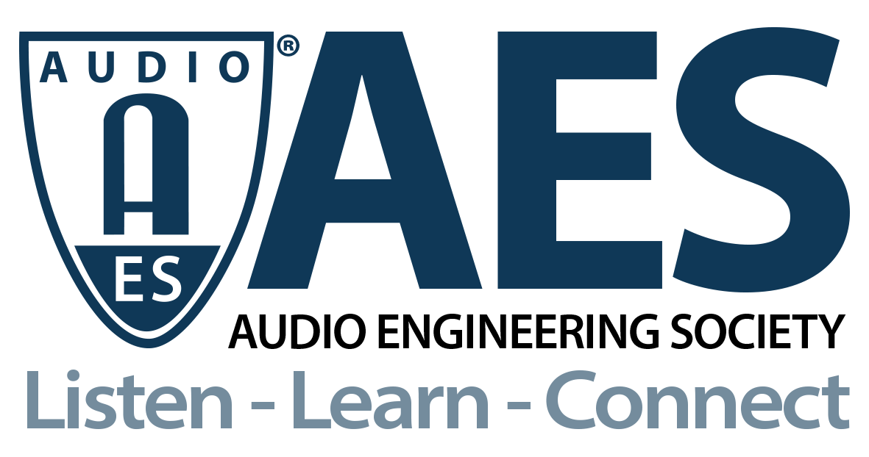

FOR IMMEDIATE RELEASE

AES Audio Product Education Institute Promotes Weekly Online Events During the Month of June

— Strong sequence of June 2021 online sessions from the AES APEI initiative will focus on Artificial Intelligence and Machine Learning, Automotive Audio, Modeling and Measurement, and Supply Chain and Sourcing —

New York, NY, June 1, 2021 — The AES Audio Product Education Institute (APEI) will host a sequence of four online events in June 2021, centered on some of its most dynamic education pillars – Artificial Intelligence and Machine Learning, Automotive Audio, Modeling and Measurement, and Supply Chain and Sourcing. The sessions will feature top industry experts and companies in each area of focus.

The webinars will take place each Wednesday in June at 9:00 AM Pacific (12:00 PM Eastern), beginning with the June 2nd session focused on “Artificial Intelligence, Machine Learning and Voice Interfaces on the Edge”. This will be the first AI&ML event since Steve F. Willenborg, VP of Sales at Linkplay Technology, accepted the chair of the APEI AI&ML pillar. Willenborg will provide an introduction to the product development process and explore the tools and technologies for designing and integrating AI&ML into products. He will be joined by Jeff Rogers, Co-Founder & VP of Sales at Sensory, who will explain the audio product potential of leading edge AI and ML, introduce some of Sensory’s key technologies for voice interfaces completely implemented on-device, and address the development of new voice UIs in smart home products, appliances and even toys.

An international executive with a strong background in engineering and business development for multiple product market segments, Willenborg has worked with some of the most iconic companies in audio, consumer electronics and automotive across a career spanning more than 35 years. At Linkplay Technology, he is directly involved in supporting companies and brands in the development of smart audio solutions, software/firmware development and the integration of wireless audio, device cloud software and streaming content.

The following week, the next APEI online event is an Automotive Audio session on Remote Sound Tuning in Automobiles, June 9, 2021. This webinar will discuss tools and practices for remotely measuring a car audio system, visualizing the data, and auralizing and tuning the system, with very close accuracy to the in-vehicle experience. Roger Shively (JJR Acoustics, LLC), APEI's Automotive Pillar Chair, together with Shelley Uprichard, independent audio engineer, will co-host the session and present on the subjective evaluation work.

Marc Levasseur, independent audio engineer and consultant, with extensive experience in automotive audio sound tuning, will describe his use of Illusonic's solutions, together with Christof Faller (Illusonic founder), who will demonstrate system auralization with head-tracking and headphone compensation equalization. Finally, Michael Fabry, General Manager at DSP Concepts Germany, former founder of S1nn, and manager of audio systems for companies such as Harman/Becker and Bose, will demonstrate capturing a vehicle and system acoustic footprint and offline tuning. The two-hour session will conclude with an opportunity for questions from attendees.

One week later on June 16, a new APEI Modeling and Measurement webinar will address Achieving Loudspeaker Design Goals Using Multiphysics Simulation. In this webinar, Lakshmikanth Tipparaju, Senior Acoustic System and Transducer Engineer at Dolby Laboratories, and Jinlan Huang, COMSOL Applications Engineer, will discuss on the role of modeling and measurements in the loudspeaker design process.

Tipparaju will share project experiences in the design of a height channel speaker for immersive audio setups, and how simulation, measurements and experiments helped to ensure that the design met the requirements. In the second talk, Huang will detail the use of simulation in audio system design and the various numerical approaches to consider for multiphysics modeling of loudspeakers.

Concluding the June series on June 23, the consistently insightful series of Audio Product Education Institute webinars focusing on Supply Chain & Sourcing will offer perspectives from two well-established design houses whose representatives will discuss their firms’ roles and contributions as a vital support option for brands in all critical stages of product development, and how the design companies explore various perspectives in audio design and engineering. Details will be confirmed soon on the APEI website.

More detailed content information, speaker bios, and registration for each of these events is available in the Audio Product Education Institute website, in the respective event pages.

Registration is now open for the June 2 event: Artificial Intelligence, Machine Learning, and Voice Interfaces on the Edge. Zoom Registration link: https://us02web.zoom.us/webinar/register/WN_VeDyQ1J_SFG5NsJLpK41kw

Information about all of the upcoming APEI events is available here: https://audioproducteducationinstitute.org.

…ends 688 words

Photo File 1: APEI_2021_June_Events.jpg
Photo Caption: The AES Audio Product Education Institute promotes a weekly calendar of online events in the month of June – every Wednesday at 12:00pm EDT.

Photo File 2: APEI_2021_June_2_Event.jpg
Photo Caption: The AES Audio Product Education Institute will host its next event, “Artificial Intelligence, Machine Learning and Voice Interfaces on the Edge,” on Wednesday, June 2 at 12:00pm EDT

promotes a weekly calendar of online events in the month of June – every Wednesday at 12:00pm EDT. On June 2nd, the AES Audio Product Education Institute

About the Audio Engineering Society
The Audio Engineering Society, celebrating over 70 years of audio excellence, now counts over 12,000 members throughout the U.S., Latin America, Europe, Japan and the Far East. The organization serves as the pivotal force in the exchange and dissemination of technical information for the industry. Currently, its members are affiliated with 90 AES professional sections and more than 120 AES student sections around the world. Section activities include guest speakers, technical tours, demonstrations and social functions. Through Conventions, Conferences, Training and Development and Member Events, and the Society’s vast online resources, members experience valuable opportunities for professional networking and personal growth. For additional information, visit AES.org.

About the Audio Product Education Institute (APEI)
The Audio Product Education Institute (APEI) was launched in January 2020, as an initiative of the Audio Engineering Society (AES), to focus on promoting methodologies, practices and technologies involved in developing and bringing audio products to market. The Institute roadmap intends to focus on seven educational pillars: Voice and DSP; Supply Chain and Sourcing; Modeling and Measurement; Product Management; Automotive Audio; Artificial Intelligence and Machine Learning; and Business Management. For more information, visit https://audioproducteducationinstitute.org.

Join the conversation and keep up with the latest AES News and Events:
Twitter: #AESorg (AES Official)
Facebook: facebook.com/AES.org

AES Marketing Communications:
Email: robert.clyne@aes.org
Tel: 615-662-1616, Fax: 615-662-1636,
Clyne Media, Inc.,
169-B Belle Forest Circle, Nashville, TN 37221;
Web: http://www.clynemedia.com

