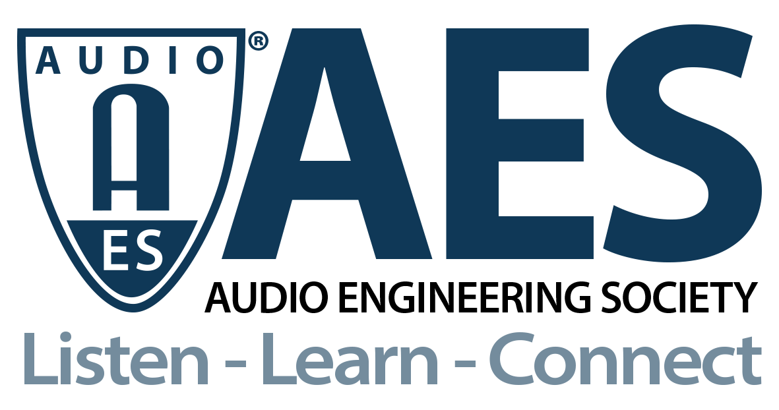

FOR IMMEDIATE RELEASE

Modeling and Measurement Webinar Illustrates the Use of Digital Twins for Architecting & Designing Audio Devices

— The AES Audio Product Education Institute (APEI) promotes a new webinar series on its Modeling and Measurement education pillar to explore the use of Digital Twins as a new simulation-driven audio architecture design —

New York, NY, September 17, 2021 — The AES Audio Product Education Institute (APEI) presents a new webinar series on the practice and benefits of simulation-driven audio architecture design by use of Digital Twins. In this series of Modeling and Measurement online events, experts from COMSOL, Facebook Reality Labs, JJR Acoustics and other companies will discuss the role of Digital Twins and how advanced experimental transducer identification can be used to influence fundamental design considerations, even before the first prototype is built to proof a concept.

In audio product development, computer modeling and simulations are often used to troubleshoot and optimize acoustic performance once fundamental design assumptions have been defined. And yet, the largest gains in audio performance are consolidated in the very early architectural design phase, where the form factor, transducer choice, and placement dictates the overall acoustic product performance. What if “high fidelity” Digital Twins and advanced experimental transducer identification was used to influence the form factor, transducer type and tuning decisions even before the first prototype is built to proof a concept?

This webinar series focuses on how experimental transducer and virtual simulation-driven audio architecture explorations can work together, impacting the very early product development cross-functional discussions with PM (Program Management), PD (Product Development) and ID (Industrial Design). The sessions will share methods and experiences of cross-functional, collaborative decision-making to meet PM’s desired audio user experience, PD’s manufacturing strategy/story, and ID’s aesthetics and function.

The presentations will provide an overview of how measurement and Digital Twins can front-load and address optimal acoustic insights to influence audio product architecture in the critical first 2-4 months of a project. Also detailed are the corresponding strategies to inform and qualify the first physical prototype made for proof of concept, and validate a commitment to investment on a product idea, with presentations of real cases of this new “virtual architectural design.”

On the first webinar, Wednesday, September 22 (12:00pm EDT), Ulrik Skov (Audio Transducer, System & Material Architectural Lead at Facebook Reality Labs), will offer an introduction to the concept of Digital Twins, and will detail his experience in front-loading a new Cross-Functional Acoustic Alignment approach to the product development and design process. The successful integration of modeling and simulation in product management will be discussed by Scott Leslie (PD Squared), APEI’s Managing Director and Product Management education pillar chair, followed by an hands-on session with Mads Herring Jensen (Technology Manager, Acoustics, COMSOL) explaining how it can be done.

The Audio Product Education Institute’s Modeling and Measurement education pillar is sponsored by COMSOL and underscores the AES’s commitment to providing its membership and the industry at large with information on real-world solutions for audio product development. Additional sessions on the topic of Digital Twins for Architecting & Designing Audio Devices are scheduled for October 27 and November 17, 2021 (taking place on Wednesdays at 9am Pacific/12pm Eastern).

Webinar registration: https://audioproducteducationinstitute.org/digital-twins-for-architecting-designing-audio-devices/

…ends 472 words

Photo File 1: APEI-2021-ModelingMeasurement-DigitalTwins-Sept22-12x9.jpg
Photo Caption: The AES Audio Product Education Institute will present the webinar Digital Twins for Architecting & Designing Audio Devices on Wednesday, September 22, at 12:00pm EDT.

Photo File 2: APEI-2021-ModelingMeasurement-DigitalTwins-Sept22-T.jpg
Photo Caption 2: The Audio Product Education Institute (APEI) presents a webinar series on the practice and benefits of simulation-driven audio architecture design by use of Digital Twins.

About the Audio Engineering Society

The Audio Engineering Society, celebrating over 70 years of audio excellence, now counts over 12,000 members throughout the U.S., Latin America, Europe, Japan and the Far East. The organization serves as the pivotal force in the exchange and dissemination of technical information for the industry. Currently, its members are affiliated with 90 AES professional sections and more than 120 AES student sections around the world. Section activities include guest speakers, technical tours, demonstrations and social functions. Through Conventions, Conferences, Training and Development and Member Events, and the Society’s vast online resources, members experience valuable opportunities for professional networking and personal growth. For additional information, visit AES.org.

About the Audio Product Education Institute (APEI)

The Audio Product Education Institute (APEI) was launched in January 2020, as an initiative of the Audio Engineering Society (AES), to focus on promoting methodologies, practices and technologies involved in developing and bringing audio products to market. The Institute roadmap intends to focus on seven educational pillars: Voice and DSP; Supply Chain and Sourcing; Modeling and Measurement; Product Management; Automotive Audio; Artificial Intelligence and Machine Learning; and Business Management. For more information, visit https://audioproducteducationinstitute.org.

Join the conversation and keep up with the latest AES News and Events:

Twitter: #AESorg (AES Official)

Facebook: facebook.com/AES.org

AES Marketing Communications:
Email: robert.clyne@aes.org
Tel: 615-662-1616, Fax: 615-662-1636,
Clyne Media, Inc.,
169-B Belle Forest Circle, Nashville, TN 37221;
Web: http://www.clynemedia.com

