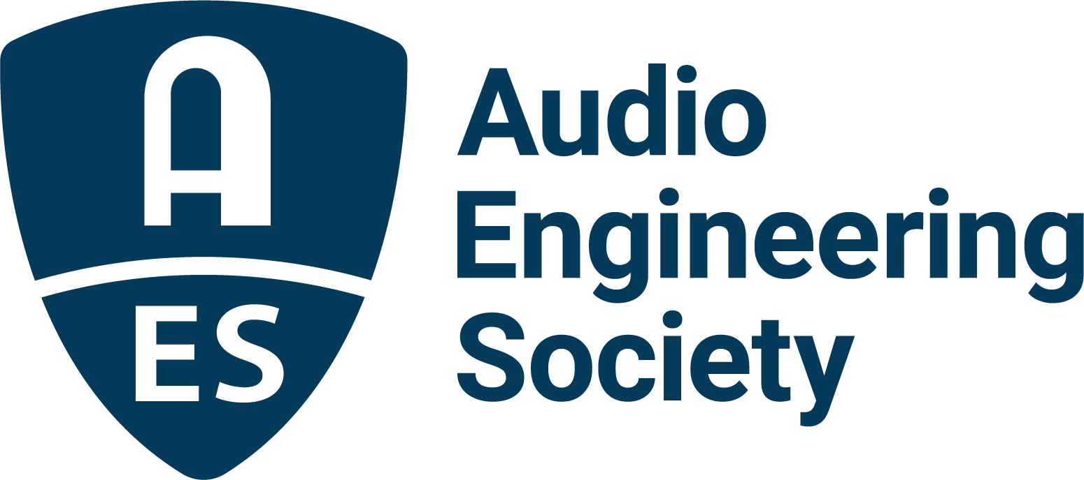

FOR IMMEDIATE RELEASE

Recording Academy® Producers & Engineers Wing® to Address Credit Collection and Archiving Practices at AES Fall Online 2021

New York, NY, October 21, 2021 — The Recording Academy® Producers & Engineers Wing® is hosting two sessions at this year’s AES Fall Online 2021 Convention that will address credit collection and archiving practices of content creators.

On Friday, October 22, from 11:00am-12:00pm EDT, the Recording Academy P&E Wing will present the session “Whose Job Is It Anyway? Collecting Credits in the Recording Studio.” This session’s presenters include Cameron Craig (producer/mixer/engineer and an executive director of the UK’s Music Producers Guild), Sylvia Massy (producer/engineer), Jr. Regisford (Manager, New Heights/New Heat Entertainment) and Craig Rosen (Executive Vice President A&R Operations/Atlantic Records), discussing the challenges of collecting creator credit metadata. Records today are made in a variety of ways, often with multiple engineers, songwriters, musicians, mixers, artists, mastering engineers, etc., which begs the question “Who Did What?” Each of the panelists will share their points of view on whose job is it to key-in this important metadata. Maureen Droney, Sr. Managing Director, Recording Academy Producers & Engineers Wing, will serve as moderator.

The P&E Wing will also, in association with Iron Mountain Entertainment Services (IMES) give AES Fall Online 2021 attendees of the Convention a first look at results from the recent survey of the P&E Wing and AES music production and engineering community on current practices and challenges in audio archiving. The session, titled How You are Protecting Legacies: Topline Results from the Recording Academy P&E Wing and Iron Mountain Entertainment Services Survey will be streamed on Thursday, October 21, from 3:00pm - 4:00pm EDT

Visit the AES Fall 2021 Online Convention website for complete program details, and register now to join the AES for Convention activities throughout the month, including additional Special Events, Tech Tours and the Topically Tracked Technical Program (Oct. 20 – 23), Immersive Audio Days (Oct. 26 – 27) and Audio Education Days (Oct. 30 – 31).

AES Fall Online 2021 Convention Sponsors are Amazon Devices, Amazon Lab126, Dell Technologies, Fraunhofer, IMES (Iron Mountain Entertainment Services), iZotope, L-Acoustics, New Audio Technology, NTP Technology and The Recording Academy Producers and Engineers Wing.

…ends 334 words

About the Audio Engineering Society
The Audio Engineering Society, celebrating over 70 years of audio excellence, now counts over 12,000 members worldwide. The organization serves as the pivotal force in the exchange and dissemination of technical information for the professional audio community. Currently, its members are affiliated with 90 AES professional sections and more than 120 AES student sections around the world. Section activities include guest speakers, technical tours, demonstrations, online events and social functions. Through Conventions, Conferences, Training and Development, and Member Events, as well as the Society’s vast online resources, members experience valuable opportunities for professional networking and personal growth. For additional information, visit aes.org.

Join the conversation and keep up with the latest AES News and Events:
Twitter: #AESorg (AES Official)
Facebook: facebook.com/AES.org

AES Marketing Communications:
Email: robert.clyne@aes.org
Tel: 615-662-1616, Fax: 615-662-1636,
Clyne Media, Inc.,
169-B Belle Forest Circle, Nashville, TN 37221;
Web: http://www.clynemedia.com

About The Recording Academy

The Recording Academy represents the voices of performers, songwriters, producers, engineers, and all music professionals. Dedicated to ensuring the recording arts remain a thriving part of our shared cultural heritage, the Academy honors music's history while investing in its future through the GRAMMY Museum®, advocates on behalf of music creators, supports music people in times of need through MusiCares®, and celebrates artistic excellence through the GRAMMY Awards—music's only peer-recognized accolade and highest achievement. As the world's leading society of music professionals, we work year-round to foster a more inspiring world for creators. For more information about the Academy and its Producers & Engineers Wing, please visit www.producersandengineers.com or @ProdEngWing on Instagram.

