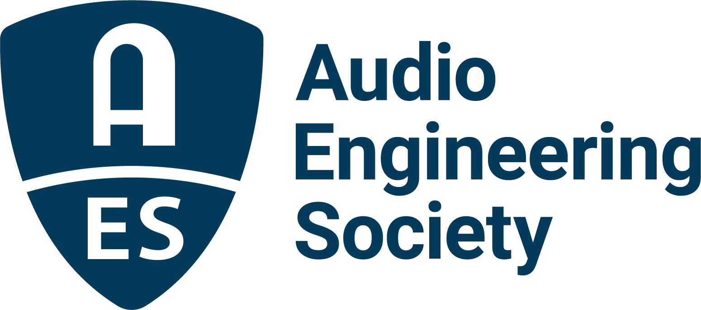

FOR IMMEDIATE RELEASE

AES Fall Online 2021 Convention Features Electronic Instrument Design, Sound Reinforcement, Broadcast and DIY in Opening Week Events

— AES 151st International Convention sessions begin on Monday, October 11, and run throughout the month of October —

New York, NY, October 7, 2021 — The Audio Engineering Society will open its AES Fall Online 2021 Convention to a worldwide audience of attendees on October 11, with live-streamed and on-demand events continuing through the month, all included in one registration. In its expanded, online format, the Convention will offer several topically focused events, beginning opening week with Electronic Instrument and Design Day (Oct. 11), Sound Reinforcement Day (Oct. 12) and Broadcast and Online Delivery Day (Oct. 13), followed by the weekend Audio Builders Workshop events (Oct. 16 – 17). The session schedule, presenters, special events and more are available at AESShow.com/Fall2021/.

Electronic Instrument Design and Applications Day
With electronic instruments serving a ubiquitous role in much of today’s music production, the AES will feature Electronic Instrument Design and Applications Day on Monday, October 11, with a host of varied sessions organized by track co-chair Michael Bierylo (Berklee College of Music). Events start off with the session “Dead Tech: Is Anything Ever Really Obsolete?” exploring how artists and engineers have been able to re-examine the usefulness of some technologies that might be considered obsolete. Redirecting to current and future technologies, “MIDI 2.0: What’s New and How It Will Affect the Way We Work” will feature a discussion with Rick Cohen (Antares Audio technologies), Mike Kent (MK2 Audio) and legendary instrument designer and AES Fellow Dave Smith (Sequential), moderated by track co-chair Jennifer Hruska (Berklee College of Music), expounding on the implications of MIDI 2.0’s uses. In the following session, Smith will join Dan Clarke (Focusrite Group U.S.) and Chris Rudzinski (InMusic) for “User Experience Design in Electronic Instruments,” also moderated by Hruska, to explore new approaches in UIX (User Interface XML) designs and whether improvement in this web application development can lead to wider consumer market penetration.

In the featured Keynote event of the day, designer and music technology pioneer Marcus Ryle (WRiiG and Line 6 co-founder) will join Bierylo and Smith for the discussion “The Soul Machine: Do Electronic Instruments Have a Personality?” where the two will explore some of the reasons behind the enduring appeal of electronic instruments from their own unique perspectives. The day concludes with the session “Prototyping New Instrument Designs with Open Source Microprocessor Platforms” with Corry Banks (Modbap Modular), Andrew Ikenberry (Qu-Bit Electronix), Kris Kaiser (Noise Engineering), Stephen McCaul (Noise Engineering) and moderator Bierylo looking into open source platforms designed specifically for instrument design and how they can lower the barrier for independent designers and manufacturers to easily bring new designs into the marketplace.

Sound Reinforcement Day
On Tuesday, October 12, the AES Fall Online 2021 Convention will host a pair of all-star Sound Reinforcement track events organized by track co-chairs Henry Cohen and Ian Corbett, beginning with Bob McCarthy (Meyer Sound) leading the session “Sound System Optimization: The Good, Bad and the Ugly” where he offer tips and insights on best system optimization practices, whether you have two days, two hours or two minutes. In the second session, “Finding the Path: Knowledge, Learning, and Professional Curiosity in Audio,” Michael Lawrence (ProSoundWeb) will moderate a roundtable discussion with guest engineers Ryan O. John, Dave Rat, Grace Royse, and Robert Scovill. A further session, “RF: Regulatory Considerations & Alternative Spectrum” with Joe Ciaudelli (Sennhesier), Jackie Green (Nexonic Designs) and Prakash Moorut (Shure Inc.), moderated by James Stoffo (Radio Active Designs), will take place on October 20 as part of the Convention’s Technical Program.

Broadcast and Online Delivery Day
The AES Convention continues on Wednesday with Broadcast and Online Delivery sessions, covering a wide range of topics in this ever-growing field. Attendees will begin the day with “Maintenance and Troubleshooting,” where Barry Mishkind (The Broadcasters’ Desktop Resource), Tracy Teagarden (Audacy) and Gary Kline (Kline Consulting) will tackle issues ranging from hardware and AoIP systems to on-air issues, transmitters and more. A discussion of “Spatial Audio in Podcasting” follows, examining creative and logistic considerations, as well as the possibilities spatial audio affords, with guests Bob Kellough, Sandra Yee Ling (Q Coda Media) and Matt Yocum, moderated by Rob Byers (MPR). A “Using SNMP (Simple Network Management Protocol)” session follows, which will discuss how SNMP works, what MIBs and OIDS are and how you can use them to monitor and control multiple devices from a single manager with Broadcast and Online Delivery chair David Bialik, Tony Peterle (Worldcast Systems) and Jeff Walton (Nautel).

The day continues with the session “Advantages of Using Metadata” with Bialik and guest John Kean (Cavell & Mertz) preceding the day’s largest panel discussion “Mission Completed! Radio Kingston’s Five-Year Design/Build Program Raises the Bar for Broadcast Radio Facility Design.” This panel will bring together Matt Ballos (WSDG), Jimmy Buff (Radio Kingston Corp.), Peter Buffett (NoVo Foundation), Kale Kaposhilin (WKNY) and Kirsten Thorne (WKNY) for a look at Radio Kingston’s recent build-out, moderated by Joshua Morris (WSDG) and WSDG co-founder and award-winning studio designer John Storyk. An additional Broadcast and Online Delivery session, “Guidelines for Stream Loudness,” featuring Bialik and Kean discussing the recently released AES Technical Council document “TD1008: Recommendations for Loudness of Internet Audio Streaming and On-Demand Distribution,” will take place on October 21 as part of the Convention’s Technical Program.

Additionally, AES Fall Online 2021 Convention attendees will be offered a virtual studio Tech Tour of Power Station at BerkleeNYC, taking place on Monday, October 11 at 1:00pm EDT, with additional tours of The Hideout Recording Studio and Worre Studios taking place during the Convention’s Technical Program, coming up October 20 - 23.

Visit the AES Fall 2021 Online Convention website for complete program details, and register now to join the AES for further Convention activities throughout the month including Audio Builders Workshop Days (Oct. 16 – 17), the Convention Keynotes, Special Events, Tech Tours and Topically Tracked Technical Program (Oct. 20 – 23), Immersive Audio Days (Oct. 26 – 27) and Audio Education Days (Oct. 30 – 31).

AES Fall Online 2021 Convention Sponsors: Dell Technologies, Fraunhofer, Genelec, IMES (Iron Mountain Entertainment Services), L-Acoustics, New Audio Technology, NTP Technology and The Recording Academy Producers and Engineers Wing.

…ends 995 words

Photo File 1: AES_Fall_Online_2021 Convention_logo.JPG
Photo Caption 1: AES Fall Online 2021 Convention opening week events to features Electronic Instrument Design and Applications Day (Oct. 11), Sound Reinforcement Day (Oct. 12), Broadcast and Online Delivery Day (October 13) and Audio Builders Workshop Days (October 16 – 17).

About the Audio Engineering Society
The Audio Engineering Society, celebrating over 70 years of audio excellence, now counts over 12,000 members worldwide. The organization serves as the pivotal force in the exchange and dissemination of technical information for the professional audio community. Currently, its members are affiliated with 90 AES professional sections and more than 120 AES student sections around the world. Section activities include guest speakers, technical tours, demonstrations, online events and social functions. Through Conventions, Conferences, Training and Development, and Member Events, as well as the Society’s vast online resources, members experience valuable opportunities for professional networking and personal growth. For additional information, visit aes.org.

Join the conversation and keep up with the latest AES News and Events:
Twitter: #AESorg (AES Official)
Facebook: facebook.com/AES.org

AES Marketing Communications:
Email: robert.clyne@aes.org
Tel: 615-662-1616, Fax: 615-662-1636,
Clyne Media, Inc.,
169-B Belle Forest Circle, Nashville, TN 37221;
Web: http://www.clynemedia.com

