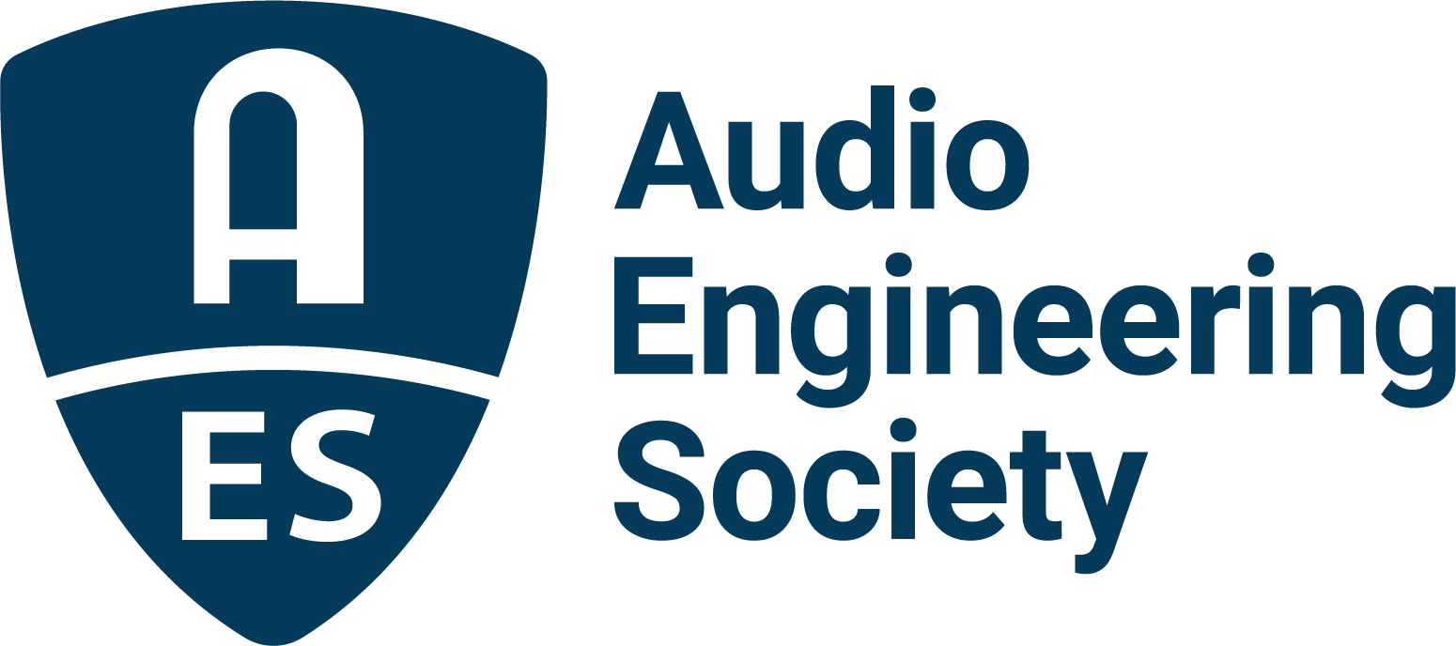

FOR IMMEDIATE RELEASE

Audio Builders Workshop Events Set for AES Fall 2021 Online Convention

— DIY and practical maintenance skills are highlights of Audio Builders Workshop sessions taking place October 16 and 17 —

New York, NY, October 5, 2021 — The Audio Engineering Society has announced the next in series of Audio Builders Workshop DIY training events to take place on October 16 – 17 as part of the AES Fall 2021 Online Convention, which carries on throughout the month of October. Audio Builders Workshop attendees will gain both practical soldering skills for building and maintaining their own audio devices, as well as creative insights and ways to share and network with others in the audio industry.

Utilizing this year’s online AES Convention format, a worldwide contingent of audio professionals and enthusiasts will take part in a series of Audio Builders Workshop sessions curated by ABW program director Chris Kincaid. “We are excited to have the popular Audio Builders Workshop sessions back as part of the upcoming AES Fall 2021 Convention, with some great sessions and builders lined up for this year’s events,” states Kincaid. “Once again, we will give beginners, as well as the more experienced, tips on fundamental and advanced audio device construction, and ways to further collaborate with other professionals and enthusiasts. Everything will build up to our hands-on, real-time DIY project, which will use our new virtual format this year, possibly making it the largest one-time build-off that we’ve hosted so far.”

Audio Builders Workshop sessions begin on October 16 with “YouTube: A DIY Playground” with panelists Sam Battle (Look Mum No Computer), Tim Sway (New Perspectives Music) and amp designer and repair technician Colleen Fazio, moderated by Kincaid. Participants will give insights into their audio backgrounds, how YouTube has been best utilized for both teaching and learning, and how developing knowledge of tools and techniques used on the platform has helped them achieve their goals. This session will be followed by “Practical Soldering Skills for the Studio” which will present a video by ABW’s Christina Milinusic introducing the basics of soldering with helpful tips to get you started, serving as a primer for the featured DIY Workshop the following day. Kincaid will conclude the session with showing participants how to build a continuity tester for diagnosing and repairing bad cables for minimal cost.

The following day will be open with Aisha Loe and the session “Reduce, Reuse, Recycle,” taking attendees on a search for inspiration through non-traditional audio components and enclosures, and back to her workspace to talk about building circuits and her own guitar pedal designs using salvaged materials. Audio Builders Workshop sessions conclude with its first-ever virtual DIY Workshop, “Build Your Own Metronome/Filter,” featuring a follow-along, real-time build of attendees’ choice of a metronome or filter kit, available for pre-event purchase. Led by the circuits’ designers, Brewster LaMacchia and Michael Swanson, audio builders of all skill levels will learn proper practices, construction and modification options, and will have access to real-time tech support as part of the session.

Visit the AES Fall 2021 Online Convention website for complete program details, and make plans to join further Convention activities throughout the month including Electronic Instrument Design and Applications Day (October 11), Sound Reinforcement Day (October 13), Broadcast and Online Delivery Day (October 13), the AoIP Summit (October 19), the Convention Keynotes, Special Events, Tech Tours and Topically Tracked Technical Program (October 20 – 23), Immersive Audio Days (October 26 – 27) and Audio Education Days (October 30 – 31).

…ends 541 words

Photo File 1: ABW Logo.JPG
Photo Caption 1: The AES Fall 2021 Online Convention will host Audio Builder Workshop Days, October 16 and 17, 2021.

Photo File 2: Chris_Kincaid.JPG
Photo Caption 2: Chris Kincaid, Audio Builders Workshop program director

About the Audio Engineering Society
The Audio Engineering Society, celebrating over 70 years of audio excellence, now counts over 12,000 members worldwide. The organization serves as the pivotal force in the exchange and dissemination of technical information for the professional audio community. Currently, its members are affiliated with 90 AES professional sections and more than 120 AES student sections around the world. Section activities include guest speakers, technical tours, demonstrations, online events and social functions. Through Conventions, Conferences, Training and Development, and Member Events, as well as the Society’s vast online resources, members experience valuable opportunities for professional networking and personal growth. For additional information, visit aes.org.

Join the conversation and keep up with the latest AES News and Events:
Twitter: #AESorg (AES Official)
Facebook: facebook.com/AES.org

AES Marketing Communications:
Email: robert.clyne@aes.org
Tel: 615-662-1616, Fax: 615-662-1636,
Clyne Media, Inc.,
169-B Belle Forest Circle, Nashville, TN 37221;
Web: http://www.clynemedia.com

