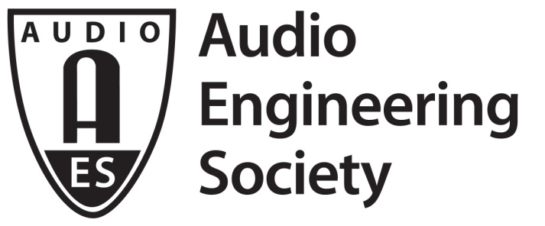

FOR IMMEDIATE RELEASE

AES Audio Product Education Institute Supply Chain Webinar December 15

— AES initiative hosts online sessions with leading audio industry manufacturing suppliers —

New York, NY, December 10, 2020 — The Audio Product Education Institute (APEI), an initiative launched in January 2020 by the Audio Engineering Society (AES) to focus on promoting methodologies, practices and technologies involved in developing and bringing audio products to market, will host its third online event addressing Supply Chain & Sourcing on Tuesday, December 15 (12:00pm ET). The webinar will welcome industry experts from two major audio industry suppliers – Fujikon Industrial and Tonly Electronics – detailing their organizations’ operations and offering valuable perspectives. In conversation with Dave Lindberg (DB Enterprises) and Mike Klasco (Menlo Scientific), the two companies will address key timely issues faced by the audio industry.

This third Supply Chain & Sourcing webinar will be the first in a series featuring key factory principals with deep experience in supplying top brands. In the session taking place December 15, registered attendees will be able to hear from Fujikon Industrial’s CEO Ben Yeung and Tonly Electronics’ Business Development Consultant Mark Trainer about the business, engineering, technology and operational challenges their companies face in bringing products to market in 2021.

The session will be hosted by Lindberg and Klasco, APEI’s chairs on Supply Chain & Sourcing, both with extensive experience and knowledge in supporting brands’ efforts to turn ideas into products and in manufacturing those products. Their conversation with Yeung and Trainer will address topics of enormous importance for the industry at this moment, including how these companies deal with tariff policies and the impact of those policies on deliveries, the changing landscape of the supply chain for companies expanding operations to new territories like Vietnam, and the pandemic fallout.

Fujikon Industrial (www.fujikon.com) is a manufacturing company with vast expertise in headphone and personal audio technology, which they leverage to the benefit of both their business and brand customers. Yeung will share insights on headphone market segments and detail product trends such as true wireless technologies, ANC platforms and future headphone applications. He will also address the current challenges of manufacturing during the COVID-19 pandemic as well as the real impacts of global trade issues on Fujikon’s business.

Tonly Electronics Holdings Ltd (www.tonlyele.com) is one of Asia's largest manufacturing suppliers and is an ODM solutions provider of audio and video products with cutting-edge resources. Trainer will provide a Tonly company overview, illuminating its areas of expertise in engineering and how the company manages its vertical integration (which includes an interesting sub-vendor management strategy). From his perspective as an expert with vast knowledge of the audio industry supply chain, Trainer will provide a detailed Tonly “virtual factory tour” and a comprehensive overview on the company’s global presence, as well as its unique production capabilities and support tools.

Each guest will also answer questions from the hosts regarding key topics currently faced by the audio industry, such as restrictions on travel, logistical challenges and the dynamics of global economics. The online event will conclude with an opportunity for attendees to ask questions during a live session with all four industry experts.

Webinar registration: https://us02web.zoom.us/webinar/register/WN_-0fOT_lLTaG96COhEjYz0Q

…ends 495 words

Photo File 1: APEI_Supply_Chain_Sourcing.JPG
Photo Caption 1: The AES Audio Product Education Institute will host its third online event addressing Supply Chain & Sourcing on Tuesday, December 15, at 12:00pm ET.

About the Audio Engineering Society
The Audio Engineering Society, celebrating over 70 years of audio excellence, now counts over 12,000 members throughout the U.S., Latin America, Europe, Japan and the Far East. The organization serves as the pivotal force in the exchange and dissemination of technical information for the industry. Currently, its members are affiliated with 90 AES professional sections and more than 120 AES student sections around the world. Section activities include guest speakers, technical tours, demonstrations and social functions. Through local AES section events members experience valuable opportunities for professional networking and personal growth. For additional information, visit aes.org.

About the Audio Product Education Institute (APEI)
The Audio Product Education Institute (APEI) was launched in January 2020, as an initiative of the Audio Engineering Society (AES), to focus on promoting methodologies, practices and technologies involved in developing and bringing audio products to market. The Institute roadmap intends to focus on six educational pillars: Interactive Voice Con; Supply Chain and Sourcing; Modeling and Measurement; Product Management; The Legal World; and Artificial Intelligence and Machine Learning. For more information, visit https://audioproducteducationinstitute.org.

Join the conversation and keep up with the latest AES News and Events:
Twitter: #AESorg (AES Official)
Facebook: facebook.com/AES.org

AES Marketing Communications:
Email: robert.clyne@aes.org
Tel: 615-662-1616, Fax: 615-662-1636,
Clyne Media, Inc.,
169-B Belle Forest Circle, Nashville, TN 37221;
Web: http://www.clynemedia.com

