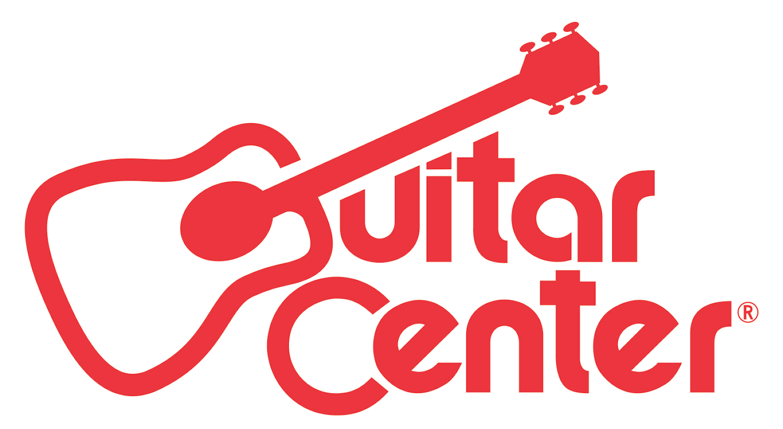

FOR IMMEDIATE RELEASE

Guitar Center Announces New Zakk Wylde Guitar Line and Exclusive Master Class with the Famed Guitarist

ANNOUNCEMENT HIGHLIGHTS:
- Guitar Center and GuitarCenter.com are retail partners for Wylde Audio, the iconic heavy metal guitarist Zakk Wylde’s new guitar line, available April 2016
- Unsigned guitarists will compete for the opportunity to win a private Master Class experience with Wylde and a VIP trip to Los Angeles

Los Angeles, CA (April 4, 2016): Guitar Center announced today a new partnership with legendary metal musician Zakk Wylde, encompassing a private Master Class program for unsigned artists and a new line of Zakk Wylde guitars called Wylde Audio. The guitars are available at Guitar Center and the iconic guitarist will also appear on the cover of Guitar Center’s April 2016 Guitar Buyer’s Guide.

“I’m very excited for the launch of Wylde Audio. For me, it’s the next logical step. You start as a player, manager, VP of Team Operations, then Team Owner. I’ve surrounded myself with super talented people to make this vision become a reality. It only makes sense to join forces with Guitar Center for a retail partnership, with their history of encouraging talent and supporting musicians.” – Zakk Wylde

The guitarist’s brand new line of guitars, which currently comes in three models (Odin, Viking and Warhammer) are arriving in April for purchase at select Guitar Center stores or online at GuitarCenter.com. All three models feature a solid mahogany body with a set 3-piece maple neck and the ebony fretboard has a 24.6" scale and 14" radius with 22 jumbo frets. Each guitar also includes a pair of Wylde’s signature EMG active pickups, a time-tested combination of EMG 85/81, that have helped define Wylde's sound.

Additionally, unsigned guitar players can compete to be part of a private, exclusive Master Class experience with Wylde starting April 1. To be considered, fans can upload videos of themselves playing Wylde’s latest single “Sleeping Dogs” and submit it through the official contest platform: GuitarCenter.com/masterclass. Wylde himself will then hand-select the top five guitarists to win the grand prize.

Guitar Center’s Master Class Grand Prize Winners Will Receive:
- A VIP trip to Los Angeles for five guitarists to attend a private master class with Zakk Wylde
- A Wylde Audio Odin Signature guitar
- New gear from Dunlop, EMG, Monster Cable and MXR
- A feature write up in Revolver Magazine

Previous promotions have included artists as varied and prolific as Slash (Guns N’ Roses), Steve Vai, Joe Satriani and Synyster Gates (Avenged Sevenfold).

Watch Zakk Wylde discuss the Master Class program here: https://youtu.be/6j-Wa6EjbLo

“With the launch of Wylde Audio, it was only fitting that we have a musician of Zakk Wylde’s caliber participate in Guitar Center’s Master Class. Zakk rarely participates in these programs, so we’re excited to bring this exclusive opportunity to our customers to receive a private master class from one the world’s greatest guitarists.”
– Jake Cheung, Guitar Center Manager, Music Marketing + Artist Relations

-30-

Photo file: GC_Wylde_MasterClass.JPG
Photo caption: Promotional graphic for Guitar Center’s Master Class with Zakk Wylde

About WYLDE AUDIO:
Zakk Wylde is known for his signature guitar with its bullseye graphic and has worked on expanding his passion for custom guitars. He left his partnership with Gibson and Marshall to start up his own company, Wylde Audio, and has just announced the signing of a worldwide distribution deal with the California guitar company Schecter Guitar Research.
The legendary guitarist has already been testing out the prototypes of three guitar designs while on the road with Black Label Society. Wylde will be debuting three models at the 2016 Winter NAMM: The models Odin, Warhammer and Viking all have an obvious theme emanating from the guitar god.

About Guitar Center:
Guitar Center is the world’s largest retailer of guitars, amplifiers, drums, keyboards, recording, live sound, DJ, and lighting equipment. With more than 270 stores across the U.S. and one of the top direct sales websites in the industry, Guitar Center has helped people make music for more than 50 years. In addition, Guitar Center’s sister brands includes Music & Arts, which operates more than 140 stores specializing in band & orchestral instruments for sale and rental, serving teachers, band directors, college professors and students, and Musician’s Friend, a leading direct marketer of musical instruments in the United States. With an unrivaled in-store experience, an industry-leading online presence and passionate commitment to making gear easy-to-buy, Guitar Center is all about enabling musicians and non-musicians alike to experience the almost indescribable joy that comes from playing an instrument. For more information about Guitar Center, please visit www.guitarcenter.com.

You can visit our press room at http://www.guitarcenter.com/pages/press-room and send media inquiries to media@guitarcenter.com.

FOR MORE INFORMATION PLEASE CONTACT:
Natania Reed | ANTHEMIC Agency | 323.464.4745 x 806 | natania@anthemicagency.com
Robert Clyne | Clyne Media, Inc. | 615-662-1616 | Robert@clynemedia.com
Syvetril Perryman | Guitar Center | 818.735.8800 | media@guitarcenter.com

