FOR IMMEDIATE RELEASE
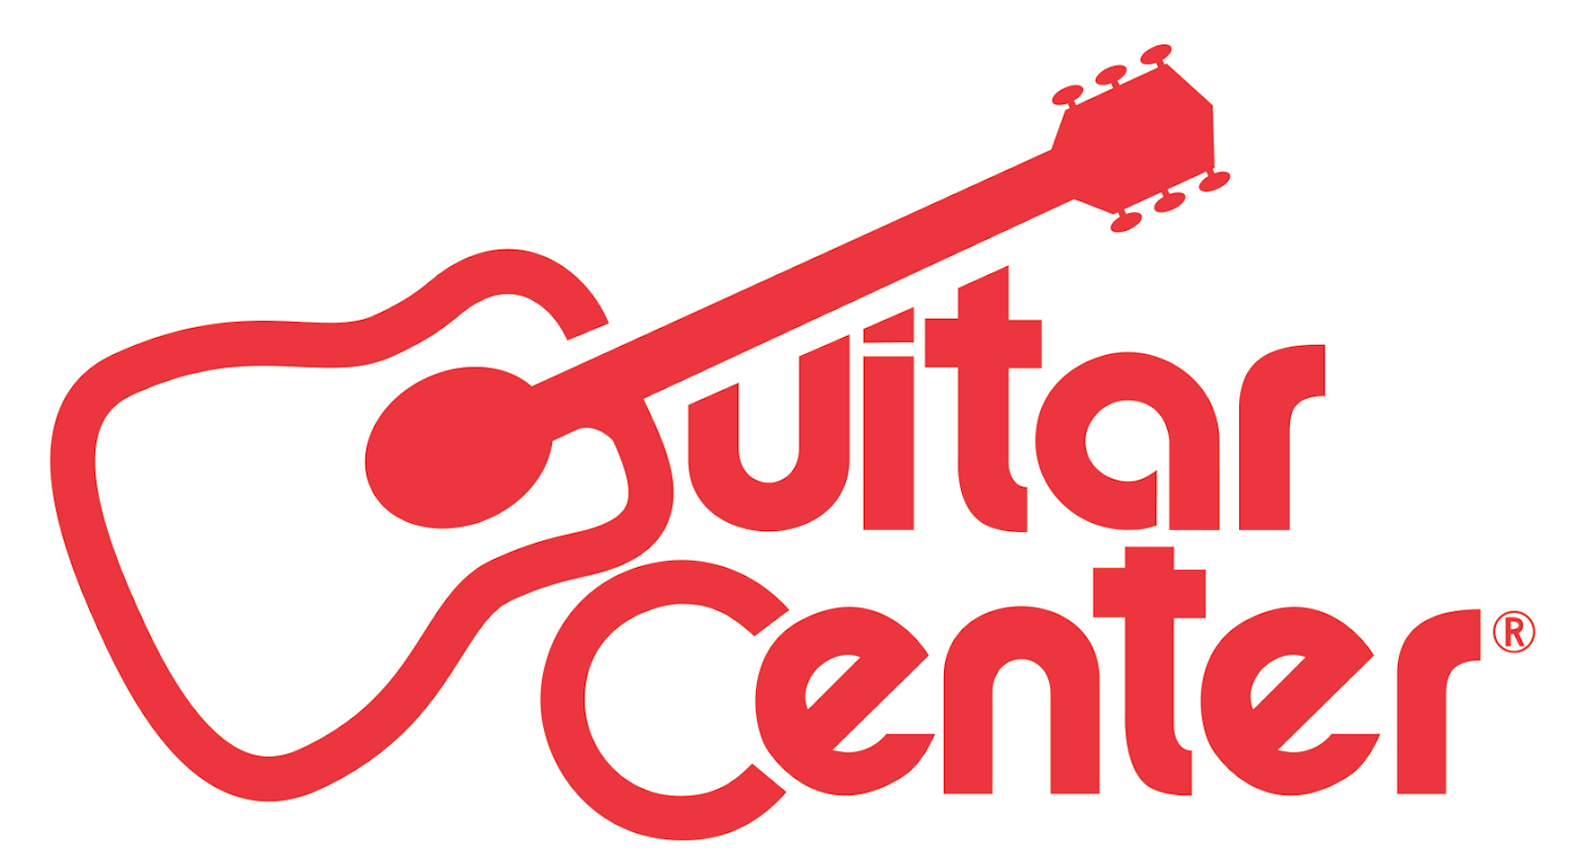

Guitar Center Announces Appointment of Retail Veteran Tony Truesdale as Chairman of Its Board of Directors

Los Angeles, CA (September 14, 2016) – Guitar Center, the world’s largest music instrument retailer, announced today the appointment of retail veteran Tony Truesdale as Chairman of the Board of Directors. The current Chairman, Norman Axelrod, will remain as member of the board.

Truesdale previously was Chief Executive Officer of Vitamin Shoppe, Inc., a national multi-channel specialty retailer of nutritional products, before his retirement in 2015. During his time at Vitamin Shoppe, Truesdale helped drive long-term growth, increase EBITDA and grow the number of retail stores from 300 to 800 nationwide. He also was instrumental in taking the company public in late 2009.

Prior to his time at Vitamin Shoppe, Truesdale worked for PetSmart from 1999-2006 in various marketing and merchandising roles and prior to that served for 20 years in senior management, operating and merchandising roles at various supermarkets in England and the United States.

“We are pleased to have Tony as our new Chairman,” said Ron Japinga, President and Chief Executive Officer of Guitar Center. “With his 30 years of experience in retail, we look forward to the major contributions Tony will make to help us achieve our goals and grow our business.”

“I am excited to assume the role of Chairman of the Board of Directors for Guitar Center,” said Truesdale. “Guitar Center is well-positioned to continue its growth, and I am looking forward to working with the team as it continues to build the retail and online businesses.”

About Guitar Center:
Guitar Center is the world’s largest retailer of guitars, amplifiers, drums, keyboards, recording, live sound, DJ, and lighting equipment. With more than 270 stores across the U.S. and one of the top direct sales websites in the industry, Guitar Center has helped people make music for more than 50 years. In addition, Guitar Center’s sister brands include Music & Arts, which operates more than 120 stores specializing in band & orchestral instruments for sale and rental, serving teachers, band directors, college professors and students, and Musician’s Friend, a leading direct marketer of musical instruments in the United States. With an unrivalled in-store experience, an industry-leading online presence and passionate commitment to making gear easy-to-buy, Guitar Center is all about enabling musicians and non-musicians alike to experience the almost indescribable joy that comes from playing an instrument. For more information about Guitar Center, please visit www.guitarcenter.com.

You can visit our press room at http://www.guitarcenter.com/pages/press-room, and send media inquiries to media@guitarcenter.com.

FOR MORE INFORMATION PLEASE CONTACT:
Robert Clyne | Clyne Media | 615.662.1616 | pr@clynemedia.com
Syvetril Perryman | Guitar Center | 818.735.8800 x 2979 | media@guitarcenter.com
Sarah Chavey | Praytell Agency | 313.407.7571 | sarah@praytellagency.com

