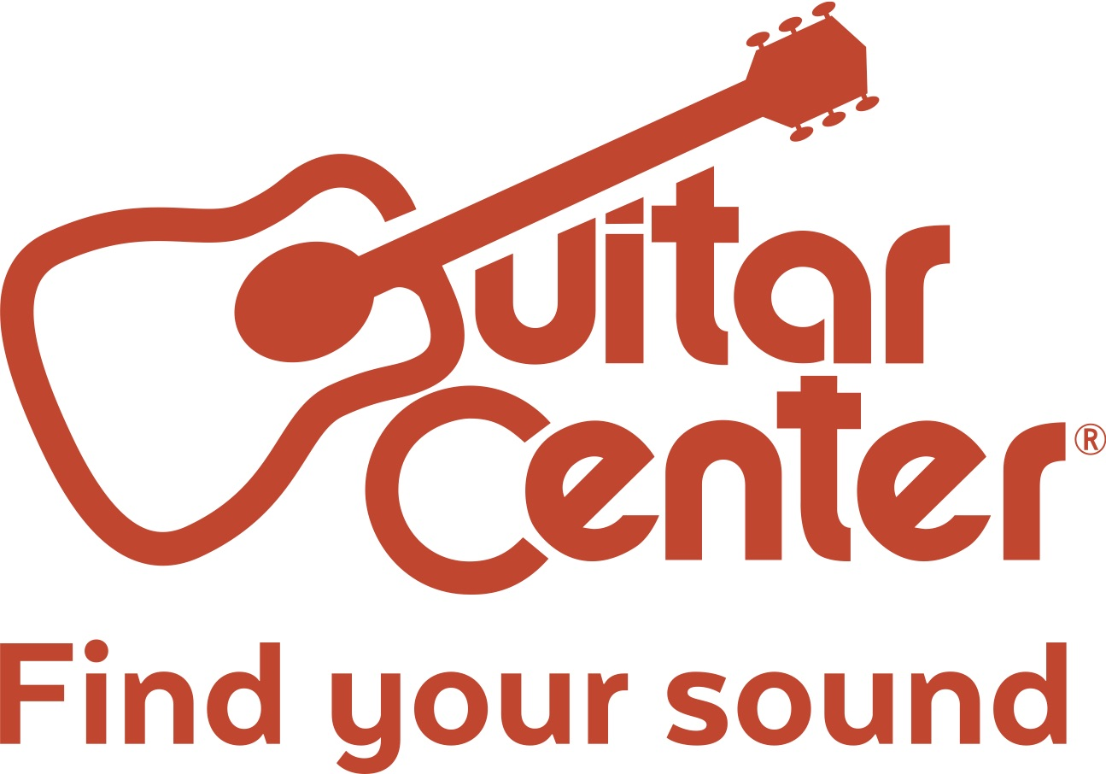

Guitar Center Opens in Silver Spring, MD

The new location offers services such as on-site lessons, repairs, free workshops, and more to meet any music-related need

Los Angeles, CA – Guitar Center, the world’s largest instrument retailer, recently opened its latest retail location, a brand-new 12,000-square-foot store in Silver Spring, MD. Located at 8661 Colesville Rd. Silver Spring, MD 20910, the store offers an expansive set of services and gear to serve the community’s music needs.

This new store, located in the Ellsworth Place shopping center, features modern showrooms equipped with the latest products for musicians — from guitars, amplifiers, percussion instruments and keyboards to live sound, DJ, lighting and recording equipment. Customer services include Guitar Center Lessons, an in-house, state-of-the-art music academy for players of all ages and skill levels, GC Repairs, an on-site maintenance and repairs service, GC Rentals, easy rentals of instruments and other gear, and Guitar Center Workshops, offering free introductory classes and instruction on guitar, ukulele, and recording. Silver Spring shoppers are also able to enjoy Guitar Center’s multi-channel “endless aisle,” which gives customers the ability to combine in-store, online and phone options to purchase music equipment from anywhere.

Guitar Center Silver Spring Store and Studio Hours
Monday – Friday 10:00 a.m. – 9:00 p.m.
Saturday 10:00 a.m. – 8:00 p.m.
Sunday 11:00 a.m. – 7:00 p.m.

Photo file 1: GC_SilverSpring_EllsworthPlace1_Outside.JPG
Photo caption 1: The outside entrance to the Ellsworth Place shopping center in Silver Spring, MD, the location of Guitar Center’s latest retail location. Photo by Newmark Grubb, Knight Frank. © 2017.

Photo file 2: GC_SilverSpring_EllsworthPlace2_Entrance.JPG
Photo caption 2: The entrance to Guitar Center’s latest retail location, at the Ellsworth Place shopping center in Silver Spring, MD. Photo by Newmark Grubb, Knight Frank. © 2017.

Photo file 3: GC_SilverSpring_EllsworthPlace3_Showroom.JPG
Photo caption 3: The showroom of Guitar Center’s latest retail location, at the Ellsworth Place shopping center in Silver Spring, MD. Photo by Newmark Grubb, Knight Frank. © 2017.

About Guitar Center:
Guitar Center is the world’s largest retailer of guitars, amplifiers, drums, keyboards, recording, live sound, DJ and lighting equipment. With more than 280 stores across the U.S. and one of the top direct sales websites in the industry, Guitar Center has helped people make music for more than 50 years. Guitar Center also provides customers with various musician based services, including Guitar Center Lessons, where musicians of all ages and skill levels can learn to play a variety of instruments in many music genres; GC Repairs, an on-site maintenance and repairs service; and GC Rentals, a program offering easy rentals of instruments and other sound reinforcement gear. Additionally, Guitar Center’s sister brands include Music & Arts, which operates more than 150 stores specializing in band & orchestral instruments for sale and rental, serving teachers, band directors, college professors and students, and Musician’s Friend, a leading direct marketer of musical instruments in the United States. With an unrivalled in-store experience, an industry-leading online presence and passionate commitment to making gear easy-to-buy, Guitar Center is all about enabling musicians and non-musicians alike to experience the almost indescribable joy that comes from playing an instrument. For more information about Guitar Center, please visit www.guitarcenter.com.

You can visit our press room at http://www.guitarcenter.com/pages/press-room, and send media inquiries to media@guitarcenter.com.

FOR MORE INFORMATION PLEASE CONTACT:
Robert Clyne | Clyne Media, Inc. | 615-662-1616 | Robert@clynemedia.com
Marisa Bettencourt | Praytell Agency | 925.817.0596 | GCPR@praytellagency.com
Syvetril Perryman | Guitar Center | 818.735.8800 x 2979 | media@guitarcenter.com

