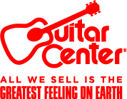
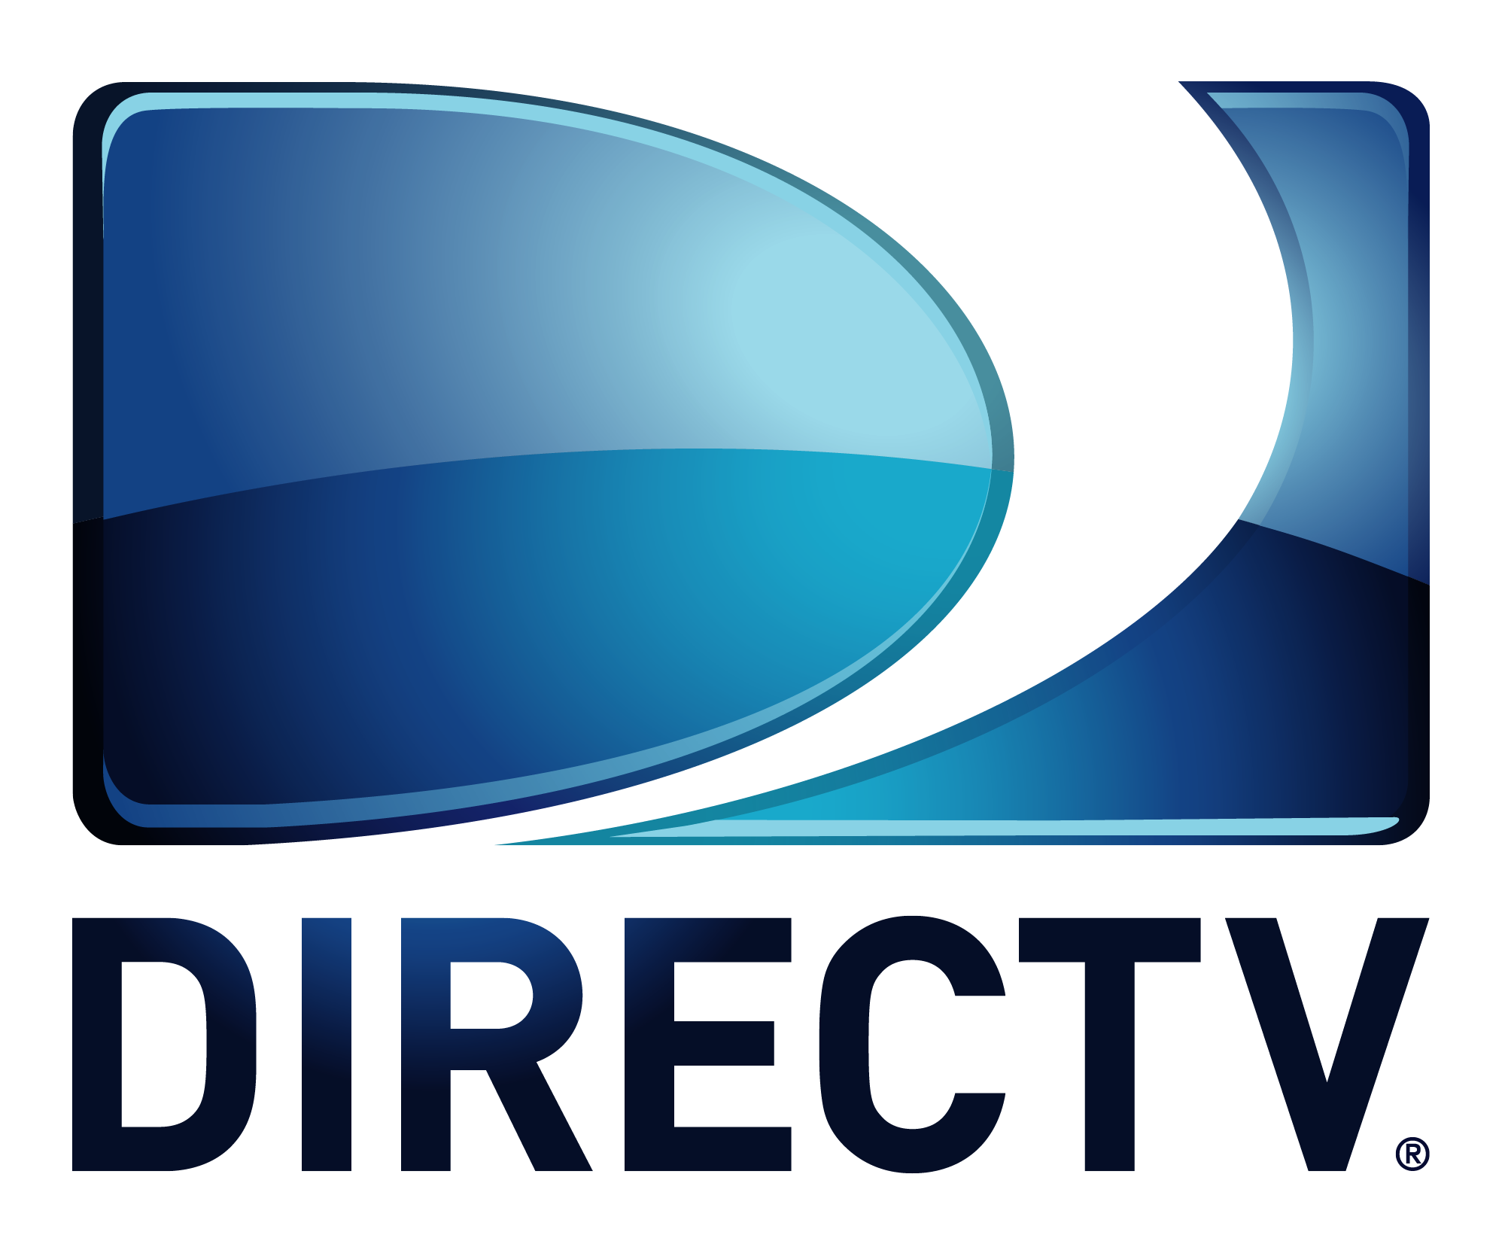

FOR IMMEDIATE RELEASE

DIRECTV’s Guitar Center Sessions Season 10 Features Nick Jonas, Jason Mraz, The Killers’ Brandon Flowers, Lifehouse and More

Season 10 Lineup Also Includes The Offspring, Dwight Yoakam, Silversun Pickups, Best Coast and Hanni El Khatib

ANNOUNCEMENT HIGHLIGHTS:
- The intimate live performance and interview series hosted by influential music tastemaker Nic Harcourt returns with 9 new episodes
- Telly Award-winning Guitar Center Sessions continues to provide music fans with top-quality music television programming in stunning high definition and 5.1 surround sound
- Season 10 to debut May 29, 2015, on DIRECTV’s Audience Network (channel 239)
Los Angeles, CA (May 21, 2015): Guitar Center and DIRECTV have announced season 10 of the retailer’s award-winning music television series Guitar Center Sessions presented by JBL. The series will return May 29, 2015, with nine new episodes available Friday nights at 9 p.m. exclusively on DIRECTV’s Audience Network (channel 239). Artists starring in season 10 include rock bands Lifehouse, The Offspring and Silversun Pickups; The Killers’ Brandon Flowers; country icon Dwight Yoakam; triple-threat singer, songwriter and actor Nick Jonas; indie darlings Best Coast and Hanni El Khatib; and multi-GRAMMY® winning singer-songwriter Jason Mraz.

Watch a preview of Guitar Center Sessions season 10 here: https://youtu.be/jyQMoBM88QE

Guitar Center Sessions Season 10 Schedule:
May 29, 2015 Brandon Flowers
June 5, 2015 Lifehouse
June 12, 2015 Hanni El Khatib
June 19, 2015 Dwight Yoakam
June 26, 2015 Nick Jonas
July 17, 2015 Best Coast
July 24, 2015 Jason Mraz
July 31, 2015 The Offspring
August 7, 2015 Silversun Pickups

Guitar Center Sessions provides award-winning music television content to all of DIRECTV’s more than 20 million subscribers, presenting exclusive live performances in stunning high definition and 5.1 surround sound. In addition to show-stopping performances, each episode features intimate interviews conducted by renowned journalist Nic Harcourt, offering rare insights into the celebrated careers of these icons and the inspirations behind their music. Born out of Guitar Center’s desire to deliver high quality music programming to music fans nationwide, the series has since gone on feature artists as diverse and iconic as Peter Gabriel, Soundgarden, Snoop Dogg, Linkin Park, OneRepublic, Phantogram, Joan Jett, The Smashing Pumpkins, Jimmy Cliff, Damon Albarn, Social Distortion and more.

“‘Guitar Center Sessions’ is an outlet through which we celebrate the music and the musicians that have inspired so many of us to pick up an instrument and learn to play. To be able to say that we have an award-winning television show entering its 10th season and nearing 100 episodes is a pretty remarkable accomplishment.“
-Brian Berman, Vice President of Marketing, Guitar Center

-30-

About Audience:
Audience is a unique and exclusive television experience available only to DIRECTV subscribers. The channel first made its mark in 2008 (as The 101 Network) by partnering with NBC to produce and air three additional seasons of the Emmy Award-winning series Friday Night Lights and in 2010 it became the exclusive home of the critically-acclaimed, Emmy Award-winning drama Damages, starring Glenn Close. DIRECTV continues its commitment to original content with series including ROGUE, an exclusive suspense-drama starring award-winning actress Thandie Newton, and Full Circle, the television debut of acclaimed writer Neil LaBute, starring Kate Walsh, Julian McMahon, Minka Kelly and David Boreanaz. The network has become the premier destination for smart, innovative and critically acclaimed TV fare as we search the globe for the best new series such as Black Mirror (United Kingdom), Secret State (United Kingdom), and Rake (Australia) The Dan Patrick Show, and its companion series The Box Score, keep sports fans up to date with the latest sports talk. Viewers also enjoy the Guitar Center Sessions series and major events such as the annual DIRECTV Celebrity Beach Bowl. For more info, please visit www.directv.com/audience

About DIRECTV:
DIRECTV (NASDAQ: DTV) is one of the world’s leading providers of digital television entertainment services delivering a premium video experience through state-of-the-art technology, unmatched programming and industry leading customer service to more than 37 million customers in the U.S. and Latin America. In the U.S., DIRECTV offers its over 20 million customers access to more than 195 HD channels and Dolby-Digital® 5.1 theater-quality sound, access to exclusive sports programming such as NFL SUNDAY TICKET™, Emmy-award winning technology and higher customer satisfaction than the leading cable companies for 13 years running. DIRECTV Latin America, through its subsidiaries and affiliated companies in Brazil, Mexico, Argentina, Venezuela, Colombia, and other Latin American countries, leads the pay TV category in technology, programming and service, delivering an unrivaled digital television experience to more than 17 million customers. DIRECTV sports and entertainment properties include two Regional Sports Networks (Rocky Mountain and Pittsburgh), and minority ownership interests in Root Sports Northwest and Game Show Network. For the most up-to-date information on DIRECTV, please visit www.directv.com.

About Guitar Center:
Guitar Center is the world’s largest retailer of guitars, amplifiers, drums, keyboards, recording, live sound, DJ, and lighting equipment. With more than 260 stores across the U.S. and one of the top direct sales websites in the industry, Guitar Center has helped people make music for more than 50 years. In addition, Guitar Center’s sister brands includes Music & Arts, which operates more than 120 stores specializing in band & orchestral instruments for sale and rental, serving teachers, band directors, college professors and students, and Musician’s Friend, a leading direct marketer of musical instruments in the United States. With an unrivaled in-store experience, an industry-leading online presence and passionate commitment to making gear easy-to-buy, Guitar Center is all about enabling musicians and non-musicians alike to experience the almost indescribable joy that comes from playing an instrument. All we sell is the greatest feeling on earth. For more information about Guitar Center, please visit www.guitarcenter.com.

You can subscribe to our RSS newsfeed at http://feeds.feedburner.com/GuitarCenterPressroom, visit our press room at http://gc.guitarcenter.com/pressroom/ and send media inquiries to media@guitarcenter.com.

FOR MORE INFORMATION PLEASE CONTACT:
Guitar Center: Robert Clyne | Clyne Media, Inc. | Robert@clynemedia.com | 615-662-1616

