FOR IMMEDIATE RELEASE 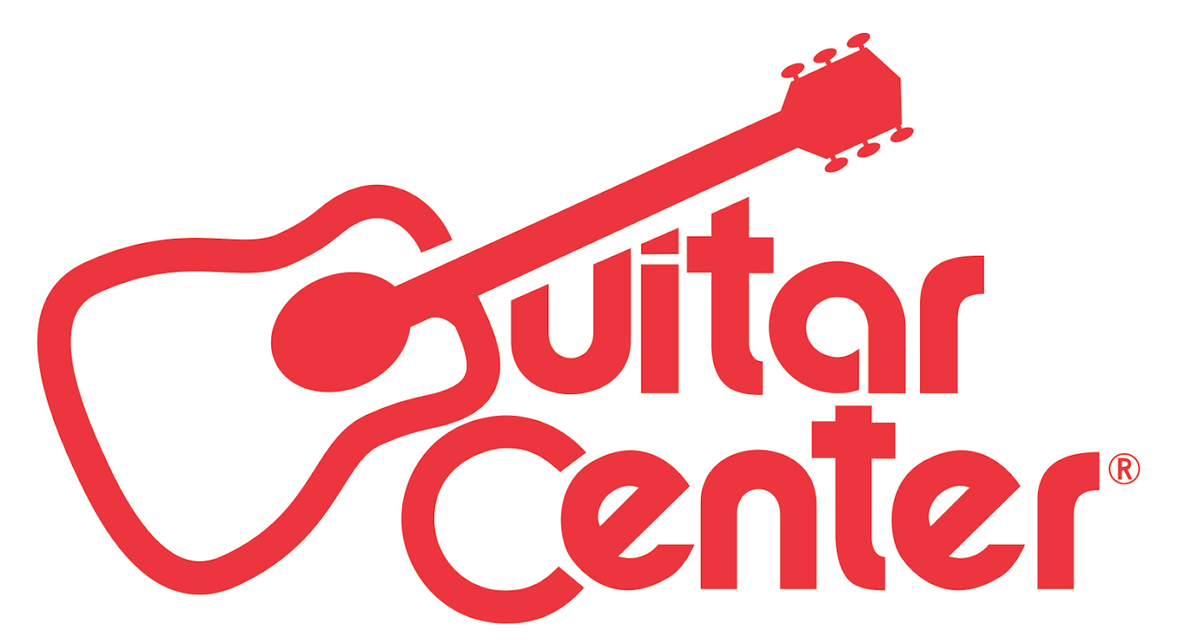

Guitar Center Opens Store in Selden, New York

The Selden location is Guitar Center’s 272nd Store and features free on-site lessons, guitar repair services and more

ANNOUNCEMENT HIGHLIGHTS:
- Guitar Center has opened its 272nd store location in the U.S.
- GC Repairs will provide stringed instrument repair and tune-up services
- GC Lessons is the first-ever GC music academy facility in the area to support the local music scene

Los Angeles, CA (April 22, 2016) – Guitar Center, the world’s largest instrument retailer, is proud to announce the grand opening of its newest retail location, a state-of-the-art musical instrument and technology center covering 11,000 square feet in Selden, NY. The grand opening took place on Thursday, April 21, at 201 Independence Plaza, Selden, NY 11784.

Guitar Center’s Selden location features modern showrooms equipped with the latest products for musicians — from guitars, amplifiers, percussion instruments and keyboards to live sound, DJ, lighting and recording equipment. The store also provides customers with a vast selection of products and a dedicated staff with unparalleled musical knowledge and experience.

Additionally, the Selden store features Guitar Center Lessons, an in-house, state-of-the-art music academy, which will create unrivalled opportunities for Selden musicians of all ages and skill levels. Guitar Center Lessons provides music lessons from beginner to advanced featuring certified instructors teaching world-class curriculum as well as one-on-one and group courses. Guitar Center’s GC Repairs, an on-site guitar repair and set-up service for stringed instruments, and GC Rentals, offering the ability to rent instruments and other gear, are also featured at the new store.

Guitar Center Selden Store and Studio Hours
Monday – Friday 10:00am – 9:00pm
Saturday 10:00am – 8:00pm
Sunday 11:00am – 7:00pm

Selden customers will also be able to attend free classes on various Wednesdays and Saturdays through Guitar Center Workshops. These classes include introductory instruction on a variety of instruments, and Recording Made Easy classes are available for anyone who wants to make the exciting journey into recording their music.

As part of Guitar Center’s initiatives designed to educate and inspire artists nationwide, Guitar Center Selden will offer unique opportunities for musicians to craft their skills, maintain their instruments and experience many other aspects of the music industry first-hand. Guitar Center offers nationwide programs designed to spearhead creativity and highlight the nation’s most promising undiscovered talent. Selden residents will now be able to participate in programs including Guitar Center Singer-Songwriter, Guitar Center’s Drum-Off, Get Out of the Garage and more.

Selden shoppers are also able to enjoy Guitar Center’s multi-channel “endless aisle,” which gives customers the ability to combine in-store, online and phone options to purchase music equipment from anywhere.

-30-

Photo File 1: GC_Selden_Storefront.JPG
Photo Caption 1: The storefront of Guitar Center’s new location in Selden, NY.

Photo File 2: GC_Selden_Employees.JPG
Photo Caption 2: The employee team at Guitar Center’s new location in Selden, NY.

About Guitar Center:
Guitar Center is the world’s largest retailer of guitars, amplifiers, drums, keyboards, recording, live sound, DJ, and lighting equipment. With more than 270 stores across the U.S. and one of the top direct sales websites in the industry, Guitar Center has helped people make music for more than 50 years. In addition, Guitar Center’s sister brands include Music & Arts, which operates more than 120 stores specializing in band & orchestral instruments for sale and rental, serving teachers, band directors, college professors and students, and Musician’s Friend, a leading direct marketer of musical instruments in the United States. With an unrivaled in-store experience, an industry-leading online presence and passionate commitment to making gear easy-to-buy, Guitar Center is all about enabling musicians and non-musicians alike to experience the almost indescribable joy that comes from playing an instrument. For more information about Guitar Center, please visit www.guitarcenter.com.

You can visit our press room at http://www.guitarcenter.com/pages/press-room, and send media inquiries to media@guitarcenter.com.

FOR MORE INFORMATION PLEASE CONTACT:
Natania Reed | ANTHEMIC Agency| 323.464.4745 x 808| natania@anthemicagency.com
Robert Clyne | Clyne Media, Inc. | 615-662-1616| Robert@clynemedia.com
Syvetril Perryman | Guitar Center | 818.735.8800 x 2979 | media@guitarcenter.com

