FOR IMMEDIATE RELEASE
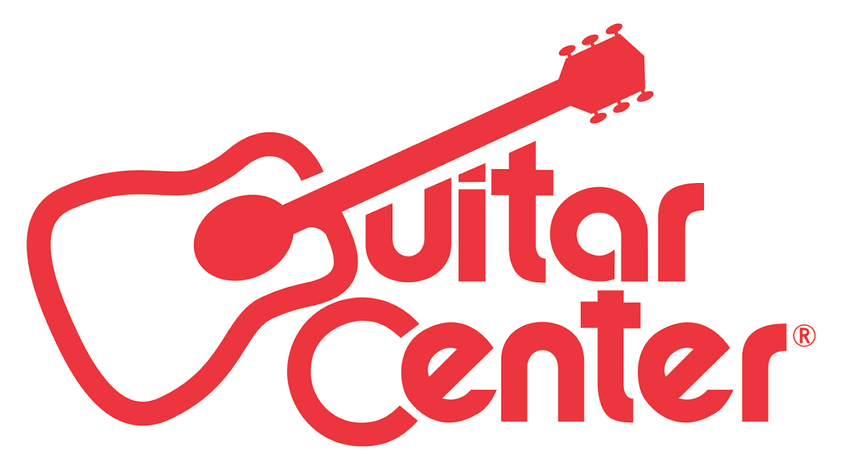

Country Music Legend Vince Gill Names Claudio Tristano Winner of Guitar Center’s OnStage Program

Overwhelmed by the talent of all five finalists, Gill invites each of the musicians to join him on his upcoming tour

Westlake Village, CA (October 4, 2016) – Guitar Center, the world’s largest instrument retailer, in partnership with GRAMMY® Award-winning country music legend Vince Gill, announced Claudio Tristano as the winner of Guitar Center’s OnStage with Vince Gill program on Wednesday, September 28, 2016, at The Mint in Los Angeles, Cailf.

Since the program began in February, thousands of aspiring guitarists submitted their original rendition of Gill’s single “Take Me Down” for a chance to win a grand prize including $10,000 cash, studio time, top-of-the-line gear, a coveted opening slot on one of Gill’s upcoming U.S. tour stops, and more. After months of combing through those submissions, Gill chose the top five finalists to perform at the finals for a shot at the grand prize.

At the finals, Gill took center stage, treating the crowd to a solo acoustic performance followed by a set with his full band, before each finalist joined him on stage for their final performance of the competition. Each finalist was judged according to originality, skill, presence and overall performance. The evening came to an exciting close as Gill, overwhelmed by the talent of all five finalists, invited each of the musicians to join him on one of his upcoming tour stops, before announcing Italian-born, Los Angeles-based musician Claudio Tristano as the grand prize winner.

As the winner of Guitar Center’s OnStage with Vince Gill, Claudio will receive:
- An opening slot at one of Vince Gill’s U.S. tour performances
- A single professionally produced by Justin Niebank
- $10,000 cash
- A meeting with Universal Music Group
- Feature in Guitar World Magazine
- Top-of-the-line music gear from Fender, Dunlop, Martin, Boss, and more

Born in southern Italy, Tristano started playing guitar at the age of ten and has had music in his life since the beginning, with many musically inclined family members. He grew up listening to the classic rock and hard rock bands from the 60s to the early 90s, often trying to emulate the riffs and solos of the icons of the time. At age 20, he took the plunge and moved to Los Angeles to attend the Musicians Institute, where he was awarded The Stanley Clarke Scholarship in 2010. A long time Guitar Center fan, Tristano has competed in Guitar Center’s King of the Blues (Hollywood winner in 2010) and Guitar Center’s Blues Masters with Joe Bonamassa (finalist in 2013). Tristano currently performs as a solo artist and with his band, Troup, and works as a session player and live guitarist for many artists in Los Angeles. For more information about Claudio Tristano, please visit http://www.claudiotristano.com/ or check out his Facebook and Youtube accounts.

“Choosing a winner was really difficult for me, not just because each finalist was so talented (which they were), but also because I truly believe that music should be about collaboration, not competition,” said Vince Gill. “In fact, I was so moved by the performances that I’ve decided to invite each of the finalists to join me on my upcoming tour. That said, I had to go with what my ears and my heart were telling me, and that was Claudio.”

“This program really means a lot to me, especially my performance at the finals which was dedicated to my uncle, who gave me such motivation and inspiration throughout the submission process but passed away recently,” said Claudio Tristano. “I hope, and truly believe, that this could be a turning point in my career as a professional musician that will allow me to be recognized by the music industry.”

“We’re thrilled to partner with country music icon Vince Gill to announce Claudio as the winner of our latest installment of OnStage,” said Manager of Music Marketing + Artist Relations at Guitar Center, Jake Cheung. “Each artist offered unique talents, which made the decision difficult, but with Vince’s guidance and golden ear, we selected a deserving winner and are so happy to be able to give Claudio a platform to share his talent with the world.”

For more information on the winner of OnStage with Vince Gill, visit guitarcenter.com/onstage. To learn where you can see Claudio Tristano performing on tour with Vince Gill, visit VinceGill.com.

Photo file: Tristano_Gill.JPG
Photo caption: Pictured L-R: Claudio Tristano and Vince Gill

About Vince Gill:
One of the most popular singers in modern country music, Vince Gill is famous for his top-notch songwriting, world-class guitar playing and warm, soaring tenor, all wrapped up in a quick and easy wit. Gill achieved his big breakthrough in 1990 with “When I Call Your Name,” which won both the Country Music Association’s Single and Song of the Year awards as well as a Grammy. Gill has won 18 CMA Awards, including Song of the Year four times – making him the most-awarded artist in that category in CMA history. Since 1990, Gill has won 20 GRAMMY Awards. A wide-ranging songwriter, his compositions earned him entry into the Nashville Songwriters Hall of Fame in 2005. The Academy of Country Music has conferred on Gill eight awards, including its prestigious Home Depot Humanitarian Award and the 2011 Career Achievement Award. Gill was inducted into the Country Music Hall of Fame in 2007. He is also a member of the Grand Ole Opry. In August 2012, Gill was honored with a star on the Hollywood Walk of Fame. He is a member of the four-time Grammy-nominated band The Time Jumpers. Gill has produced albums for LeAnn Rimes, Amy Grant and Ashley Monroe and has made guest appearances on more than 500 albums including on those by Barbra Streisand, Eric Clapton, Willie Nelson, Dolly Parton, George Jones and others. Gill’s new album, Down To My Last Bad Habit, was released Feb. 12. For a full list of tour dates, news, images and more, visit www.VinceGill.com.

About Guitar Center:
Guitar Center is the world’s largest retailer of guitars, amplifiers, drums, keyboards, recording, live sound, DJ, and lighting equipment. With more than 270 stores across the U.S. and one of the top direct sales websites in the industry, Guitar Center has helped people make music for more than 50 years. In addition, Guitar Center’s sister brands include Music & Arts, which operates more than 140 stores specializing in band & orchestral instruments for sale and rental, serving teachers, band directors, college professors and students, and Musician’s Friend, a leading direct marketer of musical instruments in the United States. With an unrivalled in-store experience, an industry-leading online presence and passionate commitment to making gear easy-to-buy, Guitar Center is all about enabling musicians and non-musicians alike to experience the almost indescribable joy that comes from playing an instrument. For more information about Guitar Center, please visit www.guitarcenter.com.
You can visit our press room at http://www.guitarcenter.com/pages/press-room, and send media inquiries to media@guitarcenter.com.

FOR MORE INFORMATION PLEASE CONTACT:
Sarah Chavey | Praytell Agency | 313.407.7571 | GCPR@praytellagency.com
Robert Clyne | Clyne Media | 615.662.1616 | pr@clynemedia.com
Syvetril Perryman | Guitar Center | 818.735.8800 x 2979 | media@guitarcenter.com

