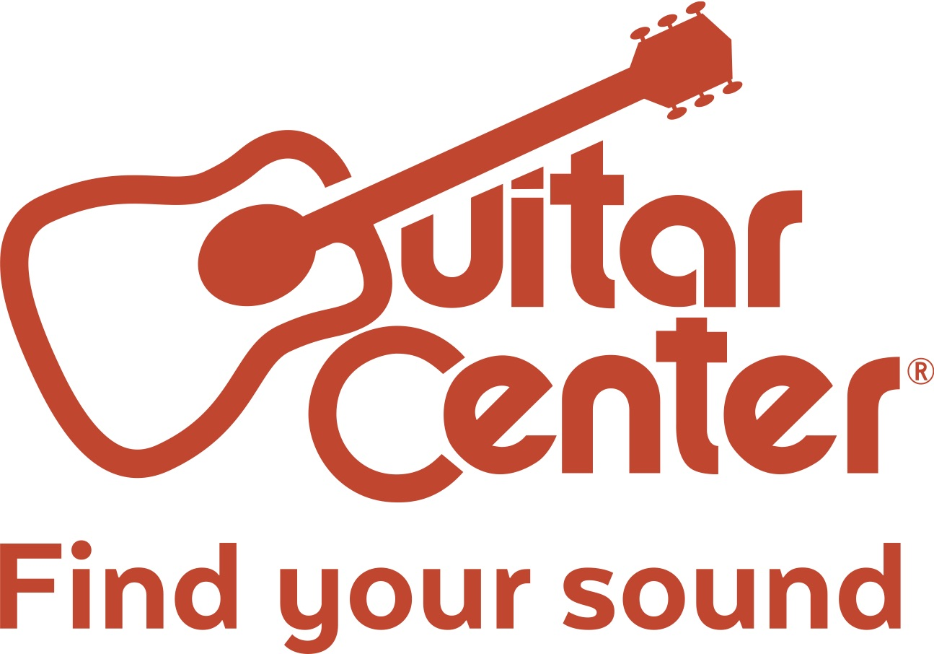

Guitar Center Opens in Daytona, Florida

The new location offers on-site lessons, repairs, free workshops, and more to meet any music-related need

Westlake Village, CA (November 17, 2017) – Guitar Center, the world’s largest instrument retailer, recently opened its latest retail location – a 10,000-square-foot facility in Daytona, Florida (1 Daytona Blvd. Daytona, FL 32114). The store offers an expansive set of services and gear to serve the music needs of the Daytona community. The grand opening took place on Thursday, November 16.

The new store features modern showrooms equipped with the latest products for musicians — from guitars, amplifiers, percussion instruments and keyboards to live sound, DJ, lighting and recording equipment. Musician services include Guitar Center Lessons, an in-house, state-of-the-art music academy for players of all ages and skill levels, GC Repairs, an on-site maintenance and repairs service, GC Rentals, easy rentals of instruments and other gear, and Guitar Center Workshops, offering free introductory classes and instruction on guitar, ukulele, and recording. Daytona shoppers are also able to enjoy Guitar Center’s multi-channel “endless aisle,” which gives customers the ability to combine in-store, online and phone options to purchase music equipment from anywhere.

The Daytona Beach store represents the final GC grand opening for 2017 – a year that saw continuing expansion for the brand, including store openings in Alexandria, Virginia; Goodlettsville, Tennessee; Dublin, California; Kennesaw, Georgia; Silver Spring, Maryland; Laurel, Maryland; and the Willowbrook district of Houston, Texas. The year also saw Guitar Center complete renovations and grand re-openings of several stores and expanding the Guitar Center Lessons facilities to 175 stores and rentals services to all stores.

Guitar Center Daytona store and studio hours:
Monday – Saturday 10:00 a.m. – 9:00 p.m.
Sunday 11:00 a.m. – 7:00 p.m.

About Guitar Center:
Guitar Center is the world’s largest retailer of guitars, amplifiers, drums, keyboards, recording, live sound, DJ and lighting equipment. With more than 280 stores across the U.S. and one of the top direct sales websites in the industry, Guitar Center has helped people make music for more than 50 years. Guitar Center also provides customers with various musician based services, including Guitar Center Lessons, where musicians of all ages and skill levels can learn to play a variety of instruments in many music genres; GC Repairs, an on-site maintenance and repairs service; and GC Rentals, a program offering easy rentals of instruments and other sound reinforcement gear. Additionally, Guitar Center’s sister brands include Music & Arts, which operates more than 150 stores specializing in band & orchestral instruments for sale and rental, serving teachers, band directors, college professors and students, and Musician’s Friend, a leading direct marketer of musical instruments in the United States. With an unrivalled in-store experience, an industry-leading online presence and passionate commitment to making gear easy-to-buy, Guitar Center is all about enabling musicians and non-musicians alike to experience the almost indescribable joy that comes from playing an instrument. For more information about Guitar Center, please visit www.guitarcenter.com.

About ONE DAYTONA:
ONE DAYTONA will feature a 300,000 square-foot retail, dining and entertainment district, along with two hotels and residential space. Visitors, race fans, will know ONE DAYTONA and residents as the place to live, work, stay and play in Daytona Beach. For more information and the latest updates, visit OneDaytona.com, follow us on Twitter (@ONEDAYTONA) or Facebook (OneDaytona).

FOR MORE INFORMATION PLEASE CONTACT:
Robert Clyne | Clyne Media, Inc. | 615-662-1616 | Robert@clynemedia.com
Marisa Bettencourt | Praytell Agency | 925.817.0596 | GCPR@praytellagency.com
Syvetril Perryman | Guitar Center | 818.735.8800 | media@guitarcenter.com

