FOR IMMEDIATE RELEASE
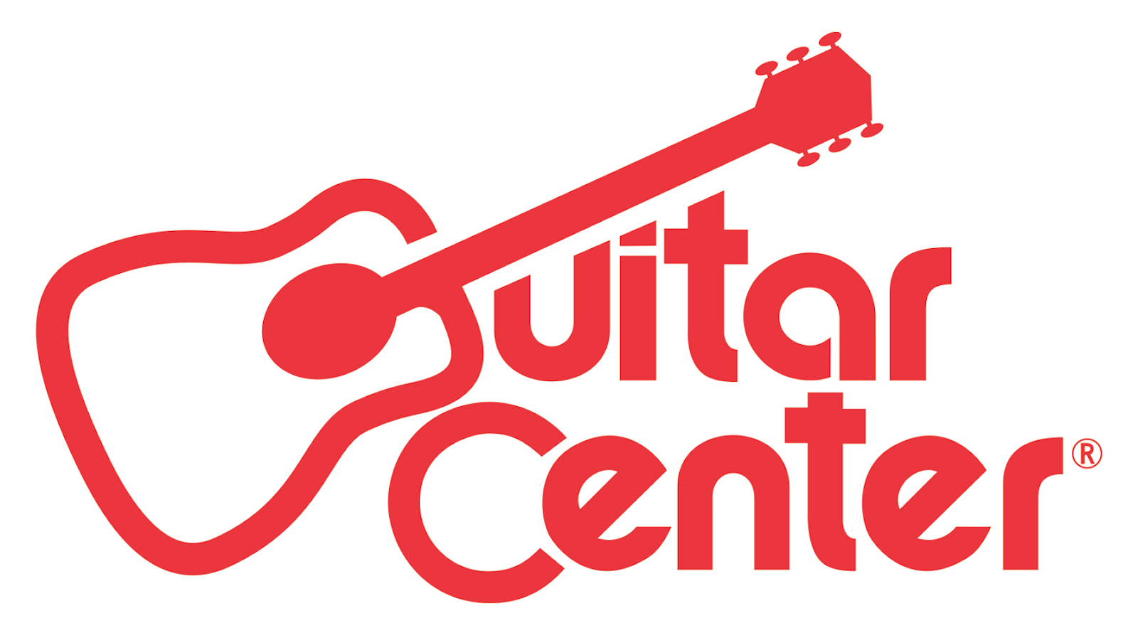

GRAMMY®-Nominated Group Above & Beyond Names Ricky Mears Winner of Guitar Center’s Cover Me Program

ANNOUNCEMENT HIGHLIGHTS:
- Guitar Center’s Cover Me is one of the retailer’s artist discovery programs created to support emerging musicians of all music genres with the tools, opportunities and platforms they need to be successful in their musical journeys
- As the winner, Mears will receive studio time with Above & Beyond, a feature with Beatport, new gear, $10,000 cash and more

Westlake Village, CA (November 17, 2016) – Guitar Center, the world’s largest instrument retailer, in partnership with GRAMMY® nominated supergroup Above & Beyond, announced Miami-based EDM artist Ricky Mears as the winner of Guitar Center’s Cover Me program.

Following on the heels of Above & Beyond’s 2016 acoustic album release, the Cover Me program asked musicians to reinterpret their music and bring it to life in a new way. Cover Me called on EDM artists from across the country to remix the group’s hit song “Blue Sky Action” via their own personal video submission. Each individual rendition was judged by Guitar Center’s Judging Panel and Above & Beyond based on technique, authenticity, originality and style. After reviewing hundreds of submissions, judges chose artist Ricky Mears’ submission video, awarding the deserving young talent with coveted Grand Prizes including an in-studio mentorship with Above & Beyond, $10,000, state-of-the-art Guitar Center gear and a feature in Beatport.

Based in Miami, Ricky Mears is a DJ, Producer and Vocalist who extracts influences from musicians including Brand New, Bassnectar and Skrillex, and seamlessly combines them with the island influences inspired by his childhood in Haiti. Mears’ work can be heard via his Soundcloud channel and on Facebook.

"I have so much respect for Above & Beyond that being hand-picked by them to win a remix competition is one of the greatest accomplishments in my musical career. I look forward to making music with them and I am so grateful that Guitar Center gave me this opportunity!” - Ricky Mears, Winner of Guitar Center’s Cover Me with Above & Beyond

"We are very humbled by the number of entries for our Blue Sky Action ‘Cover Me’ program with Guitar Center. After much deliberation over a rather impressive shortlist of talented performers and producers, Ricky Mears from Miami stood out. ‘Vibey’ is the word we would use. We look forward to meeting Ricky and working with him!" - Above & Beyond

“We were impressed by the number of outstanding submissions we received as part of Guitar Center’s Cover Me program and thrilled to partner with Above & Beyond, who share our passion for supporting emerging EDM talent and encouraging artists to find their own unique sound. Ricky Mears is an extremely talented EDM artist and we look forward to watching his career grow.” - Manager of Music Marketing + Artist Relations at Guitar Center, Jake Cheung

For more information on Guitar Center’s Cover Me program, visit AboveAndBeyond.com.

Photo file 1: RickyMears_Photo1.JPG
Photo caption 1: Ricky Mears, the winner of Guitar Center’s Cover Me program

Photo file 2: RickyMears_Photo2.JPG
Photo caption 2: Ricky Mears, the winner of Guitar Center’s Cover Me program

About Above & Beyond:
Over their four critically acclaimed studio albums, along with their acoustic project, Above & Beyond have continually been celebrated for placing real musicianship and songwriting at the heart of what they do. While their famed club mixes have resonated with the dance generation, the songs behind them have touched fans of all ages across the globe. As influenced as much by Jeff Buckley or Bon Iver as they are by their deep love of electronic music, Above & Beyond's songs and lyrics have been sung back to them at the world's biggest stadiums and stages - from Alexandra Palace, to Madison Square Garden, to LA's Forum, to their famed one million people gig at Barra Beach in Rio de Janeiro in 2007. For more, visit Aboveandbeyond.nu, or follow them on Facebook: Facebook.com/aboveandbeyond, Twitter: Twitter.com/aboveandbeyond, and Instagram:Instagram.com/aboveandbeyond.

About Guitar Center:
Guitar Center is the world’s largest retailer of guitars, amplifiers, drums, keyboards, recording, live sound, DJ, and lighting equipment. With more than 270 stores across the U.S. and one of the top direct sales websites in the industry, Guitar Center has helped people make music for more than 50 years. In addition, Guitar Center’s sister brands include Music & Arts, which operates more than 140 stores specializing in band & orchestral instruments for sale and rental, serving teachers, band directors, college professors and students, and Musician’s Friend, a leading direct marketer of musical instruments in the United States. With an unrivalled in-store experience, an industry-leading online presence and passionate commitment to making gear easy-to-buy, Guitar Center is all about enabling musicians and non-musicians alike to experience the almost indescribable joy that comes from playing an instrument. For more information about Guitar Center, please visit www.guitarcenter.com.
You can visit our press room at http://www.guitarcenter.com/pages/press-room, and send media inquiries to media@guitarcenter.com.

FOR MORE INFORMATION PLEASE CONTACT:
Sarah Chavey | Praytell Agency | 313.407.7571 | GCPR@praytellagency.com
Robert Clyne | Clyne Media | 615.662.1616 | pr@clynemedia.com
Syvetril Perryman | Guitar Center | 818.735.8800 x 2979 | media@guitarcenter.com

