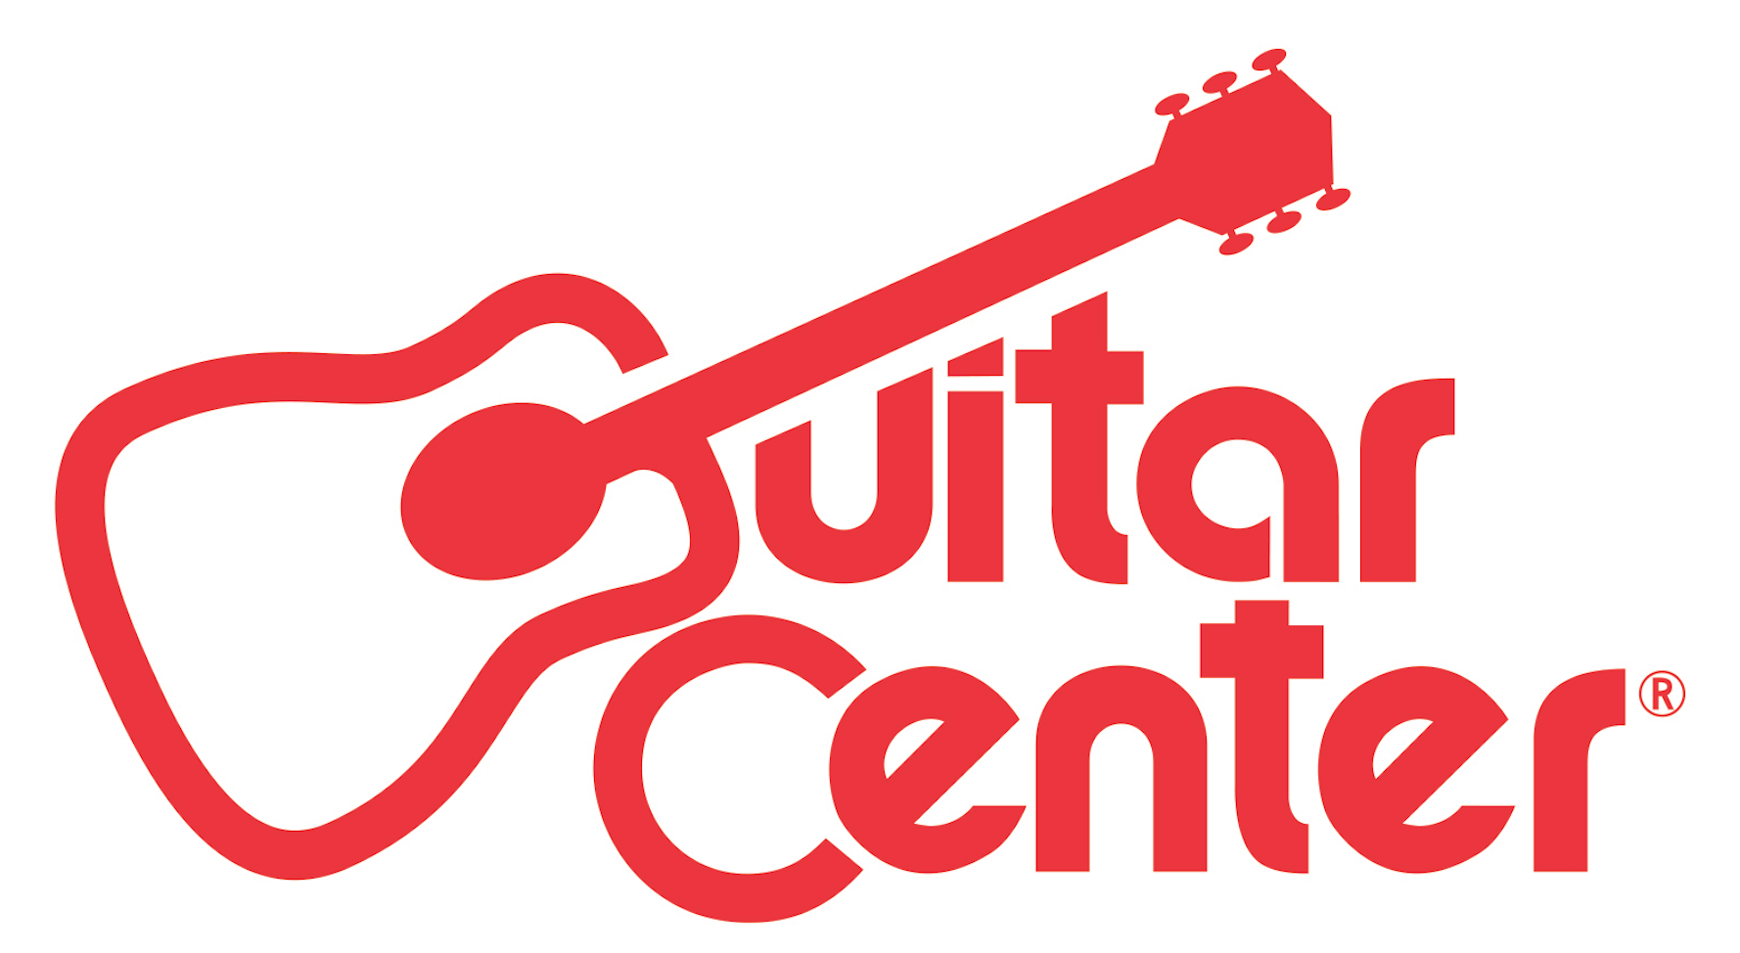

Guitar Center Donates Instruments for Live Charity Auction

Donated Guitars will benefit Buffalo, New York Not-for-Profit organization Music Is Art and have been signed by a number of celebrities, such as James Taylor, Snoop Dogg, Kevin Bacon and more

Los Angeles, CA (October 29, 2015) – Guitar Center donated 12 collectable guitars autographed by Goo Goo Dolls, Kevin Bacon, Dierks Bentley, Blink 182, Tommy Chong, Billy Ray Cyrus, Ray Davies (The Kinks), Snoop Dogg, Willie Nelson, John Rich (Big & Rich), James Taylor and Rob Thomas (Matchbox 20), for the Music Is Art charity auction in Buffalo, NY, which raised over $31,000.

All proceeds from the auction will benefit the Music Is Art organization, which is dedicated to exploring and reshaping music's cultural, social and educational impact on the community through a variety of programs and events.

“Our fundraiser raised over $31,000, which was more than double what we were anticipating,” said Tracy Shattuck, Executive Director, Music Is Art. “Thanks again to the team at Guitar Center for your generous donations and your assistance in making this fundraiser a success.”

“This year, Guitar Center started the project with Music Is Art chairman Ryan Casullo, whom we unfortunately lost in a motorcycle crash back in May. So when the board chairman Phil Aguglia contacted me to resurrect the project, it was a no-brainer. We are honored to be a part of it.” – Guitar Center Tonawanda, NY store manager, Mike Doktor
Photo file: GC_Tonawanda_MIA.JPG
Photo caption: The teams from Music Is Art and the Tonawanda, New York Guitar Center.

About Music Is Art:
Music Is Art is a not-for-profit, federal 501c3 organization founded in 2003 by Goo Goo Dolls bassist and Buffalo resident, Robby Takac. The organization is dedicated to enriching the local community with access to music. Its mission is to encourage people to find their musical voice, think about how music touches their lives, and most importantly think about the fact that...music is art.

Now in its 13th year, the Music is Art Festival is free all-day fundraiser event featuring an eclectic array of Buffalo's finest artists, musicians, DJs and entertainers. This year’s event will took place on September 12th in Delaware Park and featured a special live performance by The Goo Goo Dolls.

About Guitar Center:
Guitar Center is the world’s largest retailer of guitars, amplifiers, drums, keyboards, recording, live sound, DJ, and lighting equipment. With more than 260 stores across the U.S. and one of the top direct sales websites in the industry, Guitar Center has helped people make music for more than 50 years. In addition, Guitar Center’s sister brands includes Music & Arts, which operates more than 140 stores specializing in band & orchestral instruments for sale and rental, serving teachers, band directors, college professors and students, and Musician’s Friend, a leading direct marketer of musical instruments in the United States. With an unrivaled in-store experience, an industry-leading online presence and passionate commitment to making gear easy-to-buy, Guitar Center is all about enabling musicians and non-musicians alike to experience the almost indescribable joy that comes from playing an instrument. For more information about Guitar Center, please visit www.guitarcenter.com.

MORE INFORMATION, PLEASE CONTACT:
Robert Clyne | Clyne Media, Inc. | 615-662-1616| Robert@clynemedia.com
Tracy Shattuck | Music Is Art | 716.870.7089 | director@musicisart.com
Syvetril Perryman | Guitar Center | 818.735.8800 x 2979 | media@guitarcenter.com

###

