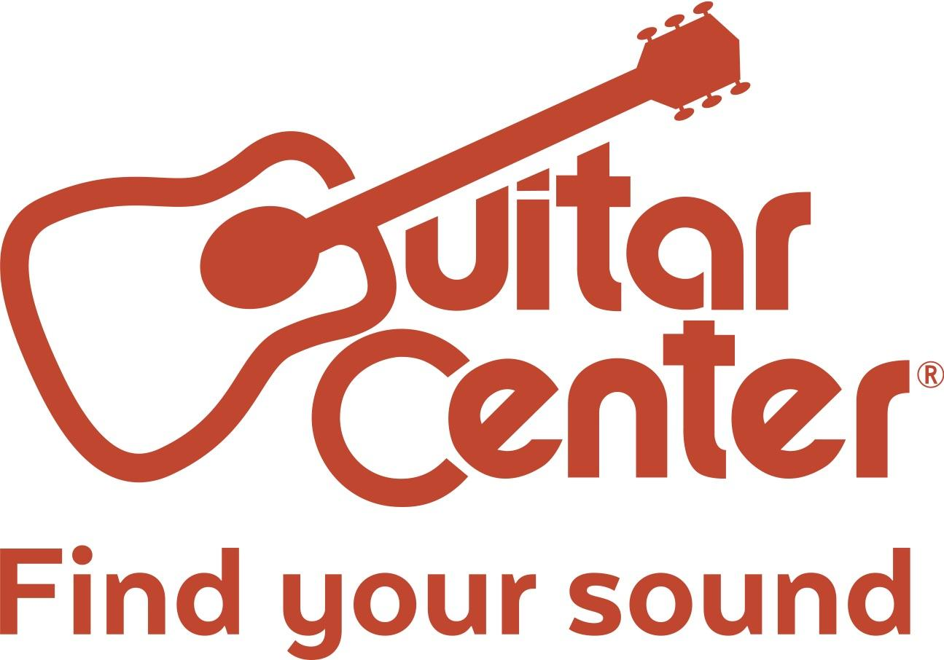
FOR IMMEDIATE RELEASE

Americans for the Arts Honors Guitar Center for Exceptional Commitment to the Arts

Business Committee for the Arts to present the award on October 11 at the annual BCA 10 Gala in New York City

Westlake Village, CA (April 27, 2017) – Americans for the Arts announced today that Guitar Center has been named a “BCA 10: Best Businesses Partnering with the Arts in America” honoree for 2017.

Presented every year by the Business Committee for the Arts (BCA), a division of Americans for the Arts, the BCA 10 awards honor 10 U.S. companies, business leaders and arts and business partnerships for their exceptional commitment to the arts through grants, local partnerships, volunteer programs, matching gifts, sponsorships, and board membership. The BCA 10 awards will be presented on October 11, 2017, at a black-tie gala at the Central Park Boathouse in New York City.

Guitar Center is the world’s largest instrument retailer with more than 280 stores nationwide. In addition to providing top of the line instruments, lessons, repairs, and rentals, for decades Guitar Center has given musicians of all skill levels a chance to shine and find their sound through impactful partnerships and initiatives that give back to musicians across the country.

Giving back is a key part of Guitar Center’s core values. In 2016 alone, Guitar Center donated hundreds of thousands of dollars toward musical equipment for musicians of various ages within diverse music genres. By partnering with celebrity ambassadors such as Colbie Caillat, Vince Gill, Cody Simpson, and national charitable organizations such as Little Kids Rock, Mr. Holland’s Opus and Girls Rock Camp, Guitar Center has helped dozens of schools improve their music education offerings, provided musician’s career-changing grants, donated music equipment to be used as therapy for veterans and much more.

“Guitar Center is a proud supporter of the arts and we’ve purposefully engaged in opportunities within the community to help aspiring artists find their own unique sound,” said Brian Berman, Guitar Center’s Vice President of Marketing. “From underserved students to the undiscovered artist, we are committed to helping all musicians plug in to the power of music.”

"We are grateful to honor these businesses and individuals for their exceptional involvement in ensuring that the arts thrive in their communities," said Robert L. Lynch, president and CEO of Americans for the Arts. "They provide the arts with significant financial and in-kind support, and they incorporate meaningful arts-related programs into their employee, customer, and community relations activities – truly setting a standard for other businesses to follow."

For information regarding BCA 10, please contact Jessica Gaines, Business Committee for the Arts Coordinator, at (202) 371-2830 or via e-mail at jgaines@artsusa.org.

Guitar Center is the world’s largest retailer of guitars, amplifiers, drums, keyboards, recording, live sound, DJ, and lighting equipment. With more than 280 stores across the U.S. and one of the top direct sales websites in the industry, Guitar Center has helped people make music for more than 50 years. In addition, Guitar Center’s sister brands include Music & Arts, which operates more than 140 stores specializing in band & orchestral instruments for sale and rental, serving teachers, band directors, college professors and students, and Musician’s Friend, a leading direct marketer of musical instruments in the United States. With an unrivalled in-store experience, an industry-leading online presence and passionate commitment to making gear easy-to-buy, Guitar Center is all about enabling musicians and non-musicians alike to experience the almost indescribable joy that comes from playing an instrument. For more information about Guitar Center, please visit www.guitarcenter.com.

Americans for the Arts is the leading nonprofit organization for advancing the arts and arts education in America. With offices in Washington, D.C. and New York City, it has a record of more than 55 years of service. Americans for the Arts is dedicated to representing and serving local communities and creating opportunities for every American to participate in and appreciate all forms of the arts. Additional information is available at AmericansForTheArts.org.

Business Committee for the Arts (BCA) was founded in 1967 by David Rockefeller. A division of Americans for the Arts, the BCA encourages, inspires, and stimulates businesses to support the arts in the workplace, in education, and in the community. BCA merged with Americans for the Arts in 2008.
###

FOR MORE INFORMATION PLEASE CONTACT:
Robert Clyne | Clyne Media, Inc. | 615-662-1616 | Robert@clynemedia.com
Marisa Bettencourt | Praytell Agency | 925.817.0596 | GCPR@praytellagency.com

