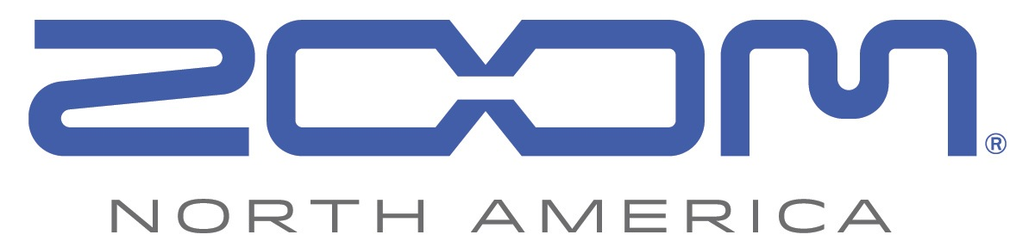
FOR RELEASE JUNE 1st 2016, 9AM EST

Zoom Introduces the H4n Pro, Offering Superior Performance and Upgraded Features

Hauppauge, NY, June 1, 2016 — Zoom North America today unveiled the new H4n Pro Handy Recorder.

With the H4n Pro, Zoom has taken everything creators love about the original H4n and brought it to the next level. Featuring advanced microphones, high-performance mic preamps, and an extremely low noise floor, the H4n Pro delivers high-quality four-track audio recording for music, film, podcasting, and beyond.

The H4n Pro’s state-of-the-art, built-in condenser mics capture sound with remarkable clarity and definition. Newly updated to handle up to a thunderous 140 dB SPL, creators can count on distortion-free X/Y recording in even the loudest environments.

The Pro’s two XLR/TRS inputs utilize the same high performance, low-noise mic preamps as the acclaimed Zoom H5 and H6 Handy Recorders. The improved noise floor (-120 dBu EIN) allows for audio capture with less noise and fewer artifacts.

The new rubberized, ergonomic body is perfect for use in the field. Newly added locking combo connectors ensure mic cables stay secure. A headphone/line out jack makes it easy to send high-definition stereo directly to a camera, while a built-in monophonic reference speaker provides quick audio reference in the field.

The H4n Pro also features three recording modes, built-in studio-grade effects, and the ability to function as a 2-input/2-output USB audio interface.

The Zoom H4n Pro Handy Recorder will be available in stores June 1, 2016 for $219.99. For more information including specs and images, visit zoom-na.com/H4nPro or contact Zoom North America at info@zoom-na.com.

Photo file 1: Zoom_H4nPro_Front.JPG
Photo caption 1: Zoom H4n Pro Handy Recorder

Photo file 2: Zoom_H4nPro_FrontSlant.JPG
Photo caption 2: Zoom H4n Pro Handy Recorder

Photo file 3: Zoom_H4nPro_Slant.JPG
Photo caption 3: Zoom H4n Pro Handy Recorder

Image Assets via Dropbox:
https://www.dropbox.com/sh/xtbdl67kfwn6uts/AABlWHO9pNXmVBHLlBFWwLoYa?dl=0

About Zoom North America:
Zoom North America is the U.S. affiliate for products manufactured by the Zoom Corporation (Japan). The company prides itself on offering its customers the very highest level of service and support.
info@zoom-na.com | Tel: 631-542-5270 | Fax: 631-542-5299

Press Contacts:
Clyne Media, Inc.
Robert Clyne
615-662-1616
Email: robert@clynemedia.com

Frank Doris
631-645-5668
Email: frank@clynemedia.com

