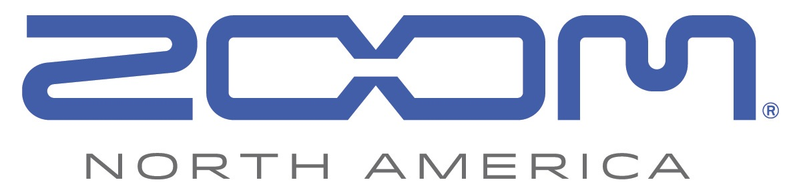
PRESS RELEASE: PRODUCT ANNOUNCEMENT

Zoom’s New H1n Handy Recorder Offers Essential Audio Recording Features and a Sleek, Portable Design

Portable H1n brings high-quality audio capture to content creators, filmmakers and musicians for a variety of recording and post-production applications

zoom-na.com/H1n

March 19, 2018 — Zoom North America now offers its H1n Handy Recorder, a compact and versatile audio recorder designed to be an essential tool for creators who are looking to capture professional-quality audio on the go. The H1n, which is currently available, offers a host of upgrades from the popular H1 and is ideal when capturing audio for film, music, podcasts, and other applications.

The H1n’s rugged, sleek design features a protective mic enclosure, an improved, bright LCD screen, a new analog-style gain control, and easy-to-access buttons and menu options. The H1n’s built-in X/Y microphone captures high-quality stereo sound in any environment, and a convenient stereo 1/8-inch mini phone jack mic/line input allows creators to connect external microphones or other line-level sources such as mixers and music players for even more versatility.

A newly designed onboard limiter enables distortion-free recording up to 120 dB SPL, letting users capture concerts, band practices, or other loud situations without compromising audio quality. The H1n’s new low-cut filter features selectable cut-off points and helps eliminate pops, wind noise, and other unwanted low-frequency rumble.

A host of new, advanced functions like Playback Speed Control and A-B Repeat provide greater flexibility during playback. The easy-to-use Overdubbing feature allows the user to layer audio easily. Auto-Record and Pre-Record settings make sure the desired audio is always captured at pristine 24-bit/96 kHz. The Voice Emphasize filter is designed specifically for dictation, making the H1n incredibly useful for interviews, lectures or podcasting.

For filmmakers using DSLRs, the H1n is equipped with all-new Test Tone and Slate Tone generators to calibrate levels and mark audio start and stop points for easily syncing audio to video. Utilizing two AAA batteries to provide up to 10 hours of recording time, the H1n is the perfect companion for on-location shoots or traveling.

The Zoom H1n Handy Recorder is currently available at $119.99 MAP. For more information including specs and images, visit zoom-na.com/H1n or contact Zoom North America at info@zoom-na.com.

Zoom H1n Handy Recorder Key Features:
- Improved 1.25-inch monochrome LCD display
- Intuitive menus for easy operation
- Built-in stereo X/Y 90-degree microphones handle up to 120 dB SPL
- Stereo 1/8-inch Mic/Line In mini phone jack
- Stereo 1/8-inch Phone/Line Output jack with dedicated volume control
- Limiter function for input signal up to 120 dB SPL
- New Playback Speed Control, Voice Emphasize Filter, Stereo Bounce (overdub), Auto-Record, Pre-Record, and Self-Timer functions
- Supports up to 24-bit/96 kHz audio in BWF-compliant WAV format
- Test Tone and Slate Tone generator
- Records directly to SD and SDHC cards up to 32 GB
- Runs on two standard AAA alkaline, Lithium, or NiMH rechargeable batteries or AC adapter (AD-17)
- Optional accessories package available – includes tripod, carrying case, windscreen, AC adapter, USB cable, and mic clip adapter (SRP: $24.99)

Photo file 1: H1n_slant01.JPG
Photo caption 1: Zoom H1n Handy Recorder

Photo file 2: H1n_slant02.JPG
Photo caption 2: Zoom H1n Handy Recorder

Photo file 3: H1n_Train1.JPG
Photo caption 3: Zoom H1n Handy Recorder application shot

Image Assets via Dropbox:
https://www.dropbox.com/sh/mdq9wk99clp9u12/AADolWdtElhILBa97S_3ZNe6a?dl=0

About Zoom North America:
Zoom North America is the U.S. affiliate for products manufactured by the Zoom Corporation (Japan).
The company prides itself on offering its customers the very highest level of service and support.
info@zoom-na.com | Tel: 631-542-5270 | Fax: 631-542-5299

For more information, please contact:
Frank Doris
631-645-5668
Email: frankdoris@frankdoris.com

