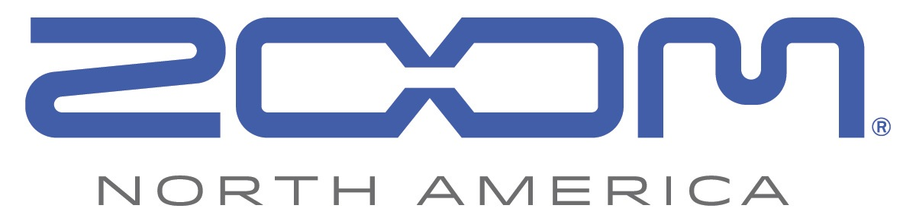
PRESS RELEASE: PRODUCT ANNOUNCEMENT

Zoom’s New F4 MultiTrack Field Recorder Captures Hollywood Sound at an Indie Budget
Compact field recorder offers six-input/eight-track recording, super-low-noise mic preamps, and time code with pinpoint accuracy
https://zoom-na.com/F4

September 6, 2016 — Zoom North America today unveiled the new F4, a six-input/eight-track field recorder that offers creators Hollywood-quality sound for film at an unprecedented price. With four super-low-noise mic preamps, precise time code and a solid metal build, the F4 is the ideal recorder for creators looking to take their filmmaking projects to the next level.

Zoom F4 MultiTrack Field Recorder “Hollywood Sound Goes Indie” video: https://youtu.be/PaLSlvMu2v0

Like the multi-award-winning Zoom F8, the F4 is equipped with high-quality mic preamps, offering pristine recording and playback at resolutions up to 24-bit/192 kHz. For precise audio/video syncing, the F4 uses a Temperature Compensated Crystal Oscillator (TCXO) that generates time code at 0.2 ppm accuracy — a first at this price point.

For recording flexibility, the F4 features four locking Neutrik XLR/TRS combo connectors, a 3.5mm stereo input, and a Zoom mic capsule input, for a total of six discrete inputs, all of which enable it to record up to eight tracks. The F4 also provides two Main Outs and two Sub Outs as well as a 1/4" headphone jack with dedicated volume control.

Compact and lightweight, the F4 weighs just 2.27 pounds without batteries and features a durable metal chassis. The F4 also includes a 1.9-inch white backlit monochromatic LCD display that makes the F4 suitable for all lighting environments, from the studio to the field.

The Zoom F4 will be available in stores October 2016 for $649.99. For more information including specs and images, visit zoom-na.com/F4 or contact Zoom North America at info@zoom-na.com.

Photo file 1: Zoom_F4_Front.JPG
Photo caption 1: Zoom F4 MultiTrack Field Recorder

Photo file 2: Zoom_F4_Slant1.JPG
Photo caption 2: Zoom F4 MultiTrack Field Recorder

Photo file 3: Zoom_F4_Slant2.JPG
Photo caption 3: Zoom F4 MultiTrack Field Recorder

Photo file 4: Zoom_F4_Rear.JPG
Photo caption 4: Zoom F4 MultiTrack Field Recorder rear view

Image Assets via Dropbox:
https://www.dropbox.com/sh/k9urecac6hnhgl4/AAD4dFW6IvBKpblPIOdaTpnca?dl=0

About Zoom North America:
Zoom North America is the U.S. affiliate for products manufactured by the Zoom Corporation (Japan).
The company prides itself on offering its customers the very highest level of service and support.
info@zoom-na.com | Tel: 631-542-5270 | Fax: 631-542-5299

Press Contacts:
Clyne Media, Inc.
Robert Clyne
615-662-1616
Email: robert@clynemedia.com

Frank Doris
631-645-5668
Email: frank@clynemedia.com

