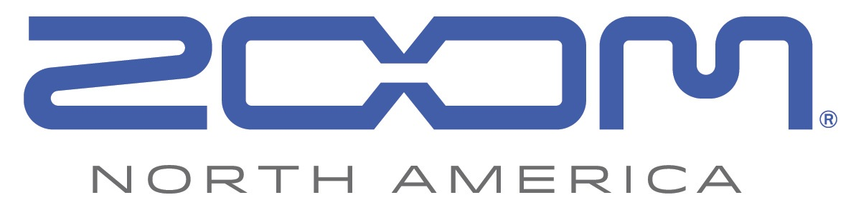
PRESS RELEASE: PRODUCT ANNOUNCEMENT

Zoom Unveils Its All-New F1-LP Field Recorder + Lavalier Mic Bundle
for Videographers

The F1-LP Field Recorder and Lavalier Mic system delivers enhanced audio quality for interviews, wedding vows, and more.

zoom-na.com/f1-lp

April 3, 2018 — Zoom North America is now shipping its new F1-LP Field Recorder + Lavalier Mic system. Designed for videographers, vloggers, and journalists, this portable recorder and mic package provides the ability to record professional-quality audio, no matter how far away the video subjects are from the camera.

Recording levels, lo-cut filter settings, battery life indication and more can be read on the F1’s new LED display, readable even under bright light. The F1 Field Recorder’s lightweight, compact design enables it to attach neatly to belts, waistbands, or inside pockets to capture audio without being seen. Featuring a rugged, durable aluminum construction, the F1 can be powered using two AAA batteries or with the optional AD-17 power adapter.

The F1-LP comes with Zoom’s newly engineered LMF-1 Lavalier Mic and can record high-resolution audio up to 24 bit/96 kHz. Unlike wireless beltpack systems, the lavalier mic connects directly to the F1 and records to a micro SD card, eliminating any interference or noise that could be caused by wireless signals. With the audio directly connected to the field recorder in the subject’s pocket, videographers are still able to move freely with their cameras while capturing every word.

Other essential features for videographers include a tone generator, sound markers, auto-level recording, on-board limiter, USB connectivity, and more. The F1 can be powered using two AAA batteries (included) or with the optional AD-17 power adapter.

In addition, the F1 Field Recorder uses a proprietary 10-pin connector for compatibility with all of Zoom’s interchangeable mic capsules, to provide options for virtually any recording situation.

The Zoom F1-LP system is currently available at authorized Zoom resellers at $199.99 MAP.

F1-LP Key Features:
- Two-channel Zoom Field Recorder (Model F1)
- Includes LMF-1 lavalier mic, MCL-1 mic clip, BCF-1 belt clip and WSL-1 windscreen
- Ideal for wedding videography, interviews and other applications requiring close miking
- Rugged, compact, lightweight aluminum body
- Improved 1.25-inch monochrome LCD display
- Intuitive menus and one-touch button controls for easy operation
- Stereo 1/8-inch Mic/Line In mini phone jack with plug-in power (2.5V)
- Stereo 1/8-inch Phone/Line Output jack with dedicated volume control
- Built-in limiter and auto level control
- Pre-Record function
- Supports up to 24-bit/96 kHz audio in BWF-compliant WAV format
- Records directly to SD and SDHC cards up to 32 GB
- Tone generator for calibrating audio levels between the F1 and a DSLR or video camera without the need for an attenuator cable
- Sound Marker function for easy syncing of audio and video
- Micro USB port enables use as an audio interface with computer or IOS device, and for data exchange
- Runs on two standard AAA alkaline (included), Lithium, or NiMH rechargeable batteries or AC adapter (AD-17)
- Compatible with Zoom microphone capsule system

Photo file 1: F1L_contents.JPG
Photo caption 1: Zoom F1-LP Field Recorder + Lavalier Mic system package contents

Photo file 2: F1_LP_Package.JPG
Photo caption 2: Zoom F1-LP Field Recorder + Lavalier Mic system

Photo file 3: F1-LP_Documentary.JPG
Photo caption 3: Zoom F1-LP Field Recorder + Lavalier Mic system application photo

Image Assets via Dropbox:
https://www.dropbox.com/sh/p06iweu4gt38qsc/AAAspQgyl_TaK2rixS1A9zAha?dl=0

About Zoom North America:
Zoom North America is the U.S. affiliate for products manufactured by the Zoom Corporation (Japan).
The company prides itself on offering its customers the very highest level of service and support.
info@zoom-na.com | Tel: 631-542-5270 | Fax: 631-542-5299

For more information, please contact:
Frank Doris
631-645-5668
Email: frankdoris@frankdoris.com

