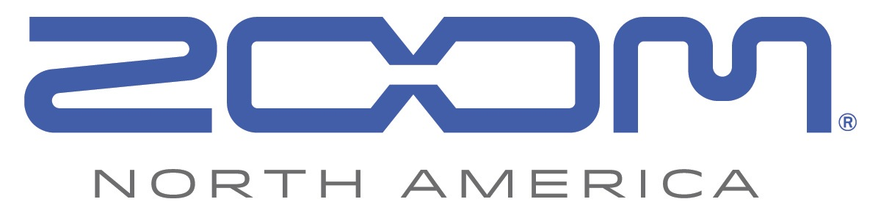
PRESS RELEASE: PRODUCT ANNOUNCEMENT

New Zoom F1 Field Recorder and Mic Systems for Filmmakers and Videographers

The all-new F1 Field Recorder takes DSLR audio recording to a new level with interchangeable shotgun and lavalier microphone options.

zoom-na.com/f1-sp and zoom-na.com/f1-lp

March 29, 2018 — Zoom North America is now shipping its F1 Field Recorder with a choice of shotgun or lavalier microphones, expanding its product line of quality audio recording solutions for video recording devices and DSLR cameras.

The F1 is the latest field recorder to join the Zoom lineup and is available in two distinct models: the F1-SP Field Recorder + Shotgun Mic, and the F1-LP Field Recorder + Lavalier Mic system. Offering a compact, lightweight design with a rugged aluminum body, the F1 Field Recorder allows filmmakers and videographers to get the most out of their audio recordings without having to carry bulky equipment. It features a newly designed LCD display that ensures readability even in direct sunlight. Users can monitor levels, battery life, rumble filter lo-cut settings and more, while the one-touch controls that surround the display make recording levels, limiter settings and volume output easily accessible.

The shotgun configuration features the SGH-6 shock-mounted shotgun mic, which provides an ultimate solution for on-the-move filmmakers, while the LMF-1 lavalier makes sure users capture all the audio nuances of interviews, weddings and other situations where up-close audio is needed. Both microphones, when paired with the F1, capture pristine audio up to 24-bit/96k directly to a microSD card.

In addition, the F1 Field Recorder utilizes Zoom’s proprietary 10-pin connector for compatibility with all of Zoom’s interchangeable mic capsules, to provide recording options for virtually any recording environment.

The Zoom F1-SP Field Recorder System with SGH-6 shotgun mic is currently available at authorized Zoom resellers at $249.99 MAP. The Zoom F1-LP Field Recorder System with LMF-1 lavalier mic is currently available at $199.99 MAP.

F1-SP and F1-LP Key Features:
- Two-channel Zoom Field Recorder (Model F1); includes SGH-6 shotgun mic, SMF-1 shock mount, SMC-1 stereo mini cable for DSLR and WSS-6 windscreen (F1-SP); or LMF-1 lavalier mic, MCL-1 mic clip, BCF-1 belt clip and WSL-1 windscreen (F1-LP)
- F1-SP is ideal for recording on-the-go video; F1-LP is perfect for wedding videography, interviews and other applications requiring close micing
- Rugged, compact, lightweight aluminum body
- Improved 1.25-inch monochrome LCD display
- Intuitive menus and one-touch button controls for easy operation
- Stereo 1/8-inch Mic/Line In mini phone jack with plug-in power (2.5V)
- Stereo 1/8-inch Phone/Line Output jack with dedicated volume control
- Built-in limiter and auto level control
- Pre-Record function
- Supports up to 24-bit/96 kHz audio in BWF-compliant WAV format
- Records directly to SD and SDHC cards up to 32 GB
- Tone generator for calibrating audio levels between the F1 and a DSLR or video camera without the need for an attenuator cable
- Sound Marker function for easy syncing of audio and video
- Micro USB port enables use as an audio interface with computer or IOS device, and for data exchange
- Runs on two standard AAA alkaline (included), Lithium, or NiMH rechargeable batteries or AC adapter (AD-17)
- Compatible with Zoom microphone capsule system
Photo file 1: F1SP-LP_pkgMockup_facing.JPG
Photo caption 1: Zoom F1-SP Field Recorder + Shotgun Mic system (left) and the F1-LP Field Recorder + Lavalier Mic system (right)

Photo file 2: F1S_wWindscreen.JPG
Photo caption 2: Zoom F1-SP Field Recorder + Shotgun Mic system, shown mounted on a camera

Photo file 3: F1_LavPackage_Front.JPG
Photo caption 3: Zoom F1-LP Field Recorder + Lavalier Mic system

Image Assets via Dropbox:
https://www.dropbox.com/sh/p06iweu4gt38qsc/AAAspQgyl_TaK2rixS1A9zAha?dl=0

About Zoom North America:
Zoom North America is the U.S. affiliate of Zoom Corporation (Japan). The company prides itself on offering its customers the very highest level of service and support.
info@zoom-na.com | Tel: 631-542-5270 | Fax: 631-542-5299

For more information, please contact:
Frank Doris
631-645-5668
Email: frankdoris@frankdoris.com

