**TIP SHEET FOR CES, JANUARY 5 – 8, 2017**
“The coolest energy tech to debut this year” – Vox

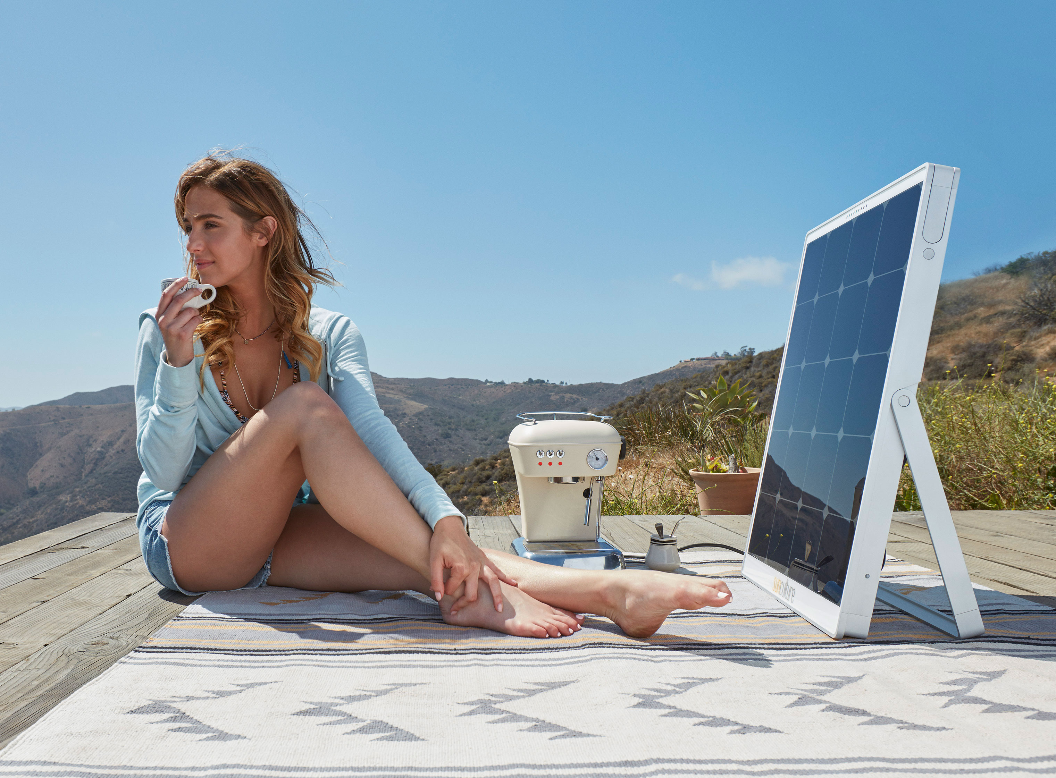

SolPad Makes Energy Accessible to Everyone Everywhere — Completely Changes Face of Sustainable Energy with First-of-Their-Kind Adaptable, Integrated, Intelligent and Personalized Products

Power anything anywhere with intuitive, simple-to-use, built-in energy storage system and an Internet of Energy smart home platform—SolPad is a personal energy solution for global use

WHO: SolPad, the world’s first integrated solar solution with built-in energy storage and an Internet of Energy (IoE) smart home platform, is giving CES attendees the first public demonstration of its breakthrough line of personalized energy products

WHAT: Being demonstrated is SolPad Mobile, a portable power solution that easily integrates into any home environment or can be taken on-the go for off-grid applications such as camping and tailgating; and SolPad Home, a rooftop solar panel device that’s like having a smart-energy computer on your roof

WHERE: Booth 41738
Smart Home Marketplace
Sands, Level 2, Halls A-D

About SunCulture Solar Inc.
SunCulture Solar was formed in 2012 and is the designer and manufacturer of the SolPad series of personal energy products. With SolPad, our mission has always been to disrupt the conventional sustainable energy landscape by delivering the world’s first 100% fully integrated, user-friendly solar energy products that provide the best, most powerful and most cost-effective green energy solutions for the sustainable smart home and off-grid power environments. SolPad’s series of products are designed to empower consumers, giving them the ability to choose energy reliance on clean power to reduce their carbon footprint. SunCulture Solar Inc. is headquartered in Mountain View, California. Be the first to find out the latest developments from SolPad at facebook.com/SolPadEnergy, on Twitter @SolPadEnergy and Instagram @SolPadEnergy. Visit www.SolPad.com for full product details.

On-site press contact:
Ed James
Clyne Media
917-593-4628
ed@clynemedia.com

