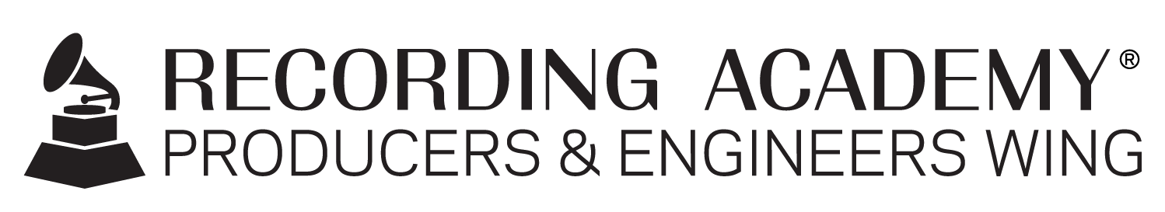

Recording Academy® Producers & Engineers Wing® announces 2022–2023 Steering Committee

Santa Monica, Calif. (DEC. 13, 2022) — The Recording Academy® Producers & Engineers Wing® has announced its 2022–2023 Steering Committee. The Committee consists of a diverse array of music engineers, producers and studio professionals who, building upon the significant legacy established by prior Steering Committees, work to address key issues confronting music production and promote meaningful technical solutions that help move the music industry forward.

The P&E Wing continues to advocate for excellence and best practices in sound recording, audio technologies and education in the recording arts, along with proper crediting, recognition and rights for music creators overall. The 2022–2023 Steering Committee is co-chaired by renowned producer/engineers Chuck Ainlay (George Strait, Lyle Lovett, Miranda Lambert, and winner of multiple GRAMMY Awards®, 10 ACMs and two CMAs), and Leslie Ann Jones (Kronos Quartet, Gordon Getty, Rosemary Clooney, Director of Music and Scoring at Skywalker Sound, and multiple GRAMMY® Award winner). Jones is returning as co-chair from last year’s committee. The Committee also includes the following music industry professionals from across the United States: Marcella Araica, Maria Elisa Ayerbe, Jimmy Douglass, Lynne Earls, Anna Frick, Steve Genewick, David "Swagg" Harris, and Ebonie Smith. Ex officio members include Recording Academy Chair Tammy Hurt and Recording Academy CEO Harvey Mason jr.

Maureen Droney, Vice President, Recording Academy Producers & Engineers Wing, stated, "Our 2022-2023 Steering Committee is a team that is ready and willing to guide the direction of the P&E Wing through the next year, while speaking and advocating for the audio community overall with diverse perspective and insight. Their input will help set the year's agenda and prioritize the issues that are most pressing to the P&E Wing's membership and the industry at large. Priorities will include finalizing a new set of updates to our Recommendations for Delivery of Recorded Music Projects, and a new focus on deliverables for immersive formats, while we continue to work on advocacy for best practices in proper crediting, archiving, preservation, and more."

Photo file 1: ChuckAinlay.JPG
Photo caption 1: Chuck Ainlay, 2022-2023 Recording Academy® Producers & Engineers Wing® Steering Committee co-chair

Photo file 2: LeslieAnnJones.JPG
Photo caption 2: Leslie Ann Jones, 2022-2023 Recording Academy® Producers & Engineers Wing® Steering Committee co-chair

about the recording academy
The Recording Academy represents the voices of performers, songwriters, producers, engineers, and all music professionals. Dedicated to ensuring the recording arts remain a thriving part of our shared cultural heritage, the Academy honors music's history while investing in its future through the GRAMMY Museum®, advocates on behalf of music creators, supports music people in times of need through MusiCares®, and celebrates artistic excellence through the GRAMMY Awards — music's only peer-recognized accolade and highest achievement. As the world's leading society of music professionals, we work year-round to foster a more inspiring world for creators.

For more information about the Academy and its Producers & Engineers Wing, please visit www.recordingacademy.com or @ProdEngWing on Instagram. For breaking news and exclusive content, follow @RecordingAcad on Twitter, "like" Recording Academy on Facebook, and join the Recording Academy's social communities on Instagram, YouTube, TikTok, and LinkedIn.

# # #

contacts

Chrissy Dudash
Recording Academy
chrissy.dudash@recordingacademy.com

Robert Clyne
Clyne Media, Inc.
T. 615.662.1616
robert@clynemedia.com

