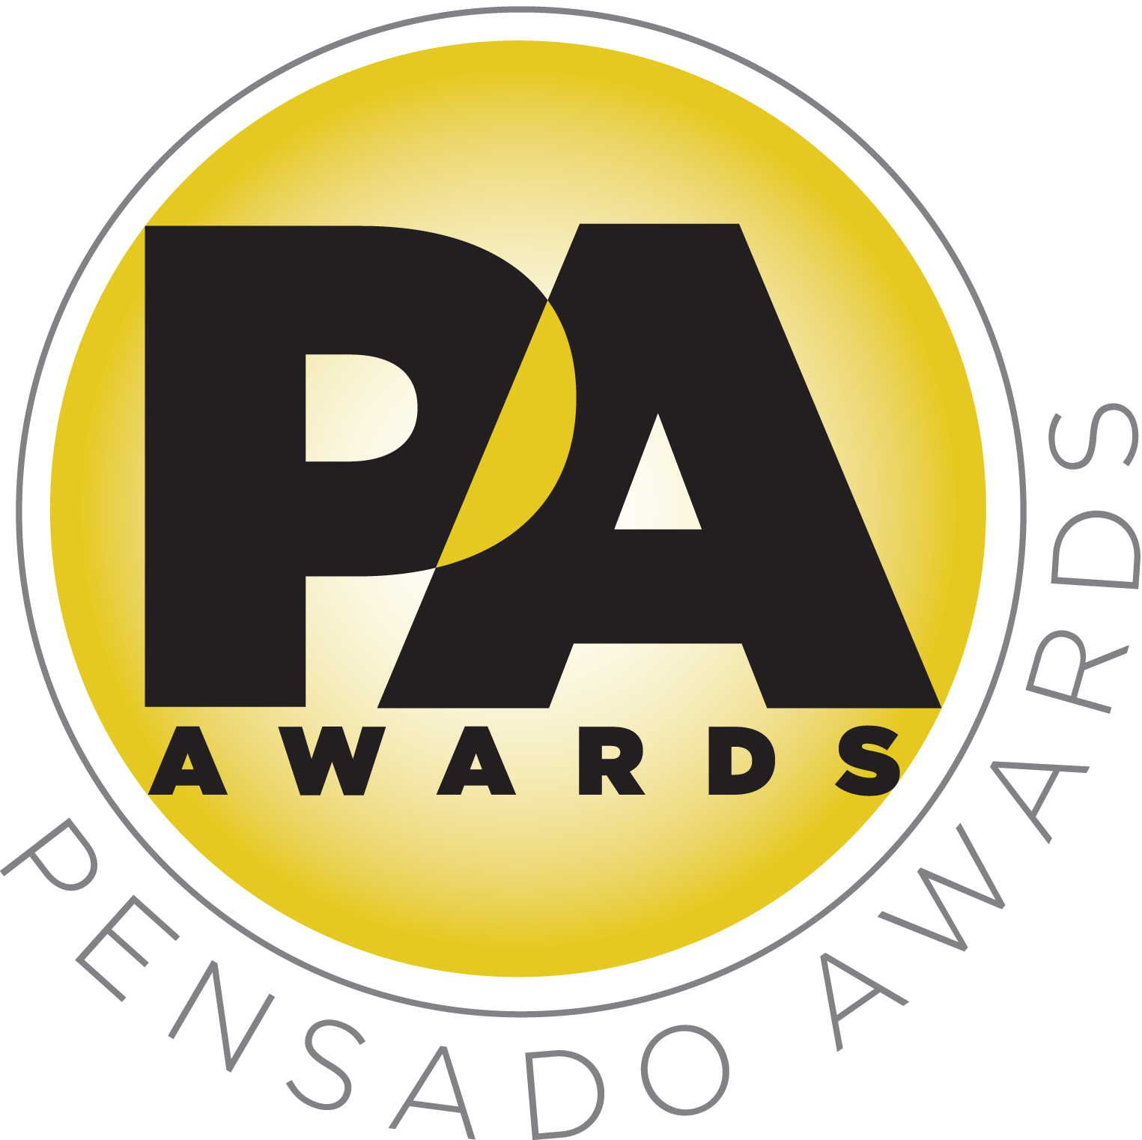

Fourth Annual Pensado Awards to Take Place Sunday, December 3, 2017, at L.A.’s Legendary Fonda Theatre

Awards show will once again “recognize the faces behind the sound” and feature returning co-hosts Samantha Maloney and Chris Lord-Alge and new co-host Kosine from Da Internz

The ceremony is sponsored by producing powerhouse 1500 or Nothin’. Other main sponsors include The Blackbird Academy, Avid, Westlake Pro, LANDR and DTS. The awards will feature a who’s-who of the recording community.

LOS ANGELES, CA, September 27, 2017 — The Pensado Awards has announced the date and venue for its fourth annual award ceremony – dubbed by insiders as the must-attend audio event of the year. Created by Herb Trawick and Dave Pensado of Penwick Media (the producers of Pensado's Place and other industry-leading audio-related media), the awards were founded as a means of acknowledging talented music producers, engineers, mixers, songwriters and their work, serving as a grand opportunity for the best pros, amateurs, brands and press to come together as one community to celebrate the uncelebrated. Since its inception, the show has continued to gain momentum and garner attention throughout the industry and beyond.

This year’s festivities will take place on Sunday, December 3, 2017, at Los Angeles’ historic Fonda Theatre, 6126 Hollywood Boulevard, Los Angeles, California 90028. The Fonda will provide an intimate backdrop for this year’s Pensado Awards 4, which will feature an entirely new vibe and new show format using cutting-edge technology, plus additional surprises throughout the night. This year’s co-hosts are drummer Samantha Maloney (Hole, Mötley Crüe, Peaches), legendary producer, engineer and mixer Chris Lord-Alge (Pink, Foo Fighters, Avril Lavigne, Green Day) and Kosine of acclaimed production duo Da Internz (Ludacris, Nicki Minaj, John Legend). Pensado Awards 4 is sponsored by hip-hop production collective 1500 or Nothin', an American musical ensemble composed of record producers, songwriters, musicians and music videographers, based in Inglewood, California. Other main sponsors include The Blackbird Academy, Avid, Westlake Pro, LANDR and DTS.

Last year’s ceremony hosted a standing-room-only crowd of recording industry figures – some as proud nominees, some as presenters, some there to simply be a part of the evening – including songwriter/producer busbee; GRAMMY®-winning movie scoring mixer Alan Meyerson; Keith Urban producer Greg Wells; Kendrick Lamar collaborator DJ Ali; jazz songbird Patti Austin, producers from Kanye West’s G.O.O.D. Music; multi-GRAMMY award-winning engineers Ed Cherney, Mick Guzauski and Al Schmitt; executives from Facebook and YouTube; and testimonials from Pitbull, Lukas Graham and Henry Fong. A special highlight was a taped tribute to producer/engineer/mixer Chris Lord-Alge, the winner of the Pensado Giant Award, from Steven Tyler, Bruce Springsteen, Pink, Stevie Nicks and Chris’s brother, GRAMMY Award-winning engineer/mixer Tom Lord-Alge. This year’s event is slated to be the best one yet!

The Pensado Awards are a natural outgrowth of the ethos behind Pensado’s Place. In recent years, developments in music and technology have changed the landscape for producers, songwriters, engineers and musicians, encouraging artists and composers of all types to hone their craft. From the self-taught basement enthusiast to the seasoned industry producer, all manner of music professionals are discovering new methods of working and novel ways to reach fans. The science and art of music-making are in a rapid state of flux, with exciting opportunities awaiting among the talented figures in and out of the spotlight – the people who are currently engineering the next sound that will move the world in the music, film, television and digital realms. Over 100,000 albums and millions of songs are released every year, not to mention the hundreds of thousands of concerts put on worldwide, but the awards often end up in the hands of a lucky select group. So the brilliance and hard work of all those producers, songwriters, DJ’s, engineers, mixers, live wizards and behind-the-scenes technicians in audio often go unnoticed. The Pensado Awards, founded as a means of acknowledging these talented individuals and their work, are a grand opportunity for the best pros, amateurs, brands and press to come together as one community to celebrate the uncelebrated.

Herb Trawick, the Co-host/Executive Producer and Creator of Pensado’s Place, as well as Manager to Co-host Dave Pensado, stated, “Dave and I wanted to refresh things a bit – create a new vibe and incorporate some new technology; these shifts are helped along with a move to L.A.’s historic Fonda Theatre, the host to such legendary performers as The Rolling Stones, Pearl Jam, Black Eyed Peas, Stevie Wonder and many more. The Fonda’s smaller theater size will bring about an intimate, immersive experience, but it also wouldn’t be a Pensado event without the usual fun and hang that we love. Stay tuned: more to come!”
###

Photo file 1: Pensado_Awards_2017_CoHosts.JPG
Photo caption 1: The co-hosts of the fourth annual Pensado Awards. Pictured L-R: Kosine, Samantha Maloney and Chris Lord-Alge.

Photo file 2: Pensado_Trawick.JPG
Photo caption 2: Pictured L-R: Dave Pensado and Herb Trawick.

About Pensado’s Place
The hour-long weekly web series Pensado’s Place was created over five years ago. Co-hosted by legendary mix engineer Dave Pensado (Black Eyed Peas, Beyoncé, Christina Aguilera, Kelly Clarkson, Michael Jackson and more) and show creator Herb Trawick, Pensado’s Place includes interviews with top music industry artists, engineers, producers, mixers, and record executives, as well as in-depth tutorials in production, engineering and mixing. Pensado’s Place has positioned itself as “the most influential show for audio engineers,” mixers and producers (Forbes Magazine). Pensado’s Place is more than just a show, as it highlights the very best in the audio industry from music, film, TV, gaming, live, hardware and software with a presence in live events. As a leading educational resource, Pensado’s Place is helping build the next generation of audio greats. http://www.pensadosplace.tv/.

PR Contacts:
Robert Clyne / Clyne Media / 615-662-1616 / Robert@clynemedia.com / www.clynemedia.com/
Lisa Roy / Rock & Roy / 310-463-1563 / lisaroyaudio@mac.com

