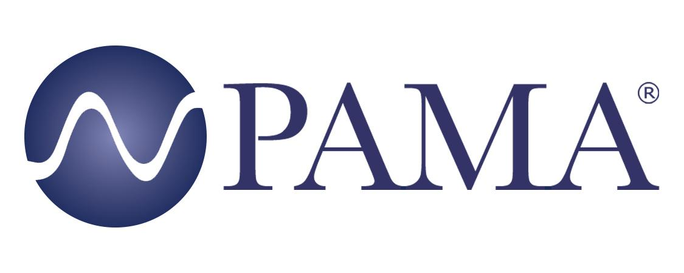

PR Contact:
Robert Clyne
President
Clyne Media, Inc.
T. 615.662.1616
robert@clynemedia.com

PAMA Contact:
Jennifer Shockley, CAE
Executive Director
Professional Audio Manufacturers Alliance
T. 717.614.4271
jennifer@aimanswers.com

For Immediate Release

PAMA Leads Industry Initiative on Neutral Nomenclature

Lemoyne, PA, June 30, 2021– The Professional Audio Manufacturers Alliance (PAMA) is working with its members and industry trade organizations to address outdated language and terminology issues increasingly identified as discouraging a spirit of inclusivity within the professional audio community.

“The goal of this project is to introduce and create normalcy around neutral language in the audio industry,” said PAMA Inclusion Committee member Dawn Birr (Sennheiser). “As we all strive for continuous improvement in our work, personal lives and society, often it’s the small steps that get us to our goals. We hope that by taking these actions we can begin making meaningful change happen over time.”

PAMA circulated a survey throughout PAMA membership companies to gather feedback regarding problematic language (e.g., master/slave in clocking references and eliminating male/female in reference to connector topology) and soliciting input on alternate, neutral terminology. “The intent is for PAMA members to recommend adopting a framework within their organizations for the implementation of unified terminology across the industry, in the spirit of inclusivity and consistency,” explained PAMA Board Chair-Elect and Inclusion Committee member Karam Kaul (Harman). “It comes down to treating each other with respect. PAMA is working in collaboration with Audinate and a few other member organizations, using an Audinate framework as a starting point, with additional added elements such as addressing the replacement of gender identification of connectors with the neutral designations plug/socket.” The result is a list of suggested terms to replace current terminology.

The PAMA document “PAMA Recommendations for Neutral Nomenclature in Pro Audio” can be downloaded here. This is a living document that will continue to evolve with ongoing input from the industry at large. “PAMA member companies have committed to seeing this initiative through in their individual documentation and communication, thoughtfully applying these guidelines,” said Kaul.

“Shoutout to PAMA for introducing neutral language for the audio industry,” said Karrie Keyes, Executive Director of the women-in-audio advocacy group SoundGirls.org, as well as monitor engineer for Pearl Jam/Eddie Vedder. “This is a tremendous undertaking and is important to continue working toward meaningful changes in our industry.”

Learn more about PAMA at www.pamalliance.org.

Photo file 1: PAMA_Logo.jpg
Photo caption 1: The Professional Audio Manufacturers Alliance (PAMA) has released recommended guidelines for neutral nomenclature adoption in professional audio

About PAMA:
Founded in 2003, the Professional Audio Manufacturers Alliance (PAMA) is the collective voice and forum for the leading manufacturers of professional audio products and the people who use them. PAMA member companies conduct business worldwide in support of high-quality audio across a wide range of industries – pursuing the state of the art in technology and practice to enable audio professionals to elevate their craft and delight listeners and audiences every day. PAMA’s mission is to promote awareness and appreciation of high-quality professional audio through market leadership, communication and education. Our core customers are pro-audio professionals around the world with an interest in promoting high-quality audio. Learn more at www.pamalliance.org.

