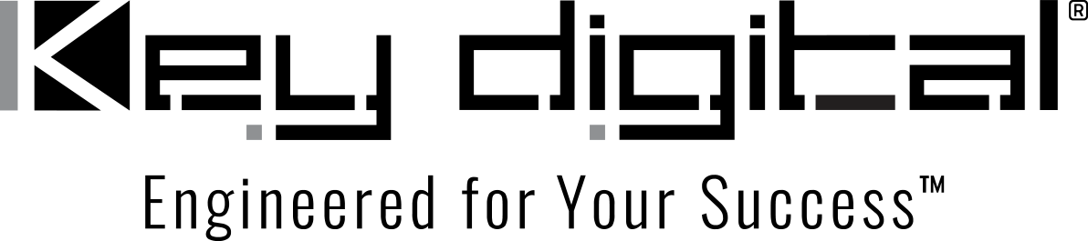

Contacts:

Key Digital

Masha Lakhter, COO

917.701.3238

masha@keydigital.com

Clyne Media, Inc.

Frank Wells, Senior Account Manager

615.585.0597

frank.wells@clynemedia.com

Key Digital enables collaboration infrastructure for e|spaces

— The KD-BYOD4K Wireless Presentation gateway is the technological backbone for content sharing by e|spaces clients seeking collaborative workspaces ranging from conference rooms to huddle rooms, with additional Key Digital hardware and software solutions facilitating cost-effective yet sophisticated presentation solutions and video wall displays throughout e|spaces locations —

MOUNT VERNON, NY, March 29, 2022 – e|spaces is a thriving company that provides meeting rooms along with coworking or private and collaborative office spaces tailored to a work-from-home and scaled-down corporate work paradigm in Tennessee (with five Nashville-area locations as well as facilities in Knoxville and Chattanooga) and in Orlando, Florida. Beyond mere space and furniture, e|spaces provides entrepreneurs, small businesses and corporate teams a sophisticated technological infrastructure including WiFi, IT support, flat-screen monitors and conference and collaboration hardware. Nashville-based workspace technology specialists Cabling Innovations, which performed the majority of e|spaces installations, has introduced solutions from Key Digital – a leading innovator in AV over IP solutions – into e|spaces huddle rooms, podcast production suites and conference rooms.

“Key Digital offers a lot of great products that make our job a lot easier,” says Cabling Innovations A/V manager Jameson Christian. Along with Key Digital encoders/decoders, HDMI and USB over CAT extenders and video processors, e|spaces facilities ubiquitously utilize Key Digital’s KD-BYOD4K Wireless Presentation Gateway to cost-effectively facilitate collaboration through a Bring Your Own Device motif that allows meeting participants to easily share up to four simultaneous content streams from laptops, tablets and phones running on Windows, Mac OSX, Chrome OS, iOS, Android OS or supporting Chromecast.

Christian remarks, “The BYOD has been such a blessing for a lot of different reasons. It’s user-friendly. There are no devices on the table that you have to connect with and the video quality is uncanny. That it’s nearly less than half the price of a less capable competitive device helps sell our customers on them.” Christian also points out that, as the BYOD serves as a network host, the customer’s internal network is securely out of reach of meeting participants, yet they can still access the internet through the gateway.

After Christian and his team installed KD-BYOD4Ks in their first e|spaces installation, he says, “I kept getting calls back from the owner saying, ‘This thing is awesome.’ For the latest e|spaces project we needed 20 more of them; the owner wants them all over his facilities.”

Christian says that there’s little need for tech support with the KD-BYOD4K. With Chromecast and iOS devices, native support means just a swipe mirrors a device to a flat screen or projected display with no software download at all. “Since we’ve installed them, they’ve had nothing but success. Not all TVs work with all different devices, but with the BYOD, anybody can literally walk in with any type of device they want to connect.”

Cabling Innovations has also installed a Key Digital-enabled video wall for e|spaces, incorporating nine 55-inch bezel-less LG televisions. With Key Digital’s Compass Control® Pro software on an iPad, Christian shares, e|spaces can control the video wall and more straight from the tablet. He also gives high marks to Key Digital’s support team: “Every time we reach out to Key Digital for support, they’ve always got our back.”

Key Digital signal extenders also play an important role in Cabling Innovations’ installations for e|spaces, reducing cabling costs and facilitating longer cable runs than possible with native signal cables. “Key Digital,” says Christian, “has saved me a lot of headache, a lot of manpower, and a lot of valuable time with their products.”

“The system is so easy to use once it’s implemented,” Christian concludes. “I get excited to know that the client’s happy with the product that they bought and that they don’t have buyer’s remorse on anything.”

For more information:
Key Digital
KD-BYOD4K
e|spaces
Cabling Innovations

…ends 572 words

Photo File 1: espaces_BYOD4K.jpg
Photo Caption 1: e|spaces collaborative professional workspaces ubiquitously utilize Key Digital’s KD-BYOD4K Wireless Presentation Gateway (shown here tucked behind a video display) to cost-effectively and intuitively enable presentations from any participant’s device

Photo File 2: espaces-screen.jpg
Photo Caption 2: The start-up screen of Key Digital’s KD-BYOD4K Wireless Presentation Gateway (shown here on an e|spaces meeting room video display) guides meeting participants through the simple connection for content sharing in up to four simultaneous windows

Photo File 3: KD-BYOD4K front.jpg
Photo Caption 3: Key Digital’s KD-BYOD4K Wireless Presentation Gateway is a cost-effective and intuitive content sharing solution. Meeting participants can share content easily as well as gain internet access through the portal while allowing facilities to maintain security of their internal networks

About Key Digital:
Established in 1999, Key Digital® designs and engineers intuitive digital A/V connectivity and control solutions that embody excellence. Key Digital delivers reliable, superior-quality, easily-implemented, versatile, high-performance products for corporate, education, government, house-of-worship, bar & restaurant, digital signage and residential A/V applications.

Founded by innovator Mike Tsinberg, holder of over 40 digital video and HDTV patents, Key Digital designs and engineers its products in-house at its USA headquarters in Mount Vernon, New York. The result of meticulous research, development and testing, Key Digital products showcase the company’s extensive, unparalleled technical knowledge and expertise, as well as its market-driven approach, serving as a partner to consultants, designers, and system integration firms in the A/V industry. Key Digital works as its clients’ extended engineering team, developing customized solutions for specific applications. Key Digital is an lnfoComm, CEDIA, CES, and NAHB award-winning manufacturer.

Key Digital, Engineered For Your Success™

For more information, visit our webpage at www.keydigital.com.

Follow Key Digital on social media:

