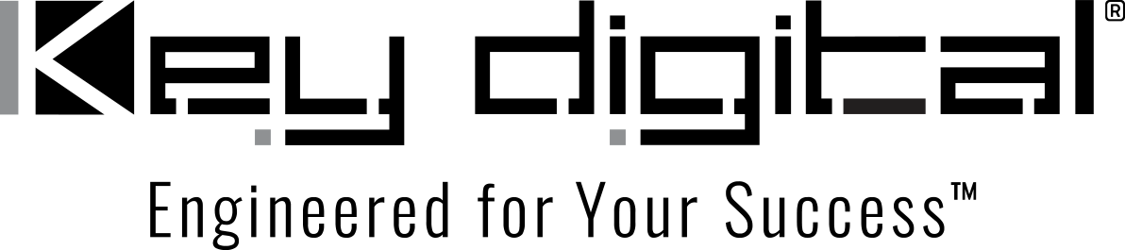

Contacts:

Key Digital

Masha Lakhter, COO

917.701.3238

masha@keydigital.com

Clyne Media, Inc.

Frank Wells, Senior Account Manager

615.585.0597

frank.wells@clynemedia.com

Key Digital’s “Conference Room In A Box” Employed for the Springs Close Foundation

— Non-profit aimed at regional support of South Carolina’s textile industry workers’ heritage has two conference rooms that are now ready to roll at the touch of a single button, thanks to Key Digital’s complete solution for meeting and presentation spaces —

MOUNT VERNON, NY, April 12, 2022 – The Springs Close Foundation, Inc., was established in 1942 by Colonel Elliott White Springs, a WWI flying ace who succeeded his father, Leroy Springs, as the head of Springs Industries, a cotton-textile company founded in 1887 that grew into an emblem of Fort Mill, South Carolina’s textile industry. Colonel Springs established the Springs Foundation to care for and support the company’s workers, their families, and the communities in which they lived, and it continues to do so today. Its offices in Fort Mill have two conference spaces: the Executive Conference Room in the main building, which seats up to a dozen meeting participants, and a second, larger space, named for the 19th-century carriage house in which it resides on the Springs Close Foundation property there, able to seat up to 18 people.

However, those meeting spaces hadn’t kept up with the times. “There were some AV products in them but they weren’t truly integrated,” explains Mike Hinson, President of Palmetto Audio & Video, based in York County, which contains Fort Mill. “For instance, they had to use different remote controls to access and operate different components of their meeting systems. It was cumbersome to use. They wanted something that was simpler but was also flexible and very reliable. That describes Key Digital’s Conference Room In A Box perfectly.”

In January, Palmetto Audio & Video installed and integrated a Conference Room In A Box (CRB) system composed of a KD-CAMUSB PTZ USB camera, a KD-X4x1WUTx 4x1 wall plate switcher, one KD-UPS52U 5-input universal presentation switcher, and a KD-CX800 Compass Master controller with Key Digital’s Compass Control software on an Apple iPad used as the system control device. The CRB systems deployed in both conference rooms also integrate the ClearOne speakerphone units recommended by Key Digital, as well as Samsung flat-panel displays (a 75-inch screen in the Executive Conference Room and a 65-inch in the carriage house). Palmetto AV also utilized Key Digital Cat-6 cabling and HDMI interconnections, which gave both conference rooms a complete Key Digital infrastructure and made it ready to interface with Microsoft Teams, Zoom and Skype. “We’ve been using Key Digital products since we opened in 2008, and they’ve been superb in every way,” says Hinson. “They have a great track record when it comes to AV, and when it comes to conferencing systems, they’ve figured that out with the CRB. It’s everything you need to give a client an excellent conference AV experience.”

The outcome for meeting participant and leaders was everything they’d hoped for. “They’re absolutely thrilled with it,” he says. “The Compass Control software is easy and intuitive to run; even guest presenters who’ve never used it before are at home on it in minutes. And another benefit is that the CRB has freed up their IT staff — they no longer need someone on hand to start meetings or connect input devices. Every meeting participant has everything they need to connect right at their seat. Their IT staff are now available to handle other important things. It’s been the answer they’d been looking for all along.”

For more information:
Key Digital
…ends 516 words

Photo File 1: Springs_Close.jpg
Photo Caption 1: Springs Close Foundation’s carriage house conference room was Palmetto Audio & Video installed and integrated a Conference Room In A Box (CRB) system composed of a KD-CAMUSB PTZ USB camera, a KD-X4x1WUTx 4x1 wall plate switcher, one KD-UPS52U 5-input universal presentation switcher, and a KD-CX800 Compass Master controller running Key Digital’s Compass Control software on an Apple iPad used as the system control device.

About Key Digital:
Established in 1999, Key Digital® designs and engineers intuitive digital A/V connectivity and control solutions that embody excellence. Key Digital delivers reliable, superior-quality, easily-implemented, versatile, high-performance products for corporate, education, government, house-of-worship, bar & restaurant, digital signage and residential A/V applications.

Founded by innovator Mike Tsinberg, holder of over 40 digital video and HDTV patents, Key Digital designs and engineers its products in-house at its USA headquarters in Mount Vernon, New York. The result of meticulous research, development and testing, Key Digital products showcase the company’s extensive, unparalleled technical knowledge and expertise, as well as its market-driven approach, serving as a partner to consultants, designers, and system integration firms in the A/V industry. Key Digital works as its clients’ extended engineering team, developing customized solutions for specific applications. Key Digital is an lnfoComm, CEDIA, CES, and NAHB award-winning manufacturer.

Key Digital, Engineered For Your Success™

For more information, visit our webpage at www.keydigital.com.

Follow Key Digital on social media:

