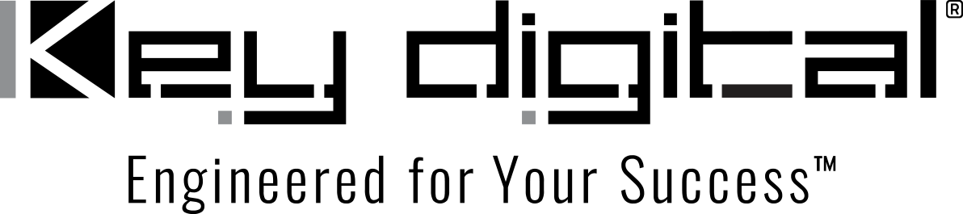

Contacts:

Key Digital

Masha Lakhter, COO

917.701.3238

masha@keydigital.com

Clyne Media, Inc.

Frank Wells, Senior Account Manager

615.585.0597

frank.wells@clynemedia.com

Key Digital appoints KLM Marketing as Manufacturer’s Rep for the Middle Atlantic region

MOUNT VERNON, NY, October 11, 2022 – Key Digital®, an award-winning developer and manufacturer of leading-edge digital video processing and video signal distribution solutions, has appointed Mechanicsville, VA-based firm KLM Marketing as its manufacturer’s rep for the Middle Atlantic region, including Maryland, Virginia, Delaware, Eastern PA, Southern NJ and Washington, D.C. The announcement was made by DeWayne Rains, Key Digital vice president of sales, and represents the brand’s ongoing initiative to expand its national sales force.

Established in 2002, KLM is a leading choice for video and intercom, access control, and new AV solutions in the mid-Atlantic region. They offer system design, sales/technical training, and site visits and strive for total customer support by working closely with end users to fit their needs with a solid solution.

Key Digital now joins KLM Marketing’s roster of brands, which also includes Alpha Communications, Axton, FLIR, KBC, TOA and VMP. Firm principals Paul Walter and Rob Leiggi will be joined by a dedicated team of sales personnel in promoting Key Digital’s products to the burgeoning market in these regions.

“When looking to better serve the mid-Atlantic region,” remarks Rains. “KLM Marketing was the obvious rep firm to partner with. They share our passion for providing effective solutions to end-user needs and a well-earned reputation for unsurpassed customer support.”

“Great technology is just a start to meeting customer needs,” adds KLM Marketing Sales Manager Rob Leiggi.” Reliability, cost-effectiveness, ease of use and the support infrastructure to ensure customer satisfaction are also critical elements. We are confident that Key Digital’s innovative product line and their willingness to go the extra mile with tailored solutions will be embraced by our customers and look forward to working together.”

For more information:
Key Digital
KLM Marketing

…ends 274 words

Photo File 1: Rob_Leiggi.jpg
Photo Caption 1: Rob Leiggi, KLM Marketing

Photo File 2: klm_logo.jpg
Photo Caption 2: KLM Marketing logo

About Key Digital:
Established in 1999, Key Digital® designs and engineers intuitive digital A/V connectivity and control solutions that embody excellence. Key Digital delivers reliable, superior-quality, easily-implemented, versatile, high-performance products for corporate, education, government, house-of-worship, bar & restaurant, digital signage and residential A/V applications.

Founded by innovator Mike Tsinberg, holder of over 40 digital video and HDTV patents, Key Digital designs and engineers its products in-house at its USA headquarters in Mount Vernon, New York. The result of meticulous research, development and testing, Key Digital products showcase the company’s extensive, unparalleled technical knowledge and expertise, as well as its market-driven approach, serving as a partner to consultants, designers, and system integration firms in the A/V industry. Key Digital works as its clients’ extended engineering team, developing customized solutions for specific applications. Key Digital is an lnfoComm, CEDIA, CES, and NAHB award-winning manufacturer.

Key Digital, Engineered For Your Success™

For more information, visit our webpage at www.keydigital.com

Follow Key Digital on social media:

