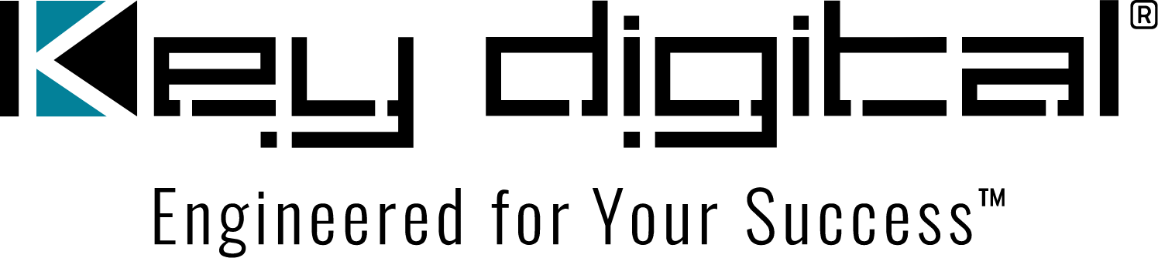

Contacts:

Key Digital

Masha Lakhter, COO

917.701.3238

masha@keydigital.com

Clyne Media, Inc.

Frank Wells, Senior Account Manager

615.585.0597

frank.wells@clynemedia.com

Key Digital® upgrades European distribution and support center

— Key Digital’s expanded Norway-based distribution, tech support and logistics center, along with a redesigned Key Digital Europe website, will serve its growing list of distributors and customers across the continent —

MOUNT VERNON, NY, January 25, 2024 – To better support the growth of its partners across Europe with additional product stock, contacts and resources from within local time zones, Key Digital®, an award-winning developer and manufacturer of leading-edge digital video processing and AV signal distribution solutions, has announced the expansion of its Key Digital Europe affiliate’s distribution, tech support and logistics center in Norway, along with a redesign of the Key Digital Europe website.

“The upgrades to the Key Digital Europe distribution hub will provide our European distributors and customers with rapid response product support and faster delivery of Key Digital hardware,” says Mike Tsinberg, Key Digital founder and president. “Our European footprint has grown to include distributors in Italy, Poland, Finland, Sweden, Malta, Slovakia, and Luxembourg, as well as in Norway where our Key Digital Europe affiliate company is located. The resources available through the facility updates, along with a fresh, modern redesign of the Key Digital Europe website, will provide a foundation for expanded growth throughout Europe as we seek to add additional regional distributors.”

Key Digital will be at ISE 2024 in Barcelona to meet with its European customers, and distributors, and to build new relationships. Key Digital staff on hand in Barcelona will demonstrate how AV integrators can solve common problems and cost-effectively build sophisticated AV systems that are easy to deploy and operate using solutions from its comprehensive line of unified communications and collaboration, AV over IP, digital video processing and switching, connectivity, and control products.

Key Digital Europe will be offering a 10% discount for purchases made through February to any customers (current or new) who get their ISE badge scanned at ISE 2024 booth 2P500. Free exhibits passes to ISE 2024 are available from a link on the Key Digital Europe website’s home page.

For more information:
Key Digital Europe: https://www.keydigitaleurope.com/
Email: sales@keydigitaleurope.com
Tel + 47 90 25 01 00
…ends 310 words

Photo File 1: DeWayne_Maik.jpg
Photo Caption 1: At ISE 2023, Key Digital Vice President of Sales DeWayne Rains and Key Digital Europe CEO Maik Maagerø demonstrate the automatic voice-tracking camera capabilities of the LeCAMbio Conferencing Systems developed in partnership with TOA Electronics

Photo File 2: KeyDigital_ISE23.jpg
Photo Caption 2: Key Digital will be putting smiles on booth visitors’ faces as they demonstrate how its AV solutions solve real-world problems and share a 10% discount with attendees at ISE 2024 (Key Digital Vice President of Product Education & Experience Jonathon Ferry [center] is shown with booth attendees at ISE 2023)

About Key Digital:
Established in 1999, Key Digital® designs and engineers intuitive digital A/V connectivity and control solutions that embody excellence. Key Digital delivers reliable, superior-quality, easily-implemented, versatile, high-performance products for corporate, education, government, house-of-worship, bar & restaurant, digital signage and residential A/V applications.

Founded by innovator Mike Tsinberg, holder of over 40 digital video and HDTV patents, Key Digital designs and engineers its products in-house at its USA headquarters in Mount Vernon, New York. The result of meticulous research, development and testing, Key Digital products showcase the company’s extensive, unparalleled technical knowledge and expertise, as well as its market-driven approach, serving as a partner to consultants, designers, and system integration firms in the A/V industry. Key Digital works as its clients’ extended engineering team, developing customized solutions for specific applications. Key Digital is an lnfoComm, CEDIA, CES, and NAHB award-winning manufacturer.

Key Digital®, Engineered for Your Success™

For more information, visit our webpage at www.keydigital.com.

Follow Key Digital on social media:

