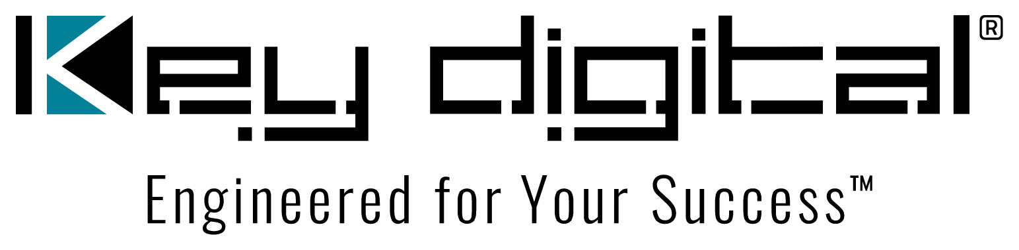

Contacts:

Key Digital

Masha Lakhter, COO

917.701.3238

masha@keydigital.com

Clyne Media, Inc.

Frank Wells, Senior Account Manager

615.585.0597

frank.wells@clynemedia.com

Key Digital shows AV solutions at CEDIA Tech Summit Toronto

— Key Digital shared its latest innovations, including the debut of the KD-4KWHCEX wireless HDMI extender kit, as well as mainstay products from its comprehensive line of solutions for unified communications and collaboration, AV over IP, digital video processing, switcher, connectivity and control during CEDIA Tech Summit Toronto in September 2023 —

MOUNT VERNON, NY, October 24, 2023 – Key Digital, an award-winning developer and manufacturer of leading-edge digital video processing and video signal distribution solutions, visited with both new and established Canadian customers at the CEDIA Tech Summit Toronto, a trade-only one-day event held Thursday, September 28, at the Parkview Manor in Toronto, Canada. “We packed an impressive eight working demos on a single six-foot table,” says Jonathon Ferry, Key Digital VP of Product Education & Experience. CEDIA Tech Summit Toronto attendees “were given an intimate tour focusing on their core application needs across residential and commercial AV,” adds Key Digital VP of Sales DeWayne Rains.

“The star of the show was the KD-4KWHCEX wireless HDMI extender kit, which made its debut at the CEDIA Tech Summit,” shares Ferry. “We had the kit’s receiver at our demo area, and attendees were able to verify the extreme distance the KD-4KWHCEX covered by walking to the far corner of the exhibit floor where the HDMI source computer was feeding the kit’s transmitter.”

Additional products on display included a 4K AV over IP video distribution system with native video wall processing based on the KD-IP922ENC-II HDMI to IP encoder and KD-IP922DEC-II IP to HDMI decoder; the KD-MLV4x4Pro multi-view video processor demonstrating how simple and affordable a sports bar can display four sporting events on a single screen; the KD-BYOD4K wireless presentation gateway for intuitive content sharing for devices using Windows, Mac, iOS, Android and Chrome operating systems; the KD-CamUSB 1080p PTZ webcam, the KD-WP8-2 8 Button Programmable IP, RS-232, IR Control Keypad which packs enormous control capability into a single-gang wall plate device; the free KD-App iOS control platform that auto-scans a shared IP network to deliver a programming-free user interface for controlling discovered Key Digital app-ready devices and systems via a pre-built UI including customized system, source and display naming, and, depending on the system, video wall control, source and displays IR control panels, and PTZ camera control; and the KD-PS42 four input x 2 mirrored output HDBaseT HDMI Presentation Switch for conference spaces.

“We’re taking pre-orders now for the KD-4KWHCEX wireless extender kit,” says Rains, “and all other existing products are shipping from stock.”

For more information:
Key Digital
KD-4KWHCEX wireless HDMI extender kit
AV over IP solutions
KD-MLV4x4Pro multi-view tiling video processor matrix
KD-BYOD4K wireless presentation gateway
KD-CamUSB 1080p PTZ webcam
KD-WP8-2 8 button programmable keypad
KD-PS42 4x2 mirrored output presentation switch

…ends 396 words

Photo File 1: CEDIA_Tech_Summit_Toronto.jpg
Photo Caption 1: Jonathon Ferry, Key Digital VP of Product Education & Experience (left), and DeWayne Rains, Key Digital VP of Sales, were on hand at the CEDIA Tech Summit Toronto in September to share the latest innovations from the award-winning manufacturer’s line of leading-edge digital video processing and video signal distribution solutions

About Key Digital:
Established in 1999, Key Digital® designs and engineers intuitive digital A/V connectivity and control solutions that embody excellence. Key Digital delivers reliable, superior-quality, easily-implemented, versatile, high-performance products for corporate, education, government, house-of-worship, bar & restaurant, digital signage and residential A/V applications.

Founded by innovator Mike Tsinberg, holder of over 40 digital video and HDTV patents, Key Digital designs and engineers its products in-house at its USA headquarters in Mount Vernon, New York. The result of meticulous research, development and testing, Key Digital products showcase the company’s extensive, unparalleled technical knowledge and expertise, as well as its market-driven approach, serving as a partner to consultants, designers, and system integration firms in the A/V industry. Key Digital works as its clients’ extended engineering team, developing customized solutions for specific applications. Key Digital is an lnfoComm, CEDIA, CES, and NAHB award-winning manufacturer.

Key Digital, Engineered For Your Success™

For more information, visit our webpage at www.keydigital.com.

Follow Key Digital on social media:

