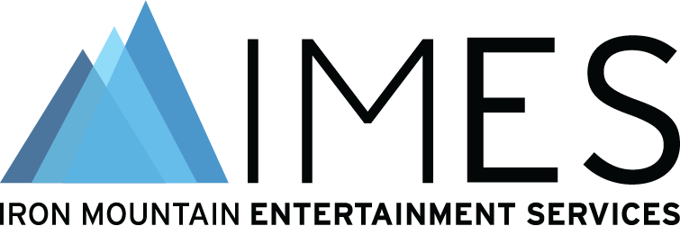

Iron Mountain Entertainment Services has strong presence at AES audio archiving event
June 23, 2023 – Pictured L-R: Robert Koszela (Director, Studio Operations North America, Iron Mountain Entertainment Services [IMES]), Nick Allen (Vice President of Asset & Archive Management, Universal Music Group), Meg Travis (Director, Global Head of Marketing & Communications, IMES), and Alex Tomlin (Senior Engineering Manager, IMES) gather at the U.S. Library of Congress National Audio-Visual Conservation Center in Culpeper, Virginia, for the for the 2023 AES Audio Archiving, Preservation and Restoration Conference. IMES played a key role throughout the three-day event, serving as the Platinum Sponsor as well as contributing to two of the Conference’s featured events, including sessions outlining their newly developed IMES Automated Media Capture System workflows for metadata and on furthering education and innovation among the next generation of audio archivists.

###

Media Contacts
Meg Travis / Iron Mountain Entertainment Services / 617-535-8366 / Margaret.Travis@ironmountain.com
Robert Clyne / Clyne Media, Inc. / 615.662.1616 / robert@clynemedia.com

