Revered supergroup The Immediate Family shares new song “Whole Lotta Rock and Roll” from their forthcoming studio album Skin In The Game, out on February 16, 2024

– New album available for pre-order on December 15 –

– Immediate Family documentary in theaters nationwide today for a one-night-only event and available everywhere on December 15, 2023 –

– Listen to “Whole Lotta Rock and Roll” here –

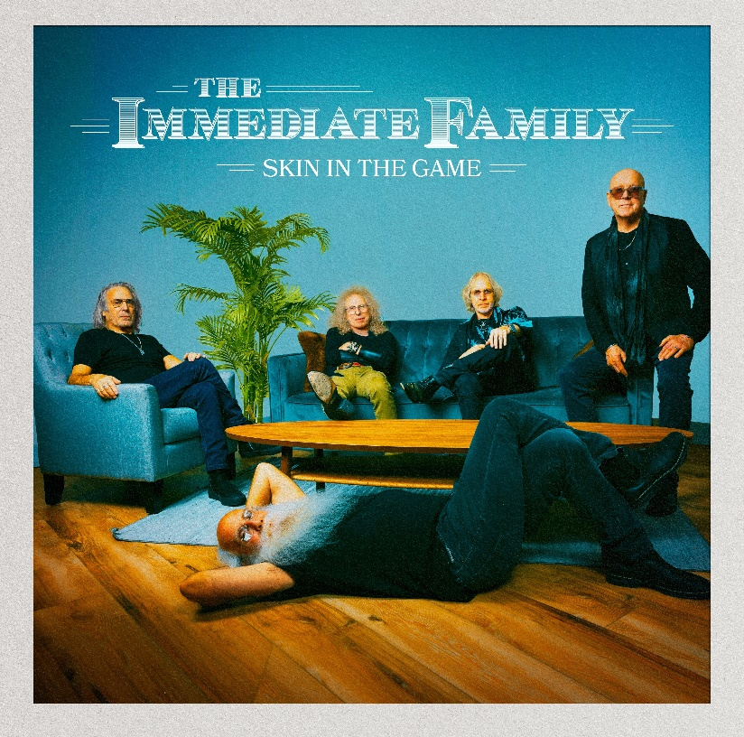

Download hi-res cover art – photo by Jay Gilbert/Chris Schmitt – Cover artwork by Brian Porizek

December 12, 2023 – With their forthcoming new studio album, Skin In The Game (Quarto Valley Records), legendary musicians The Immediate Family take another step forward in a collective career that solidifies their stature as a renowned supergroup in the truest form. Today, the band shares the lead track, appropriately titled “Whole Lotta Rock and Roll.”

Written and sung by Waddy Wachtel, “Whole Lotta Rock and Roll” effectively encapsulates the mantra this remarkable band has pursued individually and collectively. It’s a song that exudes the power and passion that typify the band’s ongoing devotion to an essential sound these musicians have furthered and formulated so well. An uncompromising example of both frenzy and finesse, this robust rocker lives up to its title courtesy of its determined delivery.

LISTEN TO THE SONG HERE.

“‘Whole Lotta Rock and Roll’ came to me in a dream,” states Wachtel. “I was sitting with Bon Scott backstage at an AC/DC concert. It was incredible. I was having the best time just talking to Bon, when all of a sudden, my dog’s cold nose touched my back and woke me up. I shouted, ‘Oh no!’ and then instantly grabbed my guitar and started writing. The song came pouring out of me. It went from a pure rock ‘n’ roll dream to a whole song before breakfast.”

Produced by the band themselves, Skin In The Game’s fourteen tracks showcase the remarkably versatile musical skills possessed by all five members of The Immediate Family: singer/songwriter/guitarists Danny Kortchmar, Waddy Wachtel and Steve Postell, and one of the most celebrated rhythm sections in rock history, Russ Kunkel and Leland Sklar.

Skin in the Game will be released worldwide on February 16, 2024, via Quarto Valley Records and is available for pre-order starting December 15.

The album’s thirteen original tracks and one cover tune, “The Toughest Girl in Town,” exuberantly careen from funky rockers such as “24/7/365,” “Confusion” and “Lost in the Shuffle” to gentler numbers, such as “Fragile Heart” and “Catch You on the Other Side.” On “Looking Away,” they effortlessly build the emotional drama by shifting from restrained acoustic guitars to a blast of electric guitar fury. Similarly, the band’s satiric edge can slide from the dark side on “Party at the Graveyard” to the lighter-hearted fun of “High Maintenance.” Sklar and Kunkel’s subtly profound ways of building and holding down a song’s foundation are present throughout Skin In The Game. The album’s title track begins with Kunkel’s drumbeat, complemented by Sklar’s sonorous bass. Together, they bring a gravitas that supports the song’s message that life isn’t just about the money; you need to have heart, soul, pride, and be willing to risk everything – “skin in the game.” The second single, the album’s title track, “Skin In The Game,” will be released in January 2024.

The tight-knit quintet (Danny Kortchmar, Waddy Wachtel, Russ Kunkel, Leland Sklar and Steve Postell) initially rose to prominence working with some of rock’s biggest names, such as Keith Richards, Linda Ronstadt, James Taylor, Carole King, Jackson Browne, Stevie Nicks, Don Henley, Billy Joel, David Crosby and Joni Mitchell, to name a few – but now they have reinforced their own identity as The Immediate Family.

The band’s unique, decades-long musical journey is the subject of the full-length documentary, Immediate Family, by acclaimed filmmaker Denny Tedesco (director of The Wrecking Crew). The film tracks the rise and collaborations of this group of legendary studio musicians Danny Kortchmar, Waddy Wachtel, Russ Kunkel and Leland Sklar, through the 1970s and onward, spotlighting their prestigious partnerships and their indelible mark that helped define the sound of a generation. Immediate Family is a backstage tour of rock history, featuring intimate interviews with the band members, as well as memorable stories from some of music’s most iconic performers including Carole King, James Taylor, Linda Ronstadt, Neil Young, Keith Richards, Don Henley, Stevie Nicks, David Crosby, Jackson Browne, Lyle Lovett and Phil Collins.

Released by Magnolia Pictures, Immediate Family is in theaters nationwide today for a special one-night screening and will be available everywhere on December 15.

Watch the Official Trailer Now

https://www.immediatefamilyfilm.com/.

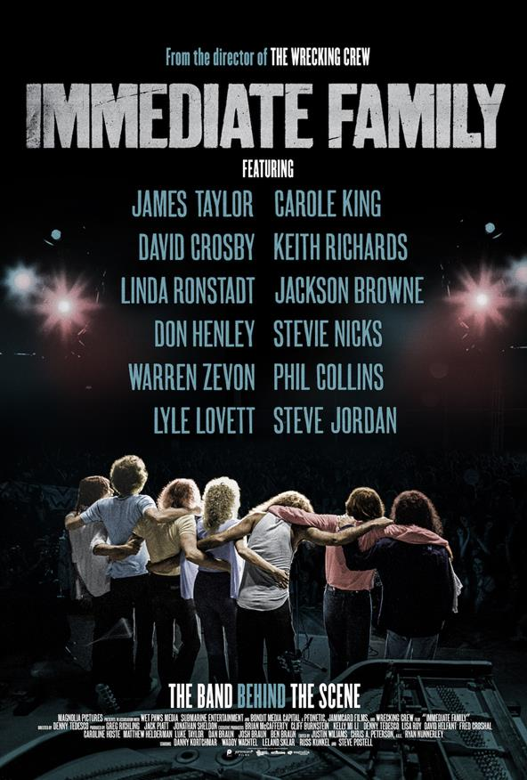
With Skin In The Game, The Immediate Family, managed by industry veterans Fred Croshal and David Helfant, have tapped into their magical connection and created a stunning collection of songs.

For more information on The Immediate Family, visit www.immediatefamilyband.com.

Follow The Immediate Family on social media:

Website Facebook Twitter.X instagram Spotify

Download press materials – photo credit: Jay Gilbert/Chris Schmitt

For promo album links contact:
Lucy Sabini – lucy.sabini@luciamediagroup.com – 917-864-0060
Robert Clyne – robert@clynemedia.com – 615-300-4666

About The Immediate Family
The Immediate Family (the modern iteration of a legendary studio ensemble known as “The Section”) is a unique group of iconic musicians composed of four of the most recorded, respected, and sought-after players in modern music: Danny Kortchmar (guitar and vocals), Waddy Wachtel (guitar and vocals), Leland Sklar (bass), Russ Kunkel (drums) and the addition of prominent touring, session guitarist and songwriter Steve Postell (guitar and vocals). Frequent collaborators both in the studio and on stage, their work can be heard on albums from Jackson Browne, James Taylor, Linda Ronstadt, Stevie Nicks, Keith Richards, Warren Zevon, Graham Nash, Neil Young, David Crosby, and many, many more. Kortchmar, Sklar, and Kunkel have worked together since the early ‘70s and made up three-quarters of The Section, best known for both their studio and live work in support of some of the top-selling singer/songwriters and solo singers in the history of music, as well as their acclaimed instrumental albums. (By the mid-70s, they were later joined by Wachtel). Collectively, these musicians helped define the sound of a generation.

About Quarto Valley Records
Founded by tech entrepreneur Bruce Quarto, the California-based independent label Quarto Valley Records represents Rock, Blues, Jazz and Americana genres with an impressive artist roster featuring legacy musicians Paul Rodgers, GRAMMY® award-winning Edgar Winter and Savoy Brown as well as the legendary talent that comprises The Immediate Family, GRAMMY® award-winning producer and renowned drummer and songwriter Tom Hambridge, GRAMMY® award-winning producer and percussionist Narada Michael Walden, blues-rock artist Sean Chambers, British blues sensation Bonham-Bullick, Wings member Denny Seiwell, acclaimed Americana singer-songwriter Al Staehely, the esteemed and soulful Richard T. Bear, and emerging artist Dominic Quarto. https://quartovalleyrecords.com.

Visit Quarto Valley Records on its social media pages: Facebook Twitter Instagram

Photo file 1: SKIN_IN_THE_GAME_COVER.JPG
Photo caption 1: Cover art for Skin In The Game. Photo by Jay Gilbert/Chris Schmitt. Cover artwork by Brian Porizek

Photo file 2: WholeLottaRockAndRoll_YouTube.JPG
Photo caption 2: Listen to “Whole Lotta Rock and Roll” at https://www.youtube.com/watch?v=shDn2Cvh0XA

Photo file 3: IF_DocumentaryPosterGraphic.JPG
Photo caption 3: Promotional graphic for the new documentary Immediate Family

Photo file 4: TIF_PRESS-1.JPG
Photo caption 4: The Immediate Family. Photo credit: Jay Gilbert/Chris Schmitt

