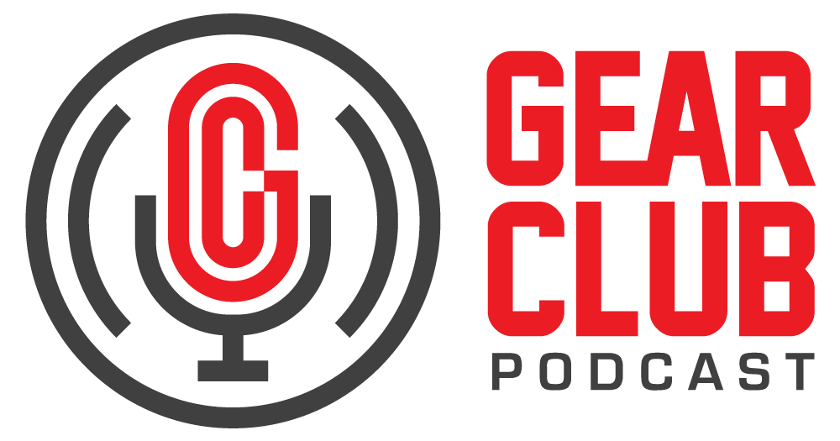

Press Release
Contact: Frank Wells
frank.wells@clynemedia.com
Tel: (615) 585-0597

FOR IMMEDIATE RELEASE

Gear Club Podcast #92 features conversation with renowned rock photographer Bob Gruen

New York, NY, October 23, 2023 — The latest episode of Gear Club Podcast, featuring a conversation with renowned rock photographer Bob Gruen, is now live online at https://www.gear-club.net/episodes/92-bob-gruen. Titled “Capturing the Passion with Bob Gruen,” the episode is an intimate sitdown with Gruen, who breaks down his long and storied career.

For decades, Gruen has documented the artists, concerts and clubs that have come to define rock music, and is responsible for some of the most iconic images of the idiom. In his over-50-year career, he has photographed the likes of Elvis Presley, John Lennon, Led Zeppelin, Frank Zappa, Harry Nilsson, The Rolling Stones, The Clash, The Who and so many others. In this episode, Gruen talks with Gear Club hosts Stewart Lerman and John Agnello about his artistic philosophy, his move from film to digital, his intimate relationship with John Lennon and Yoko Ono, and what it’s been like being on the other side of the camera as he captured and documented music history for more than 50 years in photographs that have garnered the world’s attention. For more on Bob’s life and work, read his autobiography “Right Place, Right Time: The Life Of A Rock & Roll Photographer,” available wherever books are sold.

Gear Club Podcast Episode 92: “Capturing the Passion with Bob Gruen” is available via most podcast apps, including Apple Podcasts, Google, Spotify and SoundCloud, and at gearclubpodcast.com.

Gear Club Podcast provides an in-depth, and sometimes irreverent, look into the world of audio recording with stories told by leading practitioners of the art. The podcast is sponsored by Eventide.

Hosting Gear Club are Stewart Lerman and John Agnello. Lerman is a two-time GRAMMY®-winning music producer and recording engineer based in New York City. His music credits include Elvis Costello, Shawn Colvin, Neko Case, Sharon Van Etten, Patti Smith, The Roches, St. Vincent, Antony and the Johnsons, and David Byrne. His TV and film credits include The Life Aquatic with Steve Zissou, The Royal Tenenbaums, The Marvelous Mrs. Maisel, The Aviator, Vinyl, Cafe Society, Grey Gardens and Boardwalk Empire. Agnello’s career started at the Record Plant in New York City, where he was able to work on some legendary 80s albums by Cyndi Lauper, Aerosmith and John Mellencamp. Since then, he has worked with alt rock legends Dinosaur Jr, Sonic Youth, Son Volt and Patti Smith, and up-and-comers such as Phosphorescent, Kurt Vile and Twin Peaks.

For the complete, ever-expanding catalog of Gear Club Podcasts, featuring timeless interviews with leading artists, engineers, producers and studio pros that have drawn 50,000 subscribers, visit https://www.gear-club.net/. Gear Club Podcast episodes are also available on most podcast apps including Apple Podcasts, Google Podcasts, Spotify, Soundcloud and YouTube.

...ends 439 words

Photo File: GearClubPodcast_Gruen.jpg
Photo Caption: The latest episode of Gear Club Podcast, episode #92, “Capturing the Passion with Bob Gruen,” is now online.

Clyne Media
Email: frank.wells@clynemedia.com
Tel: 615-662-1616, Mob: 615-585-0597
Clyne Media, Inc.,
169-B Belle Forest Circle, Nashville, TN 37221;
Web: http://www.clynemedia.com

