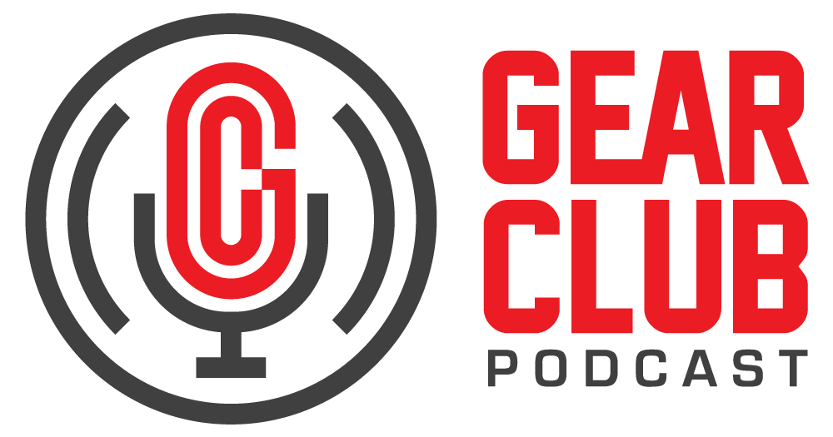

Press Release
Contact: Frank Wells
frank.wells@clynemedia.com
Tel: (615) 585-0597

FOR IMMEDIATE RELEASE

Gear Club Podcast #91 features conversation with composer, multi-instrumentalist, producer, and arranger David Mansfield

New York, NY, October 3, 2023 — The latest episode of Gear Club Podcast, featuring a conversation with composer, multi-instrumentalist, producer, and arranger David Mansfield, is now live online at https://www.gear-club.net/episodes/91-david-mansfield. Titled “The David Mansfield Multiverse,” the episode is an intimate sitdown with Mansfield, who breaks down his long and storied career.

Gear Club hosts Stewart Lerman and John Agnello have each worked with David over the years and know first-hand the talent and depth he brings to all the music he touches. Growing up in New Jersey and beginning his career in local bands, he started playing with Bob Neuwirth at The Bitter End and, at 18, joined Bob Dylan's Rolling Thunder Revue. From there, he went on to tour and record with Dylan over many albums, and in his 50-year career has worked with an endless variety of artists, including Sting, Van Morrison, Johnny Cash, Emmylou Harris, Bobby McFerrin, David Byrne, The Wainwrights, The Roches, and many more. He’s also composed an equally extensive list of music for film and television, including the movies Heaven’s Gate and The Apostle and most recently the Showtime Limited Series George & Tammy.

In this episode, David discusses his early career and influences, touring with Dylan, his scoring and composition work, and demonstrates the psaltery, one of the more unique of his many instruments.

Gear Club Podcast Episode 91: “The David Mansfield Multiverse” is available via most podcast apps, including Apple Podcasts, Google, Spotify and SoundCloud, and at gearclubpodcast.com.

Gear Club Podcast provides an in-depth, and sometimes irreverent, look into the world of audio recording with stories told by leading practitioners of the art. The podcast is sponsored by Eventide.

Hosting Gear Club are Stewart Lerman and John Agnello. Lerman is a two-time GRAMMY®-winning music producer and recording engineer based in New York City. His music credits include Elvis Costello, Shawn Colvin, Neko Case, Sharon Van Etten, Patti Smith, The Roches, St. Vincent, Antony and the Johnsons, and David Byrne. His TV and film credits include The Life Aquatic with Steve Zissou, The Royal Tenenbaums, The Marvelous Mrs. Maisel, The Aviator, Vinyl, Cafe Society, Grey Gardens and Boardwalk Empire. Agnello’s career started at the Record Plant in New York City, where he was able to work on some legendary 80s albums by Cyndi Lauper, Aerosmith and John Mellencamp. Since then, he has worked with alt rock legends Dinosaur Jr, Sonic Youth, Son Volt and Patti Smith, and up-and-comers such as Phosphorescent, Kurt Vile and Twin Peaks.

For the complete, ever-expanding catalog of Gear Club Podcasts, featuring timeless interviews with leading artists, engineers, producers and studio pros that have drawn 50,000 subscribers, visit https://www.gear-club.net/. GearClub Podcast episodes are also available on most podcast apps including Apple Podcasts, Google Podcasts, Spotify, Soundcloud and YouTube.

...ends 454 words

Photo File: GearClubPodcast_Mansfield.jpg
Photo Caption: The latest episode of Gear Club Podcast, episode #91, “The David Mansfield Multiverse,” is now online.

Clyne Media
Email: frank.wells@clynemedia.com
Tel: 615-662-1616, Mob: 615-585-0597
Clyne Media, Inc.,
169-B Belle Forest Circle, Nashville, TN 37221;
Web: http://www.clynemedia.com

