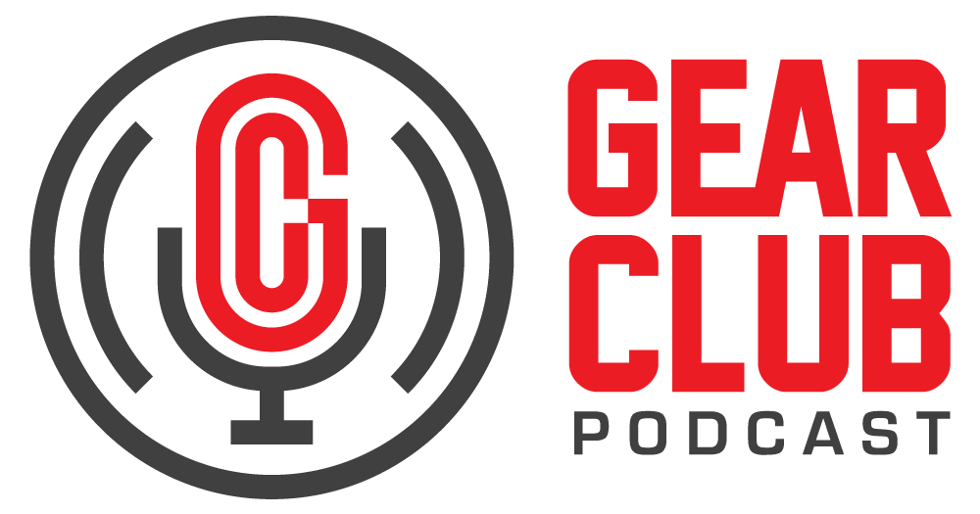

Press Release
Contact: Frank Wells
frank.wells@clynemedia.com
Tel: (615) 585-0597

FOR IMMEDIATE RELEASE

Gear Club Podcast #90 features conversation with legendary rock musician Jorma Kaukonen

New York, NY, January 30, 2023 — The latest episode of Gear Club Podcast, featuring a conversation with legendary rock musician Jorma Kaukonen, is now live online at https://www.gear-club.net/episodes/90-jorma-kaukonen. Titled “Fur Peace from Everywhere with Jorma Kaukonen,” the episode is an intimate sitdown with Kaukonen, whose long career includes time spent as electric guitarist extraordinaire for Jefferson Airplane, vocalist/blues picker for Hot Tuna, and a prolific solo artist.

At the age of 82, Jorma is still writing, teaching, and gigging with no signs of slowing down. In this episode of the podcast, hosts Stewart Lerman and John Agnello talk with Jorma about his early career playing Bay Area clubs with Janis Joplin, life in The Airplane, his guitar mentors, speedskating, touring, and holding court at his Fur Peace Ranch where he teaches and performs with guest artists who roll through. During COVID lockdown, Jorma live-streamed weekly concerts from the ranch as well.

Gear Club Podcast is available via most podcast apps and gearclubpodcast.com.

Watch on YouTube
Listen with Apple Podcasts
Listen with Spotify
Listen with Google Podcasts

Gear Club Podcast provides an in-depth, and sometimes irreverent, look into the world of audio recording with stories told by leading practitioners of the art. The podcast is sponsored by Eventide.

Hosting Gear Club are Stewart Lerman and John Agnello. Lerman is a two-time GRAMMY®-winning music producer and recording engineer based in New York City. His music credits include Elvis Costello, Shawn Colvin, Neko Case, Sharon Van Etten, Patti Smith, The Roches, St. Vincent, Antony and the Johnsons, and David Byrne. His TV and film credits include The Life Aquatic with Steve Zissou, The Royal Tenenbaums, The Marvelous Mrs. Maisel, The Aviator, Vinyl, Cafe Society, Grey Gardens and Boardwalk Empire. Agnello’s career started at the Record Plant in New York City, where he was able to work on some legendary 80s albums by Cyndi Lauper, Aerosmith and John Mellencamp. Since then, he has worked with alt rock legends Dinosaur Jr, Sonic Youth, Son Volt and Patti Smith, and up-and-comers such as Phosphorescent, Kurt Vile and Twin Peaks.

For the complete, ever-expanding catalog of Gear Club Podcasts, featuring timeless interviews with leading artists, engineers, producers and studio pros that have drawn 50,000 subscribers, visit https://www.gear-club.net/. GearClub Podcast episodes are also available on most podcast apps including Apple Podcasts, Google Podcasts, Spotify, Soundcloud and YouTube.

...ends 383 words

Photo File: GearClubPodcast_Jorma.jpg
Photo Caption: The latest episode of Gear Club Podcast, episode #90, “Fur Peace from Everywhere with Jorma Kaukonen,” is now online.

Clyne Media
Email: frank.wells@clynemedia.com
Tel: 615-662-1616, Mob: 615-585-0597
Clyne Media, Inc.,
169-B Belle Forest Circle, Nashville, TN 37221;
Web: http://www.clynemedia.com

