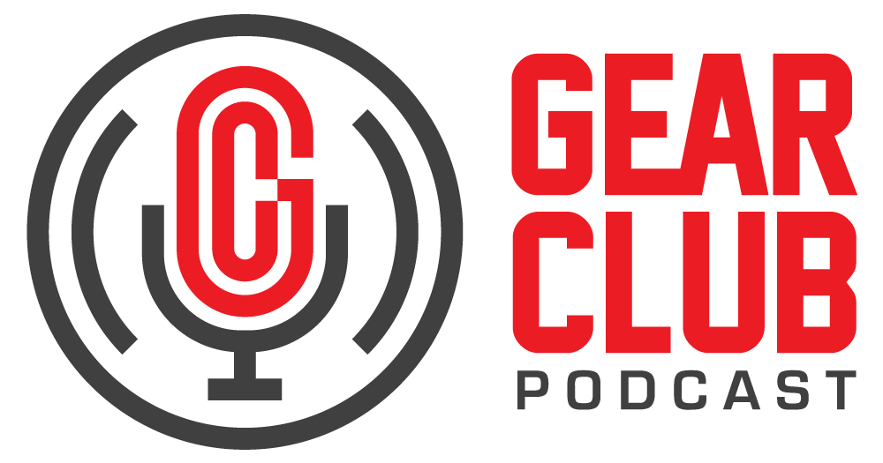

Press Release
Contact: Frank Wells
frank.wells@clynemedia.com
Tel: (615) 585-0597

FOR IMMEDIATE RELEASE

Gear Club Podcast #89 features conversation with actor, writer and musician Michael Imperioli

New York, NY, November 22, 2022 — The latest episode of Gear Club Podcast, featuring a conversation with acclaimed actor, writer and musician Michael Imperioli, is now live online at https://www.gear-club.net/episodes/89-michael-imperioli. Titled “Zen and the Art of the Power Trio,” the episode is an intimate sitdown with Imperioli, known for his Emmy award-winning run as Christopher Moltisanti on The Sopranos, as well as for his writing and music.

Since 2006, Imperioli has fronted the indie rock band Zopa, and is currently working on a new album with the podcast’s co-host John Agnello. In this episode, Imperioli talks about the parallels between acting and music performance and production, his musical influences, writing songs and screenplays, working on the new record, and whether you can know if a project is going to be a hit.

Gear Club Podcast is available via most podcast apps and gearclubpodcast.com.

Watch on YouTube
Listen with Apple Podcasts
Listen with Spotify
Listen with Google Podcasts

Gear Club Podcast provides an in-depth, and sometimes irreverent, look into the world of audio recording with stories told by leading practitioners of the art. The podcast is sponsored by Eventide.

Hosting Gear Club are Stewart Lerman and John Agnello. Lerman is a two-time GRAMMY®-winning music producer and recording engineer based in New York City. His music credits include Elvis Costello, Shawn Colvin, Neko Case, Sharon Van Etten, Patti Smith, The Roches, St. Vincent, Antony and the Johnsons, and David Byrne. His TV and film credits include The Life Aquatic with Steve Zissou, The Royal Tenenbaums, The Marvelous Mrs. Maisel, The Aviator, Vinyl, Cafe Society, Grey Gardens and Boardwalk Empire. Agnello’s career started at the Record Plant in New York City, where he was able to work on some legendary 80s albums by Cyndi Lauper, Aerosmith and John Mellencamp. Since then, he has worked with alt rock legends Dinosaur Jr, Sonic Youth, Son Volt and Patti Smith, and up-and-comers such as Phosphorescent, Kurt Vile and Twin Peaks.

For the complete, ever-expanding catalog of Gear Club Podcasts, featuring timeless interviews with leading artists, engineers, producers and studio pros that have drawn 50,000 subscribers, visit https://www.gear-club.net/. GearClub Podcast episodes are also available on most podcast apps including Apple Podcasts, Google Podcasts, Spotify, Soundcloud and YouTube.

...ends 445 words

Photo File: GearClubPodcast_Imperioli.jpg
Photo Caption: The latest episode of Gear Club Podcast, episode #89, “Michael Imperioli: Zen and the Art of the Power Trio,” is now online.

Clyne Media
Email: frank.wells@clynemedia.com
Tel: 615-662-1616, Mob: 615-585-0597
Clyne Media, Inc.,
169-B Belle Forest Circle, Nashville, TN 37221;
Web: http://www.clynemedia.com

