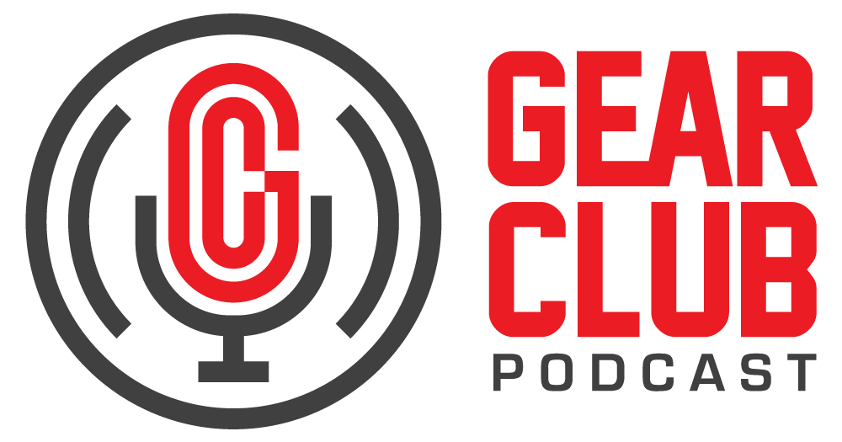

Press Release
Contact: Frank Wells
frank.wells@clynemedia.com
Tel: (615) 585-0597

FOR IMMEDIATE RELEASE

Gear Club Podcast #88 Celebrates the Legacy of John Lennon

— New episode discusses the iconic songwriter’s post-Beatles life —

New York, NY, October 7, 2022 — The latest episode of Gear Club Podcast, a special episode honoring the legacy of John Lennon, is now live online at https://bit.ly/88JohnLennon.

This new episode, Gear Club Podcast #88, celebrates the post-Beatles life of Lennon, who would have turned 82 this year on October 9. After The Beatles broke up, Lennon and Yoko Ono moved to New York, where Lennon produced, recorded, and played songs that spoke to the post-60s generation as they struggled for justice and an end to war. Lennon impacted the lives of all those he came across, and that impact continues to live on.

The episode features first-hand accounts from the producers and engineers who worked most closely with Lennon as he wrote and recorded songs from “Imagine” to “Starting Over." These people include Shelly Yakus, Jack Douglas, Rod O’Brien, Ed Stasium, Jay Messina, and Greg Calbi.

Gear Club Podcast is available via most podcast apps and gearclubpodcast.com.

Listen with Apple Podcasts
Listen with Spotify
Listen with Google Podcasts

Gear Club Podcast provides an in-depth, and sometimes irreverent, look into the world of audio recording with stories told by leading practitioners of the art. The podcast is sponsored by Eventide.

Hosting Gear Club are Stewart Lerman and John Agnello. Lerman is a two-time GRAMMY®-winning music producer and recording engineer based in New York City. His music credits include Elvis Costello, Shawn Colvin, Neko Case, Sharon Van Etten, Patti Smith, The Roches, St. Vincent, Antony and the Johnsons, and David Byrne. His TV and film credits include The Life Aquatic with Steve Zissou, The Royal Tenenbaums, The Marvelous Mrs. Maisel, The Aviator, Vinyl, Cafe Society, Grey Gardens and Boardwalk Empire. Agnello’s career started at the Record Plant in New York City, where he was able to work on some legendary 80s albums by Cyndi Lauper, Aerosmith and John Mellencamp. Since then, he has worked with alt rock legends Dinosaur Jr, Sonic Youth, Son Volt and Patti Smith, and up-and-comers such as Phosphorescent, Kurt Vile and Twin Peaks.

For the complete, ever-expanding catalog of Gear Club Podcasts, featuring timeless interviews with leading artists, engineers, producers and studio pros that have drawn 50,000 subscribers, visit https://www.gear-club.net/. GearClub Podcast episodes are also available on most podcast apps including Apple Podcasts, Google Podcasts, Spotify, Soundcloud and YouTube.

...ends 376 words

Photo File: GearClubPodcast_Lennon.jpeg
Photo Caption: The latest episode of Gear Club Podcast, episode #88, honoring the legacy of John Lennon, is now live online.

Clyne Media
Email: frank.wells@clynemedia.com
Tel: 615-662-1616, Mob: 615-585-0597
Clyne Media, Inc.,
169-B Belle Forest Circle, Nashville, TN 37221;
Web: http://www.clynemedia.com

