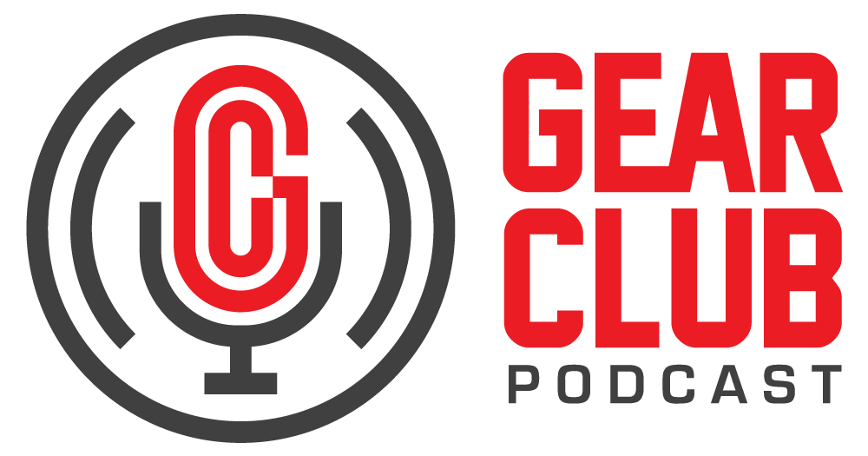

Press Release
Contact: Frank Wells
frank.wells@clynemedia.com
Tel: (615) 585-0597

FOR IMMEDIATE RELEASE

Gear Club Podcast #81: “Lucky to Be Good with Ed Stasium”

— Part two of a two-part conversation, this episode features Stasium sharing more stories from his eventful career spanning almost 50 years —

New York, NY, December 6, 2021 — The latest episode of Gear Club Podcast, “Episode 81: Lucky to Be Good with Ed Stasium,” part two of a two-part conversation, is now live at gear-club.net. Stasium’s career as a musician, engineer, and producer has spanned almost 50 years since he got his start at Tony Camillo’s New Jersey studio and went on to record Gladys Knight, The Ramones, Talking Heads, Living Colour, The Smithereens, Mick Jagger, and Motörhead, to name a few.

Listen in as Stasium tells Gear Club Podcast hosts Stewart Lerman and John Agnello how he's thankful for a drunk drummer who ended up saving him from getting aboard the ill-fated Pan Am Flight 103. For more intriguing stories, including Mick Jagger's then-partner Jerry Hall getting busted, Motörhead's obsession with a police scanner, and how having one record on his shelf got Ed the Living Colour gig, check out Part 2 of Ed Stasium's Gear Club Podcast interview.

Gear Club Podcast provides an in-depth, and sometimes irreverent, look into the world of audio recording with stories told by leading practitioners of the art. The podcast is sponsored by Eventide. Co-host Lerman is a two-time GRAMMY®-winning music producer and recording engineer based in New York City. His music credits include Elvis Costello, Shawn Colvin, Neko Case, Sharon Van Etten, Patti Smith, The Roches, St. Vincent, Antony and the Johnsons, and David Byrne. His TV and film credits include The Life Aquatic with Steve Zissou, The Royal Tenenbaums, The Marvelous Mrs. Maisel, The Aviator, Vinyl, Cafe Society, Grey Gardens and Boardwalk Empire. Gear Club’s Agnello started his career at the Record Plant in New York City, where he was able to work on some legendary 80s albums by Cyndi Lauper, Aerosmith and John Mellencamp. Since then, he has worked with alt rock legends Dinosaur Jr, Sonic Youth, Son Volt and Patti Smith, and up-and-comers such as Phosphorescent, Kurt Vile and Twin Peaks.

The complete, ever-expanding catalog of Gear Club Podcasts, featuring timeless interviews with leading artists, engineers, producers and studio pros that have drawn 50,000 subscribers, can be found at https://www.gear-club.net/. Gear Club Podcast episodes are also available on most podcast apps including Apple Podcasts, Google Podcasts, Spotify, Soundcloud and YouTube.

...ends 363 words

Photo File: EdStasium.jpeg
Photo Caption: Ed Stasium

Clyne Media
Email: frank.wells@clynemedia.com
Tel: 615-662-1616, Mob: 615-585-0597
Clyne Media, Inc.,
169-B Belle Forest Circle, Nashville, TN 37221;
Web: http://www.clynemedia.com

