EMBARGOED 11am PST - Friday 22nd January 2016

Avid and Focusrite – A future alliance in the making

Avid and Focusrite express their joint commitment to a common mission: to provide Pro Tools users with the best possible audio interface and DAW experience.

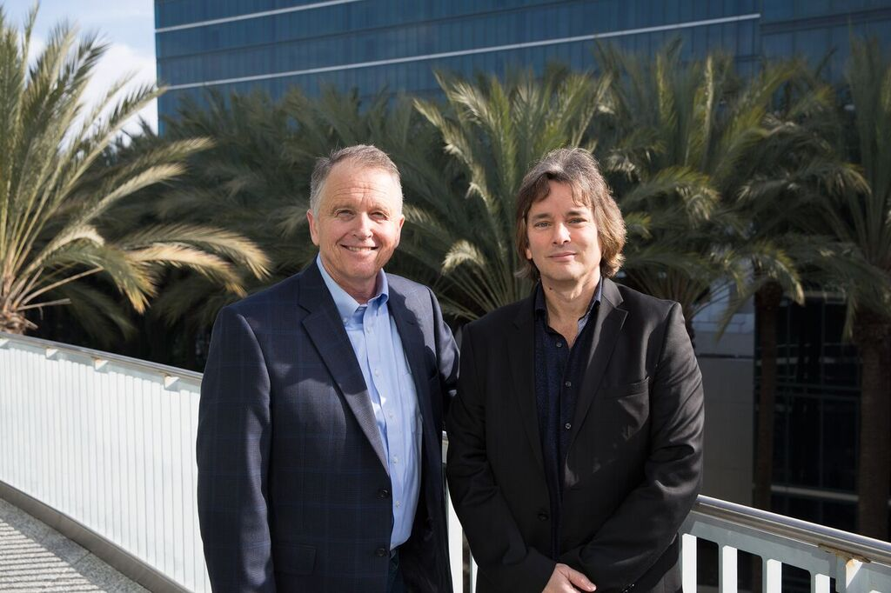

Image: Dave Froker, CEO Focusrite PLC, and Tim Carroll, VP of audio products, Avid, commit to future collaboration at NAMM 2016.

Avid® and Focusrite have a history of industry-shaping collaborations, from the world’s first plug-ins to feature a fully skeuomorphic GUI (D2 and D3), to the original Focusrite-designed Mbox® interface that brought Avid Pro Tools® software to the masses, and Control|24TM, Avid’s first mid-format console. Twenty-one years after that first collaboration, Avid and Focusrite are in deep discussions once more, the results of which they look forward to announcing soon.

As Dave Froker, CEO of Focusrite PLC, comments;

“We want to make the experience of using Focusrite hardware and Pro Tools software together the best possible experience for all our customers. Avid recognises Focusrite as an ideal companion to Pro Tools and Focusrite recognise Pro Tools as the most mature professional recording platform for new Focusrite customers to adopt.”

Focusrite are the largest manufacturer of audio interfaces in the world and their interfaces are the industry standard; from the Scarlett Solo interface for musicians just starting out on their recording journey, to their ground-breaking RedNet audio-over-IP interfaces, used by audio professionals in Live, Broadcast and of course, Music Recording.

"Avid is committed to giving artists the tools they need to create the best-sounding audio possible," said Tim Carroll, VP of audio products, Avid. “Focusrite shares that passion and is a key strategic addition to the rapidly growing number of leading technology providers that are using the Avid Connectivity Toolkit and Avid certification programs to develop solutions with that goal in mind. Focusrite interfaces provide the ideal hardware solution for Pro Tools.”

Avid and Focusrite look forward to announcing further details of their collaboration in the spring of 2016.

For further information, contact:

Global: Will Evans+44 7808 777 374 // Will.Evans@focusrite.com
USA: Hannah Bliss+1 (310) 322 5500 // Hannah.Bliss@focusrite.com

About Focusrite
Focusrite® is the premier choice for audio professionals and enthusiasts with an ear for detail. Focusrite was established back in 1985, with the introduction of the Forte console, renowned for upholding a level of sonic integrity beyond compare. Since then, Focusrite has become the biggest selling manufacture of audio interfaces; from the entry-level Scarlett Solo for today’s recording musician to the industry-shaping RedNet audio-over-IP modules for live, broadcast, studio and beyond.

About Avid
Through Avid Everywhere™, Avid delivers the industry's most open, innovative and comprehensive media platform connecting content creation with collaboration, asset protection, distribution and consumption. Media organizations and creative professionals use Avid solutions to create the most listened to, most watched and most loved media in the world—from the most prestigious and award-winning feature films, to the most popular television shows, news programs and televised sporting events, as well as a majority of today’s most celebrated music recordings and live concerts. Industry leading solutions include Pro Tools®, Media Composer®, ISIS®, Interplay®, ProSet and RealSet, Maestro, PlayMaker, and Sibelius®. For more information about Avid solutions and services, visit www.avid.com, connect with Avid on Facebook, Instagram, Twitter, YouTube, LinkedIn, or subscribe to Avid Blogs.
© 2016 Avid Technology, Inc. All rights reserved. Avid, the Avid logo, Avid Everywhere, iNEWS, Interplay, ISIS, AirSpeed, Mbox, Media Composer, Pro Tools, and Sibelius are trademarks or registered trademarks of Avid Technology, Inc. or its subsidiaries in the United States and/or other countries. The Interplay name is used with the permission of the Interplay Entertainment Corp. which bears no responsibility for Avid products. All other trademarks are the property of their respective owners. Product features, specifications, system requirements and availability are subject to change without notice.

