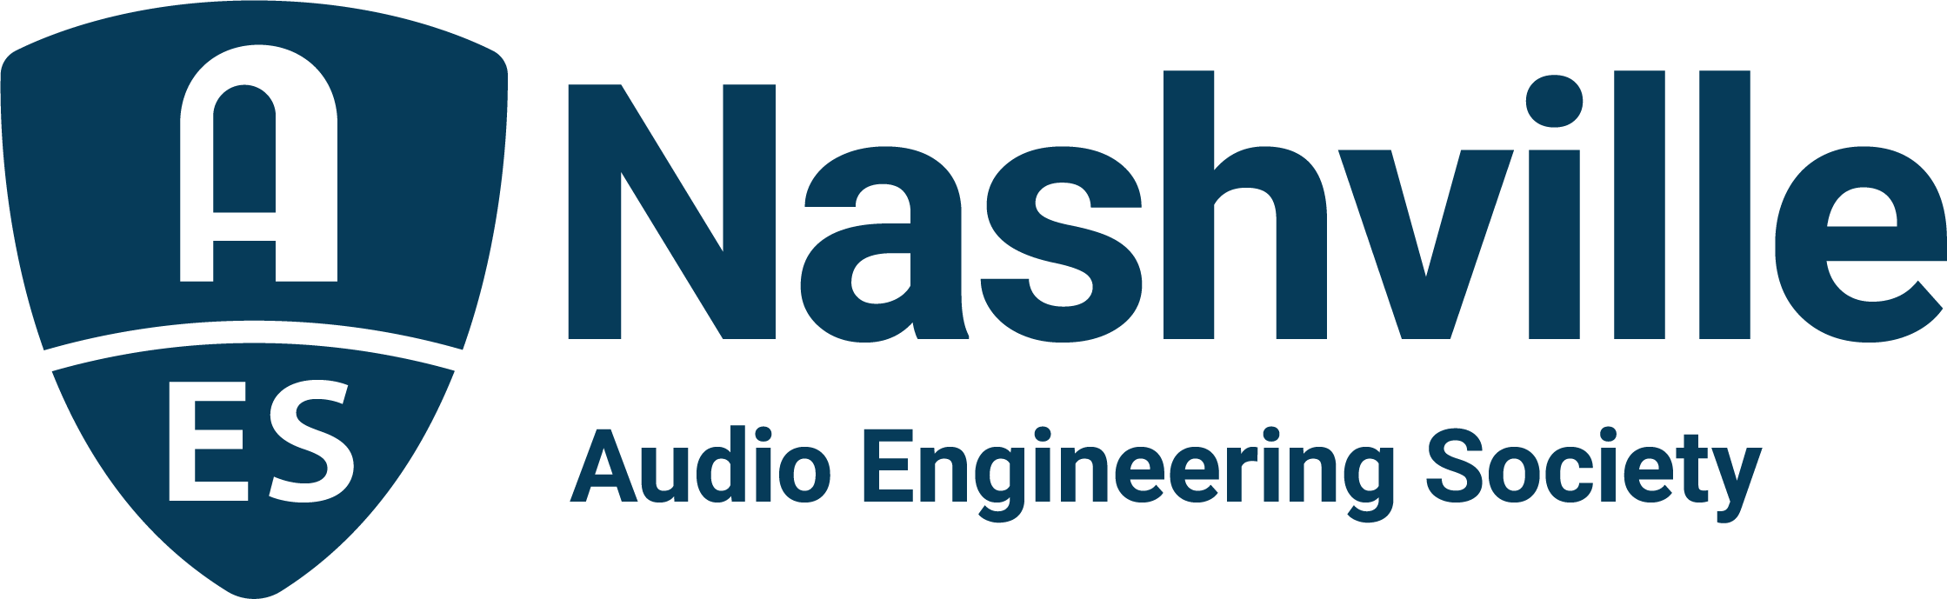

FOR IMMEDIATE RELEASE

Success Breaks Par at 25th Annual AudioMasters Nashville Benefit Golf Tournament

— The Nashville audio community gathered for two fun-filled days on the links in support of the Nashville Engineer Relief Fund —

Nashville, TN, June 2, 2023 — Players from across the country gathered at Harpeth Hills Golf Course for this year’s 25th Annual AudioMasters Nashville Benefit Golf Tournament, held May 18 and 19. This year’s event, once again hosted by the AES Nashville Section, saw the return of title sponsor DiGiCo for the “Live Day” of play on Thursday, with returning sponsor Audio-Technica serving as title sponsor for “Studio Day” on Friday. From each day’s shotgun start to the 19th hole awards dinner and reception, the course offered an array of opportunities to meet with sponsor brands while enjoying a relaxed day of play on the course, gathering swag and enjoying complimentary food and beverage options, contests, games and camaraderie with peers, pros and audio students alike. Serving as the primary fundraiser for the Nashville Engineer Relief Fund (NERF), this year’s event also paid special tribute to co-founder of NERF and of the AudioMasters tournament, “Dr.” Bil VornDick. Additional highlights included each day’s designated special VIP guest, with veteran live sound pro Chris Taylor making his way around the course on day one and recording engineer, producer and educator Mark Rubel on day two.

“It is so heartening to see the Nashville audio community come together again to support their friends and colleagues in the industry who need a hand in times of need,” states Jim Kaiser, NERF board chair. “With continued support from our sponsors, players and student volunteers each year, the AudioMasters tournament has taken on a life of its own, boasting ongoing success both in terms of fundraising and in fostering relationships within the local audio community. To see everyone, from our VIP guests to the next generation of audio professionals, offering their time and talents each year really says a lot about our Nashville audio community and our friends from far and wide. Cheers to everyone involved for another highly successful event!”

Sponsors for the 25th Annual AudioMaster Nashville Benefit Golf Tournament provided a one-of-a-kind experience for golfers, offering food and beverages, giveaways and several chances to win audio gear and services donated by top sponsoring brands. This year’s returning supporters include API, the Audio Engineering Society, Black River Entertainment, Blackbird Studios, Clair Global, Clyne Media, Corky’s Ribs and BBQ of Brentwood, DPA Microphones, Design Technik, Earthworks Audio, ErgoLab/Stealth Chairs, Focusrite, Froggy’s Fog, Genelec, Live Sound International, Loeb & Loeb, Mix Magazine, The NAMM Show, Nashville Recording Supply, RF Venue, The Recording Academy® Producers and Engineers Wing®, The Recording Studio Insurance Program, Shure, Solotech, Sound Emporium, Sound Image, Trew Audio, Teegarden Audio, VEVA Collect, Vision 2 Marketing (HARMAN), Waves and Welcome to 1979 Studios, with new sponsors Carl Tatz Design, PRG (Production Resource Group) and QSC also joining for this year’s festivities.

Stay tuned for upcoming information on the 26th Annual AudioMasters Nashville Benefit Golf Tournament taking place in May 2024.
Link: AudioMasters Benefit Golf Tournament

...ends 523 words

About the AudioMasters Nashville Benefit Golf Tournament
The AudioMasters Nashville Benefit Golf Tournament serves as the primary funding mechanism for the home-grown 501(c)(3) non-profit Nashville Engineer Relief Fund, founded to support local audio professionals in times of crisis. The tournament is produced by the AES Nashville Section with event coordinator Karen Dunn of KMD Productions.
For more information about sponsorships and play for AudioMasters 2024, contact Karen Dunn: karen@kmdpro.com or (925) 708-0307.

Photo File 1: AudioMasters_Live_2023.JPG
Photo Caption 1: Golfers gather for the start of the 25th Annual AudioMasters Nashville Benefit Golf Tournament “Live Day” sponsored by DiGiCo on Thursday, May 18, 2023, at Harpeth Hills Golf Course.
Photo File 2: AudioMasters_Studio_2023.JPG
Photo Caption 2: Golfers gather for the start of the 25th Annual AudioMasters Nashville Benefit Golf Tournament “Studio Day” sponsored by Audio-Technica on Friday, May 19, 2023.

Photo File 3: AudioMasters_Winners_2023.JPG
Photo Caption 3: Team Portus Capital Management took home the cup on both days of the 25th Annual AudioMasters Nashville Benefit Golf Tournament, Paul Banish, Nick Elovitz (shown right), Eric Gallimore and Chetan Patil (shown left) on day one with Buster Bateman taking over for Banish on Day 2, held May 18 and 19 at the Harpeth Hills Golf Course.
Photo File 4: AudioMasters_VornDick.JPG
Photo Caption 4: The 25th Annual AudioMasters Nashville Benefit Golf Tournament featured a special tribute to “Dr.” Bil VornDick, a co-founder of NERF and of the AudioMasters tourney, as well as a beloved member of the Nashville audio community. Pictured are Bil’s son and wife, Wilson and Patricia VornDick, during the 19th Hole awards ceremony and reception.

