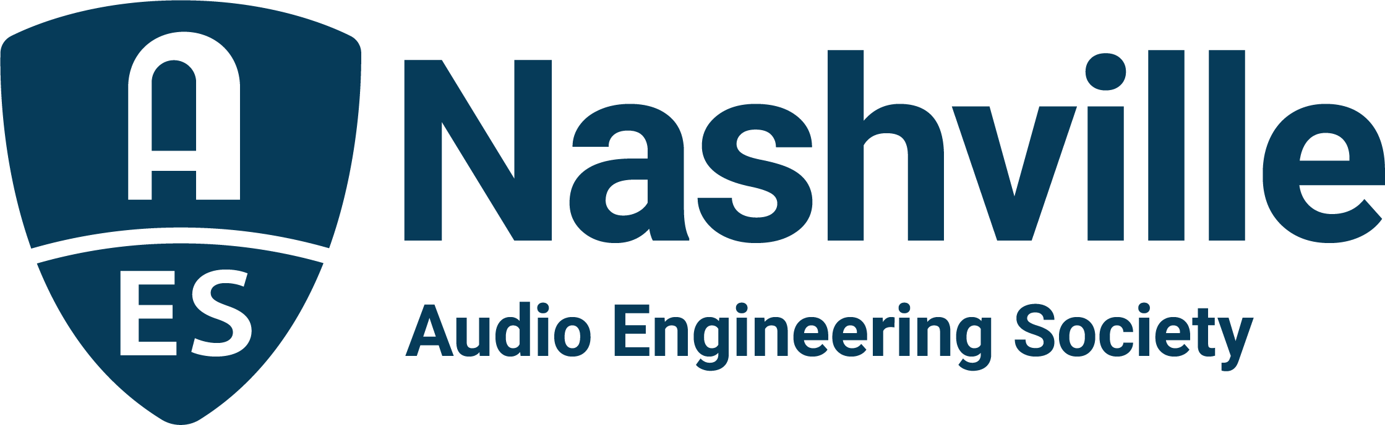

FOR IMMEDIATE RELEASE

Meet the Masters at the 25th Annual AudioMasters Nashville Benefit Golf Tournament, May 18 and 19

— Two-day fundraiser supporting the Nashville Engineer Relief Fund to feature VIP guests Chris Taylor and Mark Rubel as Music City celebrates the local audio community —

Nashville, TN, May 11, 2023 — This year’s 25th Annual Nashville AudioMasters Benefit Golf will once again bring together industry players and sponsors for this highly-anticipated outing, serving as the main fundraising event for the Nashville Engineer Relief Fund (NERF). A highlight of the tournament each year is our designated guest VIP for each day of play – this year, storied live sound engineer Chris Taylor on day one and recording engineer and educator Mark Rubel on day two. Each will be making his way around the golf course, giving both players and sponsors an opportunity to meet and greet some of our hometown heroes that have helped shape the Nashville audio community and beyond. Set to take place May 18 and 19 at the Harpeth Hills Golf Course, the fundraising event presents a highly enjoyable opportunity to meet and network with all facets of the local audio community, while helping to support audio professionals in times of need.

AudioMasters “Live Day” VIP Chris Taylor is an industry veteran with over 40 years of experience mixing a variety of popular touring acts, as well as spending nearly two decades working for Yamaha Commercial Audio in product development and applications. Taylor has done tours with an astounding list of clients including Charlie Rich, Ronnie Milsap, Conway Twitty, Amy Grant, Michael W. Smith, Janet Jackson, Joe Cocker, Lynyrd Skynyrd, Jewel, Michael Jackson and Barbra Streisand, among others. Taylor has also worked on a number of high-profile broadcast events, including Garth: Live from Central Park, the Bob Dylan HBO Tribute Show, Hit Man: David Foster & Friends, the Josh Groban HBO special, and the Charlie Daniels Volunteer Jam, as well as award shows such as the CMT Awards, Dove Awards, and the 60th GRAMMY Awards® show at Madison Square Garden.
The AudioMasters 25th Anniversary “Studio Day” VIP Mark Rubel has produced and engineered thousands of recordings with clients including Alison Krauss, Rascal Flatts, Jeff Coffin, Henry Kaiser, Fall Out Boy, Ludacris, Adrian Belew, Los Lobos, Calexico, Ani DiFranco, The National, Junior Brown, Derek Trucks, Taj Mahal, Bill Frisell and many others. Rubel serves as a panelist, moderator, lecturer, workshop leader and recording judge at numerous audio conferences, and works as an audio expert witness and forensic audio specialist. He is currently Co-Director of Education and Instructor for The Blackbird Academy and has taught audio, music technology, music business and the history of rock to thousands of students since 1985. Currently he is co-writing a history of recording studios of the 1960s and 70s for Rowman & Littlefield, The Great American Recording Studios.

In addition to our VIP lineup, the AudioMasters anniversary will also play host to the growing list of supporting sponsors, including Live Day title sponsor DiGiCo, as well as API, the Audio Engineering Society, Audio-Technica, Black River Entertainment, Blackbird Studios, Clair Global, Clyne Media, Corky’s Ribs and BBQ of Brentwood, DPA Microphones, Design Technik, Earthworks Audio, ErgoLab/Stealth Chairs, Froggy’s Fog, Genelec, Live Sound International, Loeb & Loeb, Mix Magazine, The NAMM Show, Nashville Recording Supply, RF Venue, The Recording Academy® Producers and Engineers Wing®, The Recording Studio Insurance Program, Shure, Solotech, Sound Emporium, Sound Image, Trew Audio, Teegarden Audio, VEVA Collect, Vision 2 Marketing (HARMAN), and Welcome to 1979 Studios, with new sponsors PRG (Production Resource Group) and QSC also supporting our players on the course. Additional sponsorships are still available here.

The AudioMasters Nashville Benefit Golf Tournament serves as the primary funding mechanism for the home-grown 501(c)(3) non-profit Nashville Engineer Relief Fund. The tournament is produced by the AES Nashville Section with event coordinator Karen Dunn of KMD Productions. Complete details, player registration and sponsor opportunities are available online with the latest updates available by following the AudioMasters Nashville on Instagram, Facebook and Twitter.

...ends 617 words

Photo File 1: AudioMasters_2023.JPG
Photo Caption1: The Nashville audio community will return to the links for the 25th Annual AudioMasters Benefit Golf Tournament, May 18 and 19, in support the Nashville Engineer Relief Fund

Photo File 2: Chris_Taylor.JPG
Photo Caption 2: AudioMasters Nashville Benefit Golf Tournament “Live Day” VIP Chris Taylor
Photo File 3: Mark_Rubel.JPG
Photo Caption 3: AudioMasters Nashville Benefit Golf Tournament “Studio Day” VIP Mark Rubel

For more information, contact Karen Dunn: karen@kmdpro.com or (925) 708-0307.

