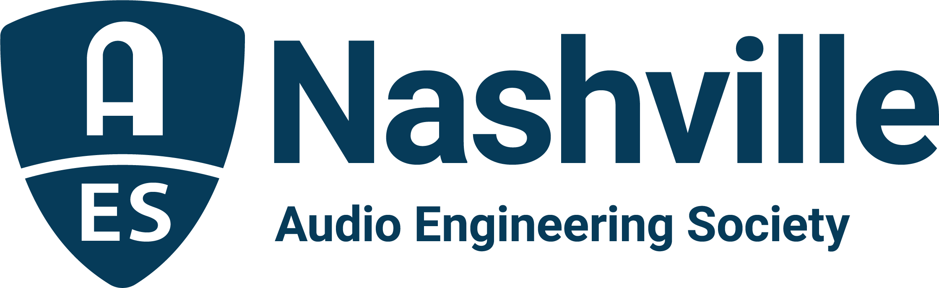

FOR IMMEDIATE RELEASE

Nashville Audio Community Heads to the Links for the DiGiCo AudioMasters Live and Sweetwater AudioMasters Benefit Golf Tournament – Back to May for 2022

- The AES Nashville Section’s 24th annual two-day golf event will take place May 12 and 13 to benefit the Nashville Engineer Relief Fund —

Nashville, TN, April 7, 2022 — The AES Nashville section’s 24th annual AudioMasters Nashville Benefit Golf Tournament returns to its traditional May schedule for 2022. The DiGiCo AudioMasters Live takes place May 12 and the Sweetwater AudioMasters on May 13 at the Harpeth Hills Golf Course in Nashville, TN. The returning title sponsors for the event, DiGiCo for the live-sound-focused day of play and Sweetwater on the studio-themed day, will play host to dozens of audio professionals from the Nashville community and beyond, for one of the most anticipated events of the year, which also serves as the primary funding mechanism for the local 501(c)(3) non-profit Nashville Engineer Relief Fund (NERF).

“The AudioMasters is back for 2022!,” proclaims NERF board chair Jim Kaiser. “Back to our traditional May schedule, back with our generous returning title sponsors, back with our legendary slate of hole, driving range, breakfast, putting green sponsors (and more), and back to growing the Nashville Engineer Relief Fund. We’re looking forward to seeing a full course gathered for the Nashville audio community’s social event of the year and to support colleagues in need. We hope you’ll join us at the 24th Annual DiGiCo AudioMasters Live and Sweetwater AudioMasters!"

Golfers and sponsors can register now at AudioMastersGolf2022.com to join in on the fun. Each day will feature a variety of golf and networking activities, from breakfast on the driving range, to the catered “19th hole” awards reception. Every course hole is sponsored by an array of area studios, live sound providers, service and sales companies, industry organizations, manufacturers and others with ties to the Nashville audio community, with activities at every tee ranging from food and beverages to swag giveaways and competitions.

“The AudioMasters is a nearly indescribable amount of fun,” says NERF board secretary, Frank Wells, “but the good times don’t overshadow that the tournament also makes possible what is arguably the best thing we do as the Nashville audio community – giving a rapid hands-up to audio pros in times of crisis through the Nashville Engineer Relief Fund.”

The tournament is produced by the Nashville AES Section with event coordinator Karen Dunn of KMD Productions. Sponsorship opportunities range from hole sponsors, to competitions, to the awards reception – limited sponsorship opportunities are still available.

More information and registration is available online at AudioMastersGolf2022.com with the latest updates available by following the AudioMasters Nashville on Instagram, Facebook, and Twitter.

...ends 393 words

Photo File1: AudioMasters_Logo_2022.JPG
Photo Caption1: The Nashville AES Section’s 24th annual AudioMasters Benefit Golf Tournament – the DiGiCo AudioMasters Live on May 12 and the Sweetwater AudioMasters on May 13 – supporting the Nashville Engineer Relief Fund

Photo File2: AudioMasters_Nashville_1.jpg
Photo Caption2: Nashville audio pros will return to the greens for the 24th Annual AudioMasters Benefit Golf Tournament. The DiGiCo AudioMasters Live on May 12 and the Sweetwater AudioMasters on May 13 support the Nashville Engineer Relief Fund

For more information, contact Karen Dunn: karen@kmdpro.com or (925) 728-0307

