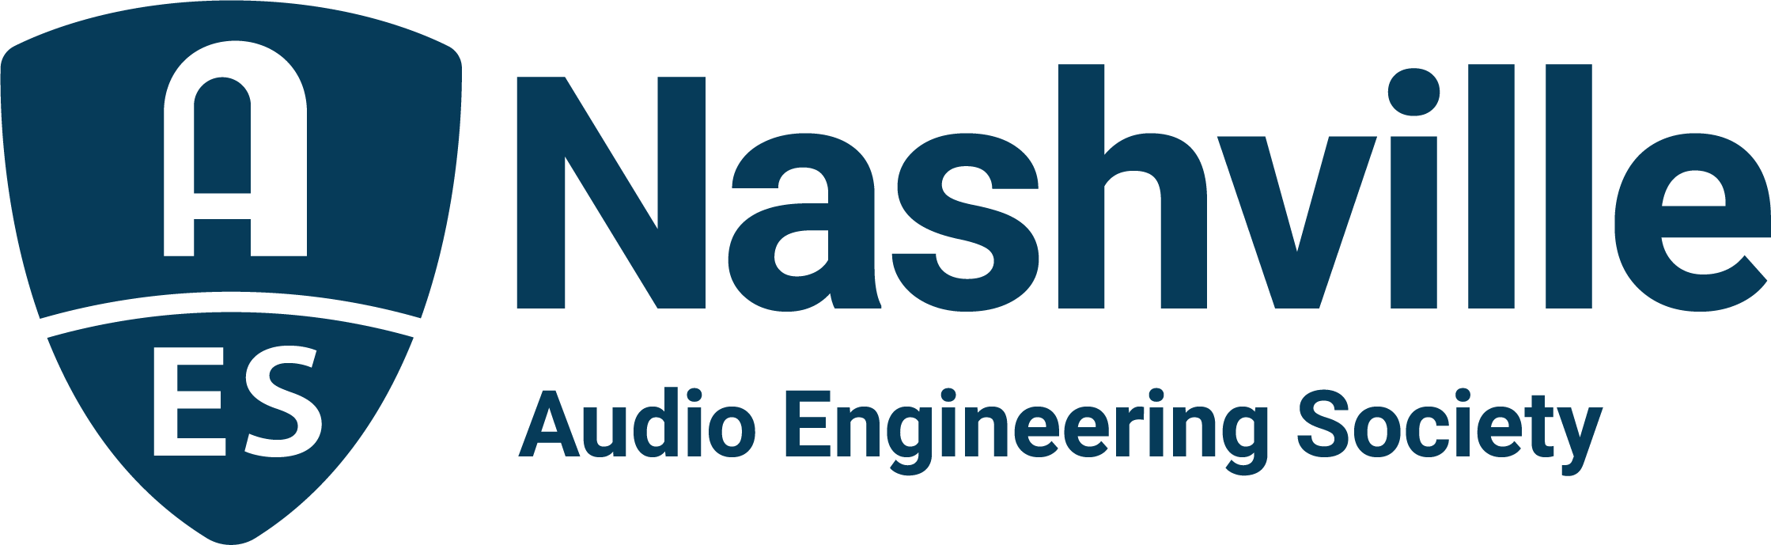

FOR IMMEDIATE RELEASE

AudioMasters Nashville Benefit Golf Tournament Announces May 2024 Dates for 26th Annual Event

— Player and sponsor opportunities come together in support of the Nashville Engineer Relief Fund, May 9 – 10, 2024, at Harpeth Hills Golf Course —

Nashville, TN, December 15, 2023 — Following their highly-anticipated 25th anniversary event held in May 2023, the Nashville Engineer Relief Fund (NERF) and the Audio Engineering Society Nashville Section have announced dates for next year’s AudioMasters Nashville Benefit Golf Tournament, set to take place May 9 – 10, 2024. Once again being held at the Harpeth Hills Golf Course, the AudioMasters has become the go-to event for the Nashville audio community and beyond, drawing players and sponsors from across the country. From each day’s shotgun start to the 19th hole awards dinner and reception, the AudioMasters offers an array of opportunities to meet and network with engineers, producers, musicians, and more, while players are ensured a relaxed day of play on the course, and sponsors uniquely showcase their brand, with many offering swag, complimentary food and beverage options, contests, games and camaraderie with peers, pros and audio students alike. Player registration, along with a myriad of sponsorship opportunities for the 2024 AudioMasters Benefit Golf Tournament, are now available at https://birdease.com/26thAnnualAudiomastersGolfTourna.

“What the Nashville Engineer Relief Fund has created over two decades ago, is truly something special for any professional community,” states Jim Kaiser, NERF board chair. “Each year, players are excited to see how our sponsors have dressed up the golf course with spectacles and experiences – and there is no shortage of that. But what they really value is the way all facets of the audio community come together to support their colleagues in times of crisis through the Nashville Engineer Relief Fund. With the tight bonds and close working relationships among all segments of the entertainment industry, especially here in Nashville, there is a willingness to give back and support our friends and colleague’s livelihoods as we look ahead to our next 25 years of the Tournament.”

Single-player and foursome registration are now open, as well as sponsorship opportunities including title sponsorship, hole sponsorships, drink carts, player gifts, comfort tents, contests and more. Single-player registration is $150 and foursome registration $600 – last year’s rate – till March 15. After the earlybird period, registration goes up to $175 and $700, respectively.

The AudioMasters Nashville Benefit Golf Tournament serves as the primary funding mechanism for the home-grown 501(c)(3) non-profit Nashville Engineer Relief Fund, founded to support local audio professionals in times of crisis. The tournament is produced by the AES Nashville Section with event coordinator Karen Dunn of KMD Productions.

...ends 390 words

Link: AudioMasters Benefit Golf Tournament
For more information about sponsorships and play for AudioMasters 2024, contact Karen Dunn: karen@kmdpro.com or (925) 708-0307.

