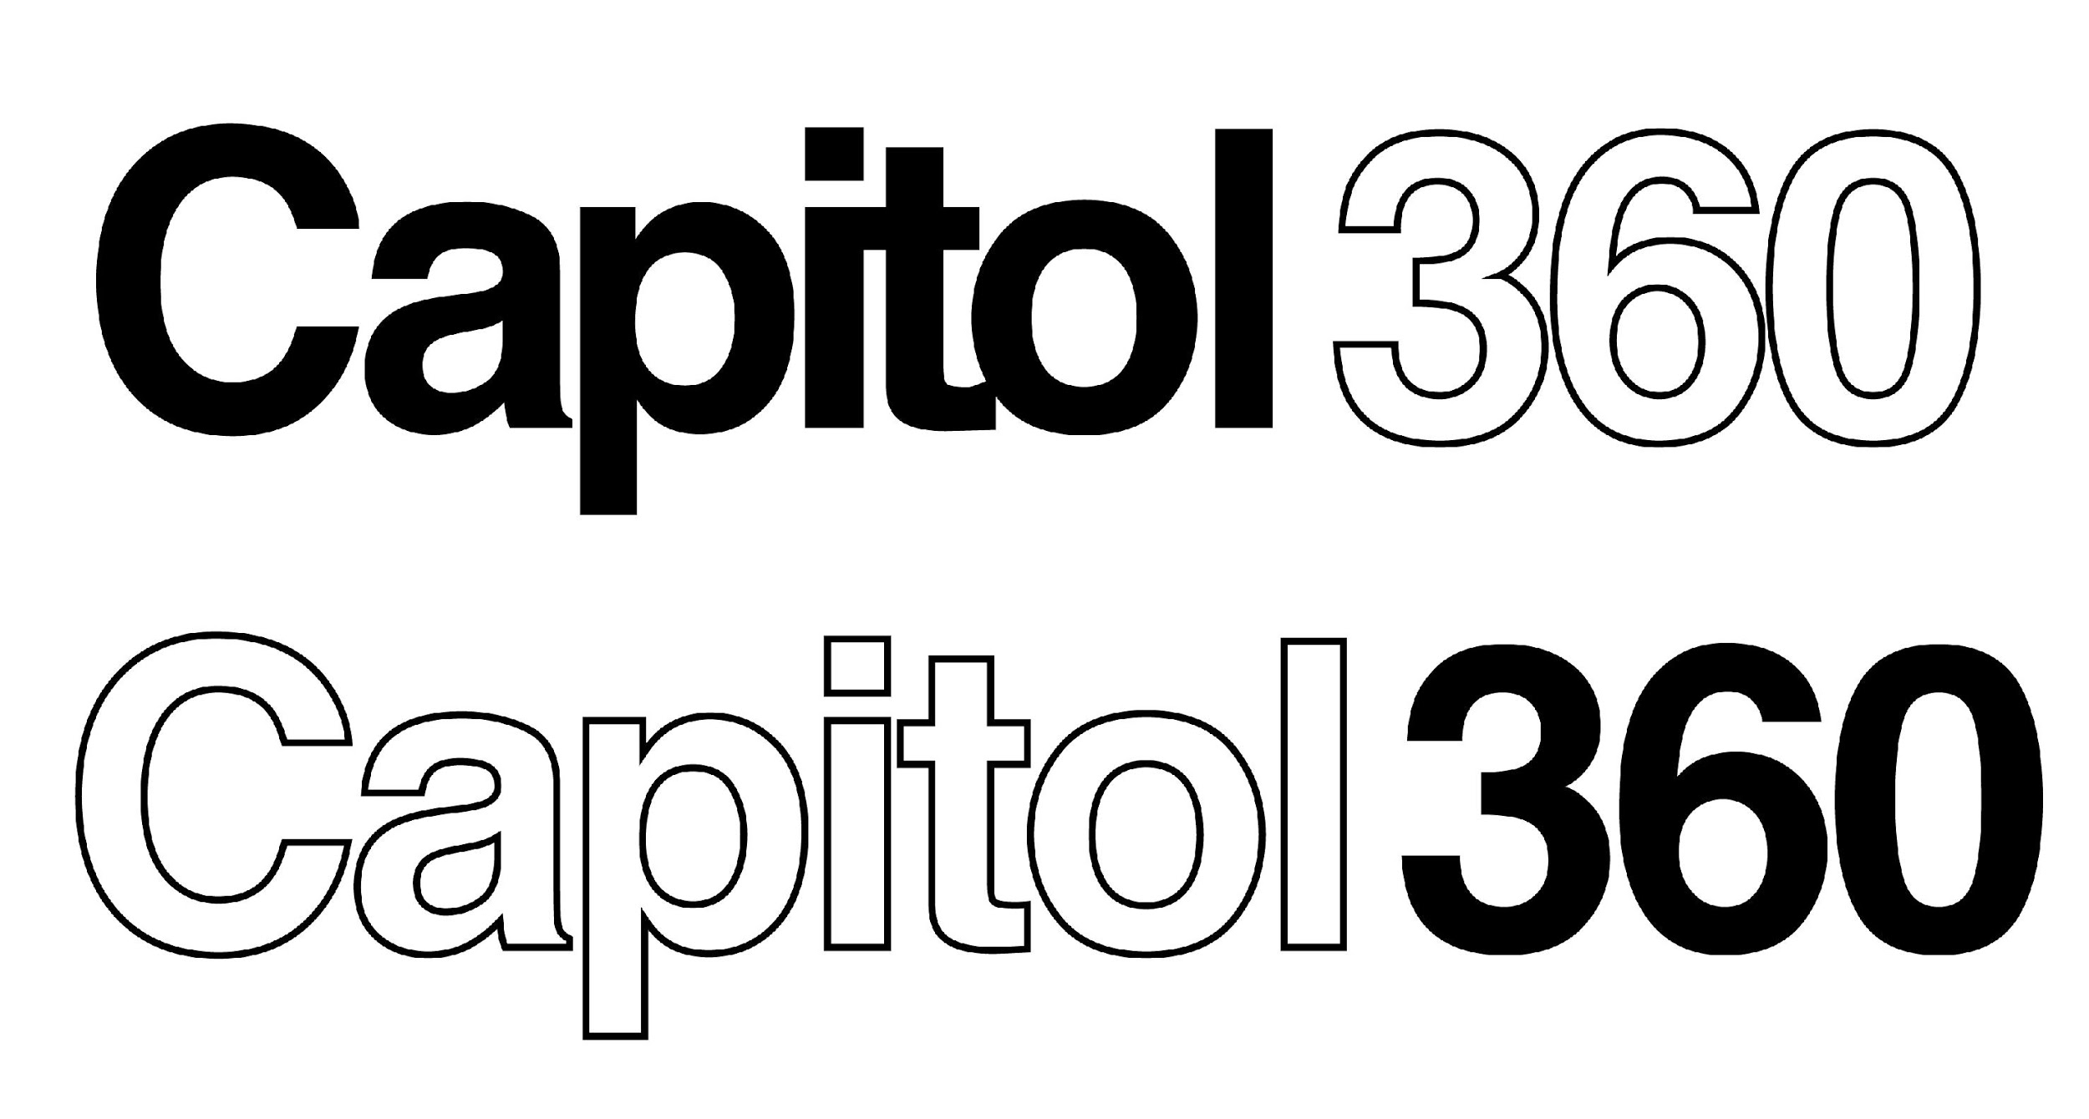
For Immediate Release

Capitol Music Group Holds Wildly Successful Creativity and Innovation Marathon, “Capitol Royale,” on December 1 – 2

Event at legendary Capitol Studios brought together creators, coders, designers, and startups to re-imagine the future state of music consumption, including a live-streamed Twitch session with Tyler “Ninja” Blevins, the world’s biggest online gamer

December 13, 2018 — (Hollywood, CA) — Signaling its commitment to being a pioneer in the music and tech crossover space, Capitol Music Group recently hosted Capitol Royale — a creativity and innovation marathon that took place at the legendary Capitol Studios in Hollywood on December 1 and 2, 2018. The two-day conference brought together the music and tech industries’ leading creatives, coders, designers, and startups to highlight innovations that disrupt the music industry, including a hackathon that challenged software developers to create products and services that reimagine music consumption and discovery.

A particular highlight was the finale featuring a live Fortnite Twitch session with Tyler “Ninja” Blevins, the world’s biggest online gamer. Ninja’s appearance also celebrated the launch of his new self-curated EDM compilation, Ninjawerks Volume 1 (being released December 14 on Astralwerks). Ninja was joined in his Twitch stream by Lil Yachty, DJ Caruso and the Lost Kings. An afterparty included DJ sets from ZAXX, CRAY, Justin Caruso, GTA, Tycho and 3LAU.

Participants in the hackathon had access to a catalog of roughly 14,000 Universal Music Group and Universal Music Publishing Group pre-cleared audio streaming tracks, as well as never-before-seen original content and mentorship from veteran industry leaders and UMG’s technical partners, including the Capitol360 Innovation Center’s founding partners, Verizon, Twitch, Cloudinary, and ConsenSys’ blockchain music platform Ujo. Other partners included Spotify, TiVo, 7digital, Roland, Unity, Qloo, LyricFind, and Havas.

In addition to the hackathon, Capitol teamed up with startup accelerator gener8tor to host a Startup Garden with curated, one-on-one pitch sessions between selected startups and venture capitalists and innovation executives from participating companies, breakout panels and workshops, partner exhibits, and artist performances.

“Capitol Royale was a highly successful event with a large online response,” stated Paula Salvatore, VP/Studio Manager, Capitol Studios. “We are proud that Capitol Studios is not only a world-class recording facility, but also an ideal venue for all manner of industry events, with the technological infrastructure to handle basically anything a particular gathering might require.”

Other Capitol Royale highlights included:

- Motown recording artists JAMESDAVIS and Verizon, with the help of the app developers participating the hackathon, partnered to re-imagine what music videos could look like in the future. Verizon’s RYOT, the immersive media and premium entertainment studio, hosted select participants two days prior to the event at the RYOT 5G Lab to explore the future state of music videos using augmented reality and motion capture animation.

- During the event, Twitch conducted a challenge that tasked software developers to create products and services that reimagine music consumption, interactivity, and discovery through Twitch Extensions.

- gBETA Musictech Demo Day — a celebration of Capitol’s inaugural class of startups focused on music technology sponsored by gener8tor.

- The Spotlight Stage featured performances from JAMESDAVIS and other Capitol Music Group artists, as well as presentations from the hackathon finalists.

- Speakers and judges included Michelle Jubelirer (Capitol Music Group), Larry Marcus (Walden & Marcy Venture Partners), McBurney Burrus (Jimmy Kimmel Live), Bill Gagnon (Universal Music Group), Daniel Miller (Unity), Marc Byers (Motown), Rishi Patel (Plus 8 Equity), Romain Reveillere (Havas/Station F), and more.

For more information, please visit the Capitol Royale website

Or contact: MacKenzie Reynolds / MacKenzie.Reynolds@umusic.com

http://www.capitolmusic360.com/
https://www.gener8tor.com/

###

Photo file 1: Capitol_Royale_Photo1.jpg
Photo caption 1: Pictured L-R: Tycho, Ninja, Lil Yachty, 3LAU, CRAY and Justin Caruso, pictured at Capitol Royale, a creativity and innovation marathon that took place at the legendary Capitol Studios in Hollywood on December 1 and 2, 2018.

Photo file 2: Capitol_Royale_Photo2.jpg
Photo caption 2: Motown trio JAMESDAVIS (Rey, Auston and Jess Reynolds), pictured performing on the Spotlight Stage at Capitol Royale, a creativity and innovation marathon that took place at the legendary Capitol Tower in Hollywood on December 1 and 2, 2018.

Photo file 3: Capitol_Royale_Photo3.jpg
Photo caption 3: Justin Caruso, performing a DJ set at the afterparty at Capitol Royale, a creativity and innovation marathon that took place at the legendary Capitol Studios in Hollywood on December 1 and 2, 2018.

Photo file 4: Capitol_Royale_Photo4.jpg
Photo caption 4: Popular gamer and streamer Ninja, pictured at Capitol Royale, a creativity and innovation marathon that took place at the legendary Capitol Studios in Hollywood on December 1 and 2, 2018.

