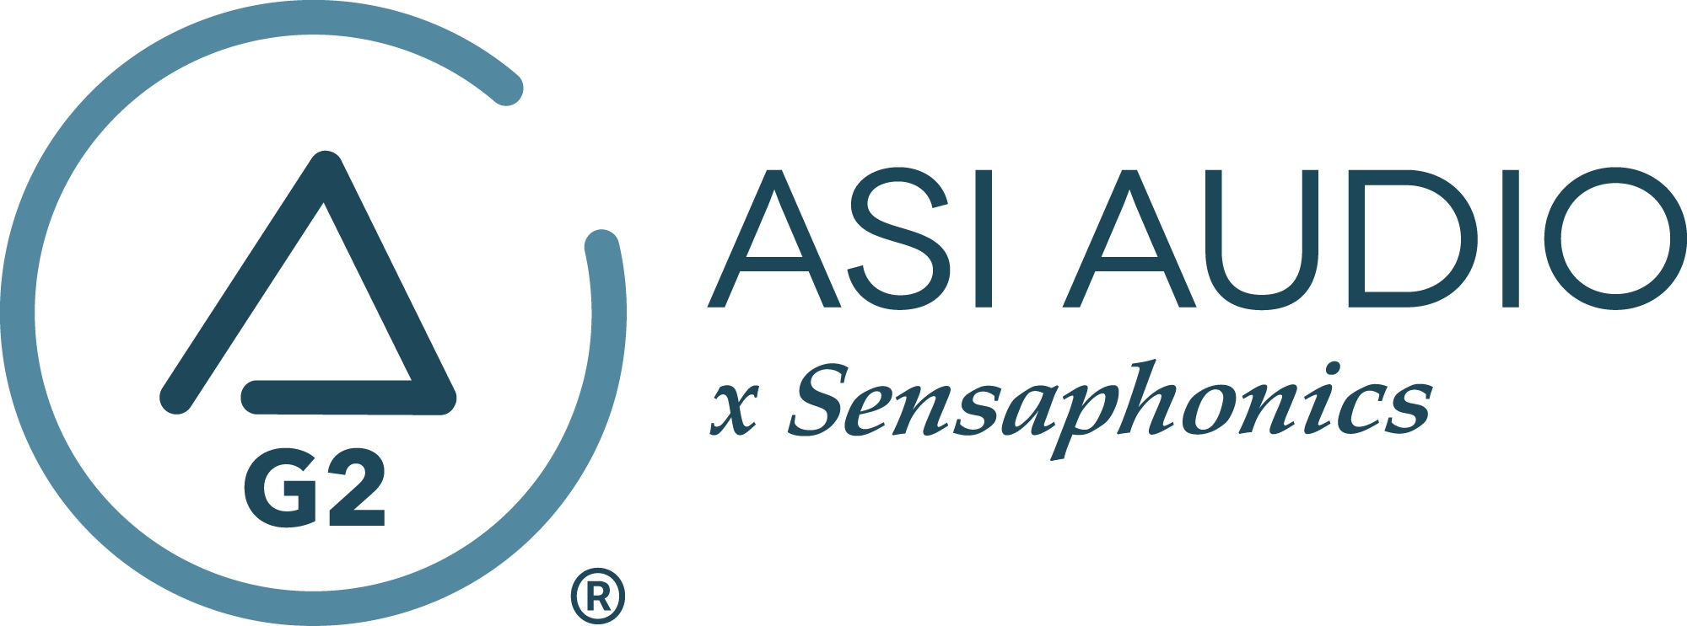 FOR IMMEDIATE RELEASE

Dr. Michael Santucci, president of ASI Audio and Sensaphonics, featured as a guest on The Table podcast

— Host Jason Squires (coming from a background in worship leadership and music ministry) seeks insights from Dr. Santucci on common issues brought about by IEM use, including ear fatigue and short- and long-term hearing loss, and how the ASI Audio x Sensaphonics 3DME Active Ambient Monitoring System addresses these issues —

Beachwood, OH, March 29, 2023 — Dr. Michael Santucci, noted audiologist and president of customized hearing protection specialists ASI Audio and Sensaphonics, is the latest guest on The Table, a podcast hosted by Jason Squires focused on the world of worship leadership and music ministry.

For nearly 40 years, Santucci has been on a mission to protect musicians—and engineers—from the damaging effects of loud sound. A musician from a family of musicians, Santucci was inspired to found Sensaphonics in 1985, initially researching and evaluating ear-filtering products, after the singer quit the band that he was in because her ears were ringing.

On the newest episode of The Table, host Jason Squires seeks insights from Santucci’s decades of experience at the intersection of hearing protection and in-ear monitoring. Squires admits that in the past he has often relied on a common trick – taking one in-ear monitor out and leaving the other in, to get a mix of the monitor signal and the room sound in the opposite ear – without considering whether it might be leaving him susceptible to hearing damage. Additionally, he is also concerned about performers setting their IEMs too loud, as well as the short- and long-term effects of ear fatigue. In this engaging conversation, Santucci provides expertise on these topics and others, and he explains the philosophy behind the ASI Audio x Sensaphonics 3DME Active Ambient Monitoring System and how it serves as a solution to all of the above-mentioned problems.

Access The Table podcast now on all major streaming platforms.
Apple Podcasts
Spotify

To learn more about the 3DME, visit https://asiaudio.com/.
…ends 260 words

Photo file 1: Santucci.JPG
Photo caption 1: Dr. Michael Santucci, noted audiologist and president of customized hearing protection specialists ASI Audio and Sensaphonics, is the latest guest on The Table

Press contact:
Clyne Media, Inc.
Frank Wells, Senior Account Manager
615.585.0597
frank.wells@clynemedia.com

ASI Audio contact:
Evan MacKenzie, Vice President, Marketing and Sales
216.970.4468 ext.104
evanmackenzie@asiaudio.com

ABOUT ASI AUDIO
Founded in 2019 by the team of hearing health advocate Dr. Michael Santucci Au.D. of Sensaphonics and Think-A-Move, Ltd. (developers of innovative speech recognition products for high-volume environments), ASI Audio x Sensaphonics has combined patented technologies and market insights to create 3DME Music Enhancement, a fundamentally different approach to in-ear monitoring and hearing protection. 3DME combines Active Ambient technology and personalized sound quality via the intuitive ASI Audio app, creating a system equally useful for amplified and acoustic monitoring for musicians and concertgoers alike. Web: www.ASIaudio.com.

