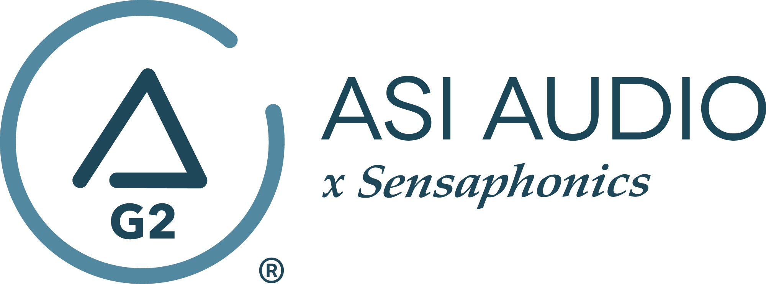 FOR IMMEDIATE RELEASE

Singer-songwriter Marc Lee Shannon chooses ASI Audio x Sensaphonics 3DME Music Enhancement IEM System

— “It’s a game changer”: from solo acoustic performances to a full nine-piece band with horns, the acclaimed songwriter Marc Lee Shannon relies on the ASI 3DME system for organic and musical in-ear monitoring. —

Beachwood, OH, October 27, 2022 — After several decades in music, Marc Lee Shannon is living his dream. Based in Akron, Ohio, Shannon creates music that reflects his Rust Belt roots. A champion of everyday heroes, his soulful, melodic music chronicles the struggles and redemption of the lost, the found, the deserted, and the delivered. And he has taken quite the road to get to where he is now: “In my early years, I was a professional musician based in L.A.,” but after 11 years of road trips, rest stops, sessions, and performances, Shannon returned home to start a new chapter of his career. There, a friend connected him with northeast Ohio’s favorite son, Michael Stanley, sparking what would become not just a musical partnership, but a decades-long mentorship and friendship. At the same time, he was working a corporate job. “I was still playing and making music, but having a job like that limits how much time and energy you can put toward your artistry. But in 2014 I decided to focus on the music and left the suit-and-tie world, and I’ve been lucky to have a decent amount of success with my music in recent years.” His most recent album, Lucky 7, was released fall 2021 to critical acclaim.

Shannon can scale his performance up or down to suit the setting – from solo shows to three- or four-piece combos to full nine-piece bands with live horns. And his recent concerts have benefitted from a new crucial tool in Shannon’s arsenal: the ASI Audio x Sensaphonics 3DME Gen2 Active Ambient Monitoring System. “I’ve used in-ear monitors before, but the 3DME system is something different and very special. The nature of the different gigs I do means that often there is no dedicated monitor engineer, which makes it pretty difficult to dial in most in-ears and make them work for you. But the 3DME is another thing altogether. I am able to control the ambient environment very easily, and I’m able to push the peak frequencies that I really need as a singer. It really sounds and feels to me like I’m hearing myself sing in a room – not the sterile ‘studio’ sound you get from a lot of other in-ears. I’m able to phonetically express myself in a natural way, and that just makes me more comfortable as a vocalist, and the performance is better as a result. It’s a game-changer, whether I’m performing solo or with a larger combo.”

Another benefit to Shannon that the 3DME system provides is its contribution to his hearing wellness. “I know after 46 years playing shows, I have had some hearing loss, especially in the high end,” he remarks. “To counter that, many monitoring solutions would involve cranking things up to unsafe levels, which just makes the problem worse in the long run. With the 3DME, you can really dial things in, in addition to the natural hearing protection they provide. I often still like to use stage wedges in addition to the 3DME system, but the 3DME just gives you a high level of control. I can hear certain frequencies in a way I wouldn’t be able to otherwise, and it’s all in a very safe place. It’s better for the music and better for your hearing health. I’ve been waiting for this kind of product to come around for a very long time.”

The 3DME Music Enhancement IEM System Gen2 consists of Active Ambient earphones with embedded binaural MEMS ambient microphones, a bodypack mixer/controller/DSP processor/headphone amplifier and the Bluetooth-enabled ASI Audio App for control. The free ASI Audio App allows untethered adjustment of the system’s 7-band stereo EQ and limiter threshold. The App also offers an Audio Seal Test to confirm perfect IEM fit and allows the saving and recall of User Presets to ensure repeat access to preferred sound signatures. In operation, after locking in the preferred EQ and limiter settings, up/down switches on the bodypack make it easy to add the perfect amount of ambience to the monitor mix, so the performer can hear exactly what they want, no matter the style of music or type of venue. When used without a monitor mix, 3DME functions as variable-level, high fidelity earplugs. The universal-fit earphones supplied with 3DME can be converted to custom fit with silicone sleeves from Sensaphonics or upgraded to Custom Pro earpieces.

To learn more, visit www.ASIaudio.com and https://www.marcleeshannon.com/.

…ends 725 words

Photo file 1: MarcLeeShannon_Photo1.JPG
Photo caption 1: Singer-songwriter Marc Lee Shannon, pictured with his ASI Audio x Sensaphonics 3DME Music Enhancement IEM System

Photo file 2: MarcLeeShannon_Photo2.JPG
Photo caption 2: Singer-songwriter Marc Lee Shannon employs the ASI Audio x Sensaphonics 3DME Music Enhancement IEM System for organic and musical in-ear monitoring

Photo file 3: MarcLeeShannon_Photo3.JPG
Photo caption 3: Singer-songwriter Marc Lee Shannon employs the ASI Audio x Sensaphonics 3DME Music Enhancement IEM System for solo performances, small combo gigs, and full band shows with horns

Press contact:
Clyne Media, Inc.
Frank Wells, Senior Account Manager
615.585.0597
frank.wells@clynemedia.com

ASI Audio contact:
Evan MacKenzie, Vice President, Marketing and Sales
216.970.4468 ext.104
evanmackenzie@asiaudio.com

ABOUT ASI AUDIO
Founded in 2019 by the team of hearing health advocate Dr. Michael Santucci Au.D. of Sensaphonics and Think-A-Move, Ltd. (developers of innovative speech recognition products for high-volume environments), ASI Audio x Sensaphonics has combined patented technologies and market insights to create 3DME Music Enhancement, a fundamentally different approach to in-ear monitoring and hearing protection. 3DME combines Active Ambient technology and personalized sound quality via the intuitive ASI Audio app, creating a system equally useful for amplified and acoustic monitoring for musicians and concertgoers alike. Web: www.ASIaudio.com.

