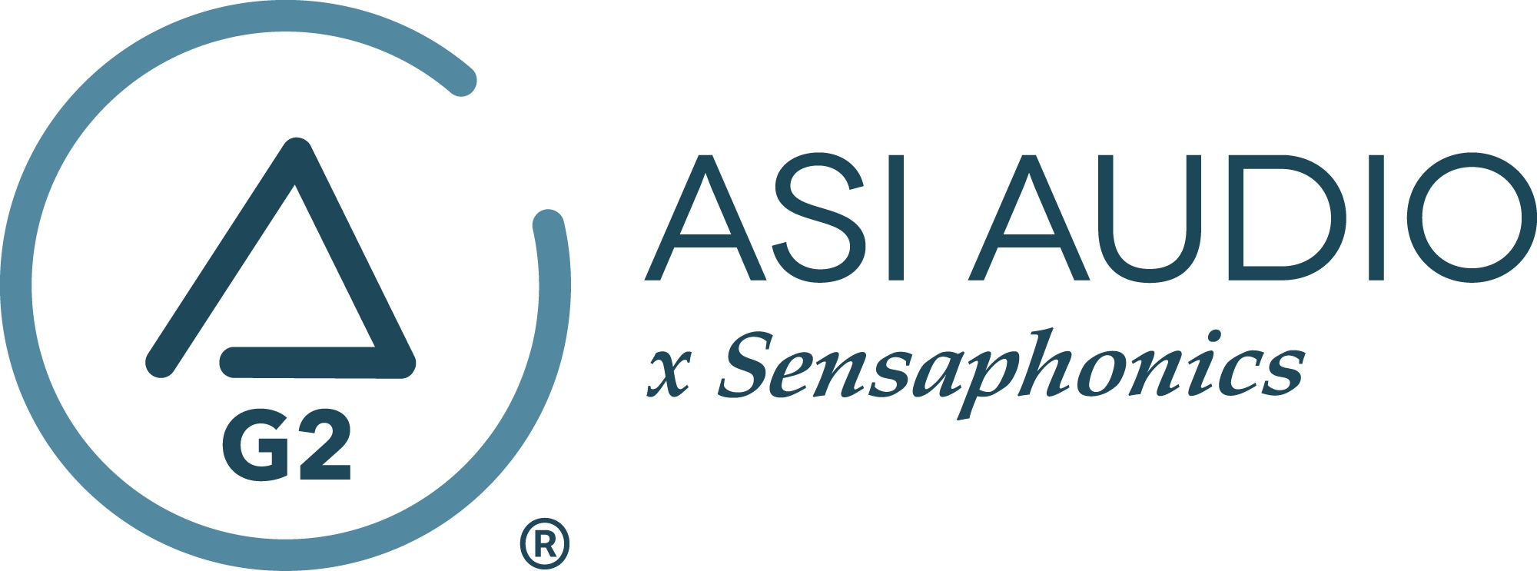 FOR IMMEDIATE RELEASE

ASI Audio tailors DJ Cable interconnect for wired users

— The premium-quality ASI Audio DJ Cable is tailored specifically for 3DME Active Ambient IEM DJ users, while also suited also for musicians using personal monitor mixers with a 3DME system —

Beachwood, OH, September 7, 2022 — In response to requests from DJs using the ASI Audio 3DME Active Ambient IEM system with a DJ mixer, ASI Audio x Sensaphonics is now offering the ASI Audio DJ Cable. Both ends of the cable are fitted with high-quality gold-plated 3.5mm TRS plugs. On the mixer end of the cable, the plug has a spring strain relief at the cable entry and is also threaded for an included 1/4-inch adapter to accommodate mixers with 1/4-inch headphone output jacks.

The premium-quality cable, tailored specifically for DJ use but also suited for use by musicians feeding their 3DME system from a personal monitor mixer, has a woven outer wrap for durability and to avoid kinks and knots in a gig bag. Its 1.6-meter/5.25-foot cable length is optimal for its target application. The ASI Audio DJ Cable is available immediately at a price of $39.99 (USD) when sold separately and $29.99 when bundled with a 3DME system purchase.

More Information: asiaudio.com

Photo file 1: ASI_Audio_DJ_Cable.jpg
Photo caption 1: The ASI Audio DJ Cable is a premium-quality, 1.6m, 3.5mm to 3.5mm TRS cable tailored specifically for DJ use, and suited also for musicians feeding their ASI Audio 3DME Active Ambient IEM system from a personal monitor mixer

# # # # #

Press contact:
Clyne Media, Inc.
Frank Wells, Senior Account Manager
615.585.0597
frank.wells@clynemedia.com

ASI Audio contact:
Evan MacKenzie, Vice President, Marketing and Sales
216.970.4468 ext.104
evanmackenzie@asiaudio.com

ABOUT ASI AUDIO
Founded in 2019 by the team of hearing health advocate Dr. Michael Santucci Au.D. of Sensaphonics and Think-A-Move, Ltd. (developers of innovative speech recognition products for high-volume environments), ASI Audio x Sensaphonics has combined patented technologies and market insights to create 3DME Music Enhancement, a fundamentally different approach to in-ear monitoring and hearing protection. 3DME combines Active Ambient technology and personalized sound quality via the intuitive ASI Audio app, creating a system equally useful for amplified and acoustic monitoring for musicians and concertgoers alike. Web: www.ASIaudio.com.

